Wellington North Power Inc.
290 Queen Street West, P.O. Box 359
Mount Forest, ON N0G 2L0
Phone: 519-323-1710 Fax: 519-323-2425
e-mail wnp@wellingtonnorthpower.com

March 18, 2009

Ms. Kirsten Walli
Board Secretary
Ontario Energy Board
P.O. Box 2319
27th Floor
2300 Yonge Street
Toronto, ON M4P 1E4

Dear Ms. Walli:

Wellington North Power Inc. - OEB License ED-2002-0511
2009 3rd Generation Incentive Regulation Mechanism (IRM) Rate Application
Board File No. EB-2008-0217

Wellington North Power Inc. has reviewed the draft Tariff of Rates and Charges as set out in Appendix A of the Ontario Energy Board’s Decision and Order regarding EB-2008-0217.

Please accept this letter as confirmation of our assessment that the draft Tariff of Rates and Charges are complete and no inaccuracies were found in the information set out in Appendix A of the Ontario Energy Board’s Decision and Order regarding EB-2008-0217 dated March 17, 2009.

We trust this written submission confirms the accuracy and completeness of the draft Tariff of Rates and Charges in Schedule A of the Ontario Board’s Decision and Order. Wellington North Power Inc. understands the draft Tariff of Rates and Charges set out in Appendix A of this Order will become final, effective May 1, 2009, and will apply to electricity consumed or estimated to have been consumed on and after May 1, 2009.

If you have any questions or require further clarification please contact me at 519-323-1710 or jrosebrugh@wellingtonnorthpower.com.

Yours truly,
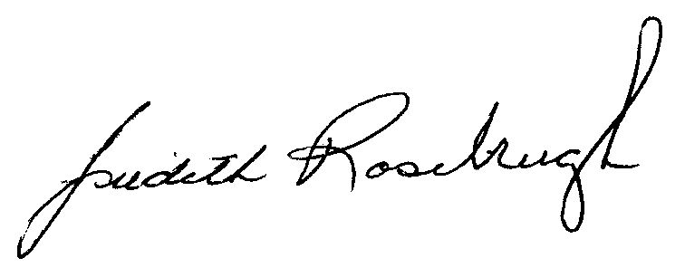
Judith Rosebrugh, President/CEO
Wellington North Power Inc.

