

August 15, 2007

Ontario Energy Board
Attention: Kirsten Walli, Board Secretary
2300 Yonge Street, 27th Floor
P.O. Box 2319
Toronto, ON M4P 1E4

Dear Ms. Walli: Hydro 2000 Inc. - OEB Licence ED-2002-0542
Request for Filing Extension
EB-2007-0704 - 2008 Rate Application

Hydro 2000 Inc. has been working diligently with our consultant Elenchus Research Associates (ERA) to complete and file our 2008 rate application by August 15, 2007. However, as you were advised in a recent meeting with ERA, most of the Distributors filing for 2008 rates will not be able to complete their applications by August 15th due to challenges with the ERA model.

We are committed to filing a 2008 rate application that is not only compliant with the Board’s minimum filing requirements, but also provides clear and complete evidence in support of our application. Shortcomings in our filing will create problems for Board staff as well as for us and our stakeholders.

Hydro 2000 Inc. has carefully reviewed the status of our work to date and the timelines for completing our filing. As a result of this review, we wish to advise you that will be able to complete our 2008 rate application by Friday, September 28, 2007. We regret any inconvenience that may result from this delay, but we are confident that it is in the interest of everyone concerned to take the extra few weeks to complete a filing that can be processed with the minimum of effort. Wellington North Power will continue to make every effort to complete the filing at the earliest possible date and file with the Board in advance of the dates noted above.

If you have any question please contact the undersigned at 613-679-4093.

Yours truly,

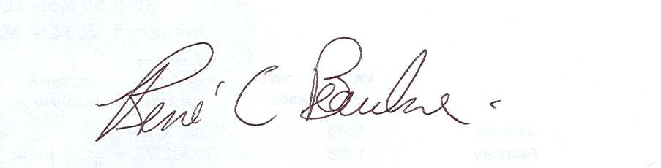
Rene Beaulne (Bone), Manager

