

Monday, August 31, 2009

Via Facsimile: +1 (416) 440-7656

Kirsten Walli
Board Secretary
Ontario Energy Board
27th Floor, 2300 Yonge Street
P.O. Box 2319
Toronto, Ontario M4P 1E4

Dear Ms. Walli:

Re: Hydro One - Karn Transformer Station
File no. 41982

Further to the Board hearing on August 18, 2009, we can now advise you that Hydro One Networks Inc. and the intervenor, I-ON-X Acres Inc., have entered into an agreement which will, upon completion, eliminate the need to expropriate any interest in the land. Accordingly, once the transaction is completed HONI’s application for authority to expropriate can be withdraw in its entirety.

The transaction is scheduled to close on September 30, 2009 and, as a hearing has been scheduled for September 1, 2009, we would ask that the hearing be adjourned sine die or, in the alternative to a date beyond September 30. Upon completion of the transaction, we will advise the Board that the application can be withdrawn. By a copy of this letter to the solicitors for the intervenor, we would ask for their consent to this procedure.

Should you require further information do not hesitate to contact us.

Yours very truly,
BURGAR ROWE
Professional Corporation
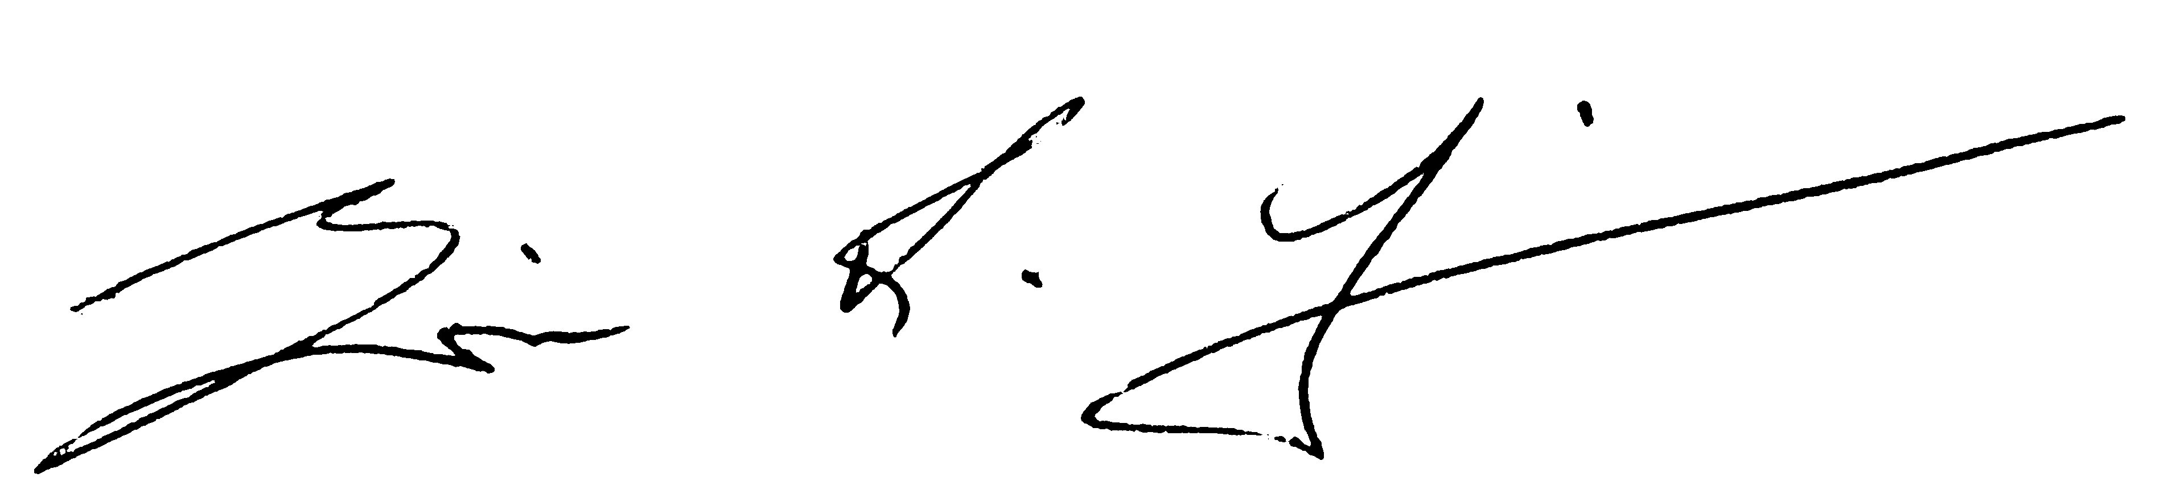
Per: Eric R. Finn | 
Ef/kc
efinn@burgarrowe.com
cc: R. MacDougall
L. Cochrane
client

