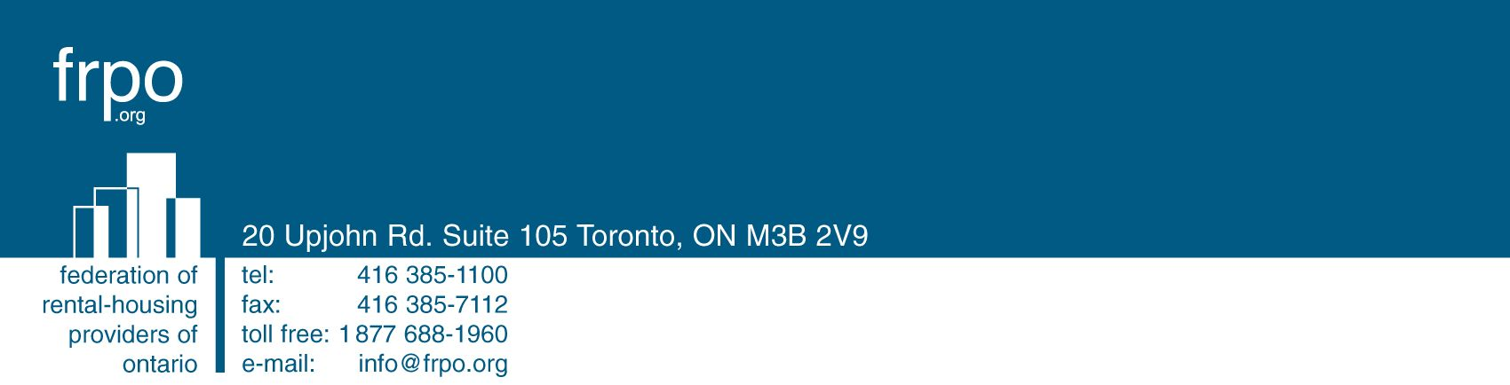
September 1, 2009
Delivered and Via Email
Ms. Kirsten Walli
Board Secretary
Ontario Energy Board
2300 Yonge Street
27th Floor
Toronto, ON M4P 1E4

Dear Ms. Walli:

Re: | Motion to Review a Decision and Order dated August 13, 2009  Board File No. EB-2009-0111  Federation of Rental-Housing Providers of Ontario (“FRPO”)

FRPO is the largest association in Ontario representing more than 800 persons and entities that own, manage, build and finance residential rental properties. FRPO participated in the above-noted proceeding and filed a detailed Submission dated May 26, 2009.
The Decision and Order of the Ontario Energy Board (the “Board”) in the above proceeding was issued on August 13, 2009. Given the size of FRPO’s membership and the impact of summer holidays on scheduling, it was not possible to communicate with FRPO’s members and to receive instructions in respect of the Board’s Decision and Order until today. I am writing to advise that FRPO hereby requests that the Board review all or part of the Decision and Order and to vary, suspend or cancel all or portions of the Decision and Order. FRPO’s request for review is made in accordance with Part VII of the Board’s Rules of Practice and Procedure. This request for review may include a request to stay all or aspects of the Decision and Order.
Unfortunately, given the size of FRPO’s membership and the time it has required to receive instructions, it has not been possible for FRPO to retain counsel and file a detailed Notice of Motion within 20 calendar days of the date of the Decision and Order. FRPO therefore respectfully requests that the Board grant an extension to FRPO for the purposes of filing more detailed and additional grounds for review and/or a stay beyond the 20-day notice period provided in Rule 42.03.
Without limiting the generality of these further grounds and submissions, FRPO respectfully submits that there are compelling reasons to question the correctness of portions of the Decision and Order, including that portion of the Decision at page 10 which suggests that smart sub-metering providers may be the agents of landlords, which is factually incorrect. FRPO submits that there is no evidentiary basis to suggest the existence of such a relationship and facts confirming this were not submitted earlier in the proceeding because the proceeding did not include this as an issue.
FRPO will move as expeditiously as possible to prepare and file a more detailed request for review in the near future.
We trust this is satisfactory.
Sincerely,

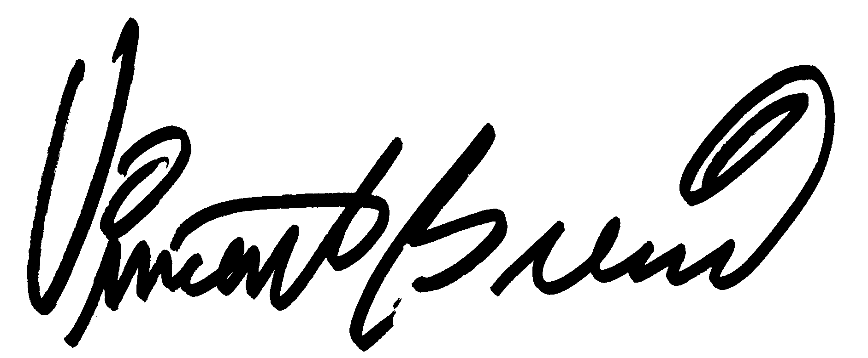
Vincent Brescia
President & CEO

