Friday, October 2nd 2009.

EB-2009-0187
Enbridge Gas Distribution Inc.
Application and Hearing

Harten Consultants wishes to be an intervening in the application and hearing of Enbridge Gas Distributions seeking leave to construct a natural gas pipe line to supply gas to York Region energy centre as per EB-2009-0187. Harten Consulting represents a rate payer group- Hunter’s Green Rate Payers Association and other interested parties who will be impacted from an environmental and adverse health effect as well as other social and economic impacts.

We intent to make a presentation detailing our concerns in considerable detail.

As an intervener representing affected residence of King Township, we would expect to seek cause for the applicant since our intervention will provide an important perspective and public service.

Our preference is for an oral hearing since it would allow the opportunity of presenting important visual material which would not be possible in a written presentation. Further, an oral hearing would allow an opportunity for last minute introduction of information that we are now researching and inclusion of last minute testimony.

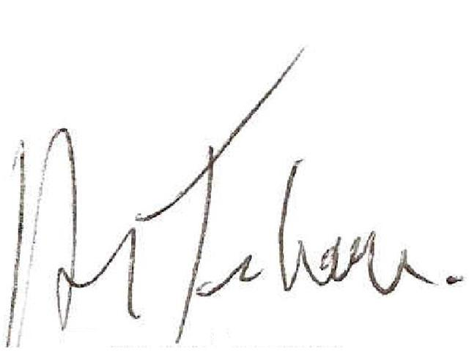

Harten Consultants
Attn: Harvey Tenenbaum
1232 Kingston Road
Scarborough, ON
M1N 1P3
Phone: (416)691-4167 fax: (416)691-8112
Email- h.tenenbaum@hartengroup.ca

