Hydro One Brampton Networks Inc.
175 Sandalwood Pkwy West
Brampton, Ontario L7A 1E8
Tel: (905) 840 6300
www.HydroOneBrampton.com
October 22, 2009

Ontario Energy Board
P. O. Box 2319, 27th Floor
2300 Yonge Street
Toronto, Ontario M4P 1E4

Attention: Ms Kirsten Walli, Board Secretary

Dear Ms Walli:

Re: EB-2008-0381 (Combined PILs Proceeding)

Hydro One Brampton Networks Inc. (“Hydro One Brampton”) believes that it would be most helpful for the Board to deal with the Bill 210 threshold jurisdictional issue as proposed by Board Staff.

Hydro One Brampton also agrees with the suggestion of EnWin Utilities Ltd. in EnWin’s October 13th letter, in which EnWin suggested that it would be appropriate and helpful for the Board’s procedural order to direct Board Staff to make a first submission on the threshold question, to which submission the applicants and intervenors would have at least 21 days to respond.

Yours very truly,

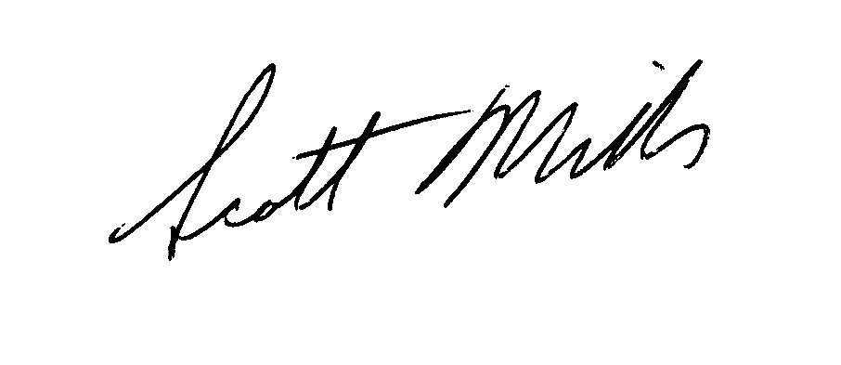
Scott Miller
Regulatory Affairs Manager
Hydro One Brampton Networks Inc.
smiller@HydroOneBrampton.com
905-452-5504

Roger A. Albert, President & CEO, Hydro One Brampton Networks Inc.
Jamie Gribbon, Vice-President Finance and Administration, Hydro One Brampton Networks Inc.

Encl.

