Hydro One Brampton Networks Inc.
175 Sandalwood Pkwy West
Brampton, Ontario L7A 1E8
Tel: (905) 840-6300
www.HydroOneBrampton.com

September 19, 2007
Ms. Kirsten Walli
Board Secretary
Ontario Energy Board
P.O. Box 2319
2300 Yonge Street, 27th Floor
Toronto, Ontario
M4P 1E4

Dear Ms. Walli,

Re: Electricity Distributors’ Provision of Service and Application of Charges (EB-2007-0722)

Hydro One Brampton Networks Inc. ( Hydro One Brampton) would like to participate in the Electricity Distributors’ Provision of Service and Application of Charges consultation scheduled October 18, 2007. Hydro One Brampton will be sending representatives to the meeting. Hydro One Brampton will not request cost eligibility.

Sincerely,
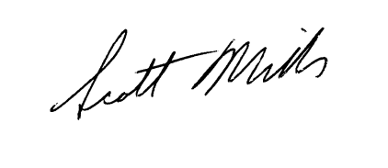

Scott Miller
Regulatory Affairs Manager
Hydro One Brampton Networks Inc.
smiller@HydroOneBrampton.com
905-452-5504
Roger A. Albert, President & CEO, Hydro One Brampton Networks Inc.
Jamie Gribbon, Vice President Finance and Administration, Hydro One Brampton Networks Inc.

