
25 Adelaide St. E
Suite 1602
Toronto ON, M5C 3A1

July 29, 2026

Ms. Kirsten Walli
Board Secretary
Ontario Energy Board
2300 Yonge Street
27th Floor
Toronto, ON M4P 1E4

Dear Ms. Walli,

Re: Board File No. EB-2009-0347; Ontario Power Authority
Proposed 2010 Revenue Requirement

The Association of Power Producers of Ontario (APPrO) requests Observer status in the above noted proceeding.

Sincerely,

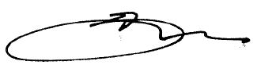

David Butters
President & CEO

Cc M. Lyle, OPA

