December 23, 2009

Ms. Kirstin Walli
Board Secretary
Ontario Energy Board
P.O. Box 2319
2300 Yonge Street, 27th Floor
Toronto, ON M4P 1E4

Re: Chatham-Kent Hydro Inc. 2010 Cost of Service Application EB-2009-0261

Dear Ms. Walli:

Please find enclosed the Chatham-Kent Hydro Inc. responses to the Board Staff Interrogatories with the exceptions of questions 63 to 68 which will be forward to the Intervenors and the Board on January 5.

Yours truly,

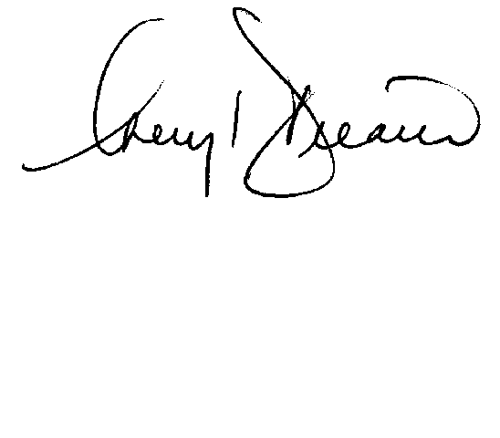

Cheryl Decaire
Co-ordinator of Regulatory and Rates
(519) 352-6300 ext 405
Email: cheryldecaire@ckenergy.com

CC: Dave Kenney, President of Chatham Kent Hydro
Chris Cowel, Chief Financial and Regulatory Officer

