January 5, 2010

Ms. Kirsten Walli
Board Secretary
Ontario Energy Board
P.O. Box 2319
2300 Yonge Street, 27th Floor
Toronto, ON M4P 1E4

Re: EB-2009-0261 Chatham-Kent Hydro 2010 Cost Service Application

Dear Ms. Walli:

Chatham-Kent Hydro would appreciate the extension in submitting our responses to the LRAM Interrogatories. Due to the unforeseen circumstances we will not be able to meet the current deadline, Chatham-Kent Hydro wish to advise the board that we will be able to complete the responses to the LRAM Interrogatories from Board Staff Interrogatories 63 to 68 and Vulnerable Energy Consumers Coalition Interrogatories 26 to 31 by January 7, 2010. We regret any inconvenience that may caused by this delay.

Should there be any questions, please contact me at the number below.

Yours truly,
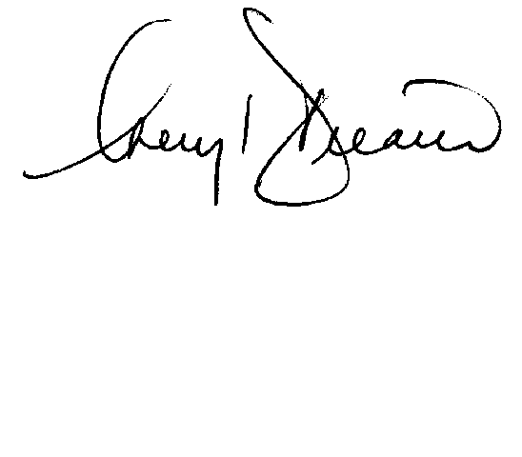

Cheryl Decaire
Co-ordinator of Regulatory and Rates
(519) 352-6300 ext 405
Email: cheryldecaire@ckenergy.com

CC: Dave Kenney, President of Chatham Kent Hydro
Chris Cowell, Chief Financial and Regulatory Officer

