

Chiefs and Councils

Saugeen Ojibway Nation

Chippewas of Saugeen, RR 1, Southampton ON N0H 2L0 519-797-2781
Chippewas of Nawash, RR 5, Wiarton ON N0H 2T0 519-534-1689

11 May 2007

Kirsten Walli, Board Secretary
Ontario Energy Board
PO Box 2319, 27th Floor
2300 Yonge Street
Toronto, ON, M4P 1E4
(By Email: boardsec@oeb.gov.on.ca)

Dear Ms Walli,

RE: Hydro One Bruce-Milton Transmission Reinforcement Project (Project),
EB-2007-0050

Please accept this letter as our request for intervenor status in the Board’s hearings regarding the Bruce-Milton Transmission Reinforcement Project (Project). We represent some 4,000 First Nations’ people in whose traditional territories Hydro One’s Transmission Project will be built. The Saugeen Ojibway Nations consist of the Chippewas of Nawash Unceded First Nation and the Saugeen First Nations.

The traditional lands of the Saugeen Ojibway Nations extend east from Lake Huron to the Nottawasaga River and south from the tip of the Bruce Peninsula to the Maitland River system (11 miles south of Goderich). The traditional waters around these lands include the lakebed of Lake Huron from the shore to the US border and the lakebed of Georgian Bay to the halfway point. In addition we have proven commercial fishing rights in our traditional waters (Jones-Nadjiwon 1993), and maintain aboriginal rights to hunt, fish and gather in all our traditional territories. We also have two major land claims before the courts: one is an aboriginal title claim to the lake beds of our traditional waters; and the other affects the whole of the Bruce Peninsula, including the land under navigable rivers and lakes.

The Project is part of Ontario’s energy policy and is designed to deliver electricity generated at Bruce Nuclear and several wind farms, all situated in our traditional territories. We retain rights to hunt, fish and gather throughout the lands and waters the Project will cross. Although we are in consultation with certain proponents (eg, Bruce Power and some wind farms) regarding the impact of their projects on our rights and claims, we have had no discussions with the Province on the impact of its energy policy (including the transmission of electricity) on our interests.

The Crown has failed in its duty to consult the Saugeen Ojibway Nations on its plans for energy generation and transmission in our traditional territories. To its credit, Hydro One has sought us out and we are in consultations with the company on the Project. However, we believe the Project, which in effect delivers the Crown’s policy, will have a profound impact on the way of life of our people.

The Project is being developed at a very rapid pace. We note that Hydro One will not have completed all the required environmental and archaeological assessments before it seeks approval of the Project from the OEB. We are concerned that the Board will be asked to make a decision without all the evidence before it—including whether the duty of the Crown to consult with the Saugeen Ojibway Nations has been fulfilled.

In our experience, we have found that our interests are best served when matters affecting our rights and claims are debated in public forums and we would prefer to make both written and oral submissions. In addition, we will seek costs to study the Province’s energy policy as it impacts on our rights and claims.

If you require further information, please contact our Environmental Office Coordinator, David McLaren at 519-534-4107 or d.mclaren@the-matrix.ca.

Miigwetch
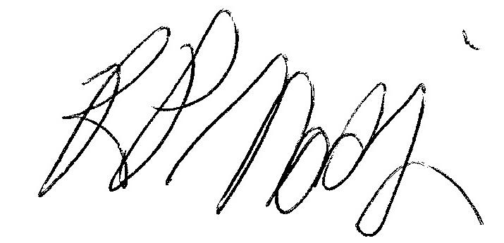 | 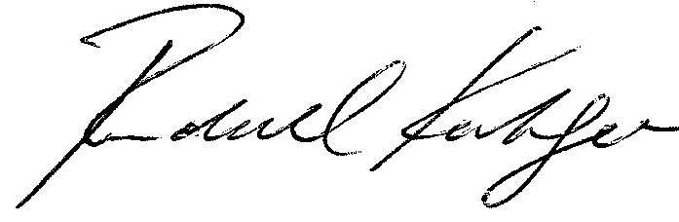
Chief R Paul Nadjiwan | Chief Randall Kahgee
Chippewas of Nawash Unceded First Nation | Chippewas of Saugeen First Nation

cc. Michael Sheehan, Vice President Real Estate, Hydro One
Peter Gregg, Vice President Corporate & Regulatory Affairs
Peter Wallace, Deputy Minister, Ministry of Energy
Dr. Jan Carr, CEO, Ontario Power Authority.

