2730 Highway #3 Telephone (519) 737-9811
Oldcastle, ON N0R 1L0 Fax (519) 737-7064


January 28, 2010

Kirsten Walli
Board Secretary
Ontario Energy Board
2300 Yonge St.
Suite 2700, P.O. Box 2319
Toronto, ON M4P 1E4

Dear Ms. Walli

Re: Ontario Energy Board File no: EB-2009-0143
Essex Powerlines Corporation
Electricity Distribution Rate Application

Please find below the outstanding response to the Board Staff interrogatory #50. Also included are revised responses to Board Staff interrogatories #32 & 47. The response is being filed electronically through RESS and emailed to each intervenor.
Regards,

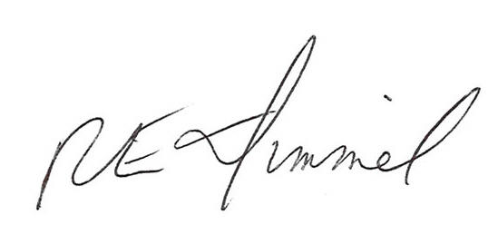

Richard Dimmel
General Manager
Essex Powerlines Corporation
519-776-8900 ext. 487
rdimmel@essexpowerlines.ca

CC: Andrew Taylor, Ogilvy Renault LLP
Energy Probe, Randy Aiken/David MacIntosh
School Energy Coalition, Wayne McNally/John De Vellis
Vulnerable Energy Consumers Coalition (VECC), Michael Buonaguro/ William Harper
The Corporation of the Town of LaSalle, Joe Milicia
EnWin Utilities Ltd. (“EnWin”), Andrew Sasso

Question #50

Ref: Exhibit 1 / Tab 4 / Sch. 9 – Revenue Requirement Work Form

Based on the responses to the first and second round interrogatories from all parties, please submit an updated Microsoft Excel file containing the revenue requirement work form.

Response:
The revenue requirement work form presented below.

Please provide a listing of all changes made to Essex’ original application (by exhibit), including an updated derivation of its revenue requirement, PILs calculation, base rates, rate adders/riders, and bill impacts.
Response:
A listing of all changes made to Essex’s original application, including an updated
derivation of its revenue requirement, PILs calculation, base rates, rate
adders/riders, and bill impacts based on changes that Essex is accepting or proposing as a result of responses to the first and supplemental rounds of interrogatories is presented below.

Essex is also requesting that its rate of return be updated to reflect any changes in rates approved by the board.

 |  |  |  | Service Revenue Requirement Proposed in Rate Application |  |  |  | $ 12,192,424
Exhibit | Tab | Schedule | Intervenor | Question# | Round 1 Interrogatories: | Change | Revenue Requiement Effect
2 | 4 | 1 | OEB | 2d | updated capital incl on continuity schedule for 2010 | (34,001) | (1,083)
4 | 8 | 3 | OEB | 18 | tax rates used in PILs calculation | (83,208) | (83,208)
5 | 1 | 1 | OEB | 19 | correction to short term debt rate used | 3,319 | 3,319
5 | 1 | 2 | OEB | 21 | update to long term debt rates | (134,527) | (134,527)
4 | 1 | 1 | EP | 36a | change to include property taxes | 32,001 | 32,376
8 | 4 | 3 | EP | 38 | exemption for OCT | (538) | (538)
4 | 8 | 2 | EP | 41 | change resulting from adjustment to 2010 CCA Schedule | (201,922) | (201,904) | (385,565)
 |  |  |  |  | update to Transmission Rates | (31,170) | (298) | (298)
 |  |  |  |  | Round 2 Interrogatories
2 | 4 | 1 | OEB | 40a | updated capital incl on continuity schedule for 2009 | (120,255) | (7,660)
2 | 4 | 1 | OEB | 40a | Updated depreciation for capital continuity schedule changes | (5,428) | (5,428)
2 | 5 | 1 | OEB | 40a | updated capital continuity schedule PILS impact | (2,589) | (2,589)
2 | 1 | 3 | EP | 67 | change in calculation for cost of power | (35,934) | (2,289) | (17,966)
 |  |  |  | Revised Service Revenue Requirement Proposed in Rate Application |  |  |  | $ 11,788,595

REVENUE REQUIREMENT:
Rate Base
2009 ending Net Fixed Assets |  | 32,225,714
2010 ending Net Fixed Assets |  | 34,142,005
Average Net Fixed Assets |  |  | 33,183,859
Working Capital Allowance Base |  | 54,256,511
Working Capital Allowance |  | 15.0% | 8,138,477
Rate Base |  |  | 41,322,336
Return On Rate Base
Deemed Short-Term Debt % |  | 4.00% | 1,652,893
Deemed Long-Term Debt % |  | 56.00% | 23,140,508
Deemed Equity % |  | 40.00% | 16,528,934
Short-Term Interest |  | 1.33% | 21,983
Long-Term Interest |  | 5.56% | 1,285,859
Return On Equity |  | 8.01% | 1,323,968
Return On Rate Base |  |  | 2,631,810
Distribution Expenses & Taxes
OM&A |  | 6,472,942
Amortization |  | 2,240,755
PILs/Taxes |  | 443,088 | 9,156,785
Revenue Offsets |  |  | (601,073)
Distribution Revenue Requirement |  |  | 11,187,522
Distribution Revenue at Existing Rates |  | 9,772,057
Revenue Sufficiency (Deficiency) |  | (1,415,466)
Rate Adders
Low Voltage Charges |  | 530,819
Transformer Allowances |  | (78,810)
Transformer Allowance Recoveries |  | 78,810
Smart Meters |  | 799,433
Utility-funded CDM expenses
 |  |  | 1,330,252
Variance / Deferral Account Rate Riders
Variance Accounts |  | (467,069)
LRAM & SSM
 |  |  | (467,069)
Proceeds from Rate Adders / Riders |  |  | 863,183

PILS CALCULATION:
 | 2009  Projection | 2010  Projection ¹ | 2010  Test ¹
Regulatory Taxable Income/(Loss) | 1,387,824 | (84,159) | 942,284
Combined Income Tax Rate | 33.00% |  | 31.00%
Total Income Taxes | 457,982 |  | 292,108
Investment & Miscellaneous Tax Credits
Income Tax Payable | 457,982 |  | 292,108
Large Corporations Tax (LCT)
Ontario Capital Tax (OCT) | 55,562 | 19,743 | 19,743
Grossed-up Income Tax |  |  | 423,345
Grossed-up LCT
Total PILs Expense | 513,544 | 19,743 | 443,088

BASE RATES:
Variable Rates |  | Base | Low Voltage | Trans. Allow. | Total Variable
Residential | kWh | 0.0150 | 0.0010 | 0.0000 | 0.0161
General Service Less Than 50 kW | kWh | 0.0063 | 0.0010 | 0.0000 | 0.0073
General Service 50 to 2,999 kW | kW | 1.8493 | 0.3506 | 0.1687 | 2.3686
General Service 3,000 to 4,999 kW | kW | 1.3912 | 0.4094 | 0.0000 | 1.8006
Unmetered Scattered Load | kWh | 0.0281 | 0.0010 | 0.0000 | 0.0291
Sentinel Lighting | kW | 6.0160 | 0.2816 | 0.0000 | 6.2976
Street Lighting | kW | 4.6800 | 0.2798 | 0.0000 | 4.9598
Fixed Rates |  | Base | Smart Meter |  | Total Fixed
Residential |  | 13.2400 | 1.9600 |  | 15.20
General Service Less Than 50 kW |  | 21.6100 | 1.9600 |  | 23.57
General Service 50 to 2,999 kW |  | 343.1300 | 1.9600 |  | 345.09
General Service 3,000 to 4,999 kW |  | 1,894.6100 | 1.9600 |  | 1,896.57
Unmetered Scattered Load |  | 8.8700 |  |  | 8.87
Sentinel Lighting |  | 2.1200 |  |  | 2.12
Street Lighting |  | 1.7800 |  |  | 1.78

RATE ADDERS/RIDERS:

Deferral / Variance Account | Residential | General Service Less Than 50 kW | General Service 50 to 2,999 kW | General Service 3,000 to 4,999 kW | Unmetered Scattered Load | Sentinel Lighting | Street Lighting
Proposed Rate Rider | ($0.0009) | ($0.0008) | ($0.2992) | ($1.3040) | ($0.0008) | ($0.3095) | ($0.1784)
per | kWh | kWh | kW | kW | kWh | kW | kW

BILL IMPACTS:
 | Volume |  | Distribution Charges |  | Total Bill
 | kWh | kW | $ change | % change | $ change | % change
Residential | 800 |  | $ 4.13 | 17.2% | $ 5.23 | 5.6%
General Service Less than 50kW | 2,000 |  | $ 14.57 | 61.7% | $ 17.30 | 8.6%
General Service 50 to 2,999kW | 100,000 | 500 | $ (188.87) | -11.0% | $ 16.68 | 0.1%
General Service 3,000 to 4,999kW | 800,000 | 3,000 | $ (11,206.86) | -60.6% | $ (12,610.67) | -13.7%
Unmetered Scattered Load | 100 |  | $ (0.23) | -1.9% | $ (0.10) | 0.5%
Sentinenl Lighting | 190 | 0.55 | $ 1.69 | 43.5% | $ 1.85 | 9.6%
Steet Lighting | 190 | 0.55 | $ 1.53 | 51.4% | $ 1.76 | 9.5%

REVENUE REQUIREMENT WORK FORM:

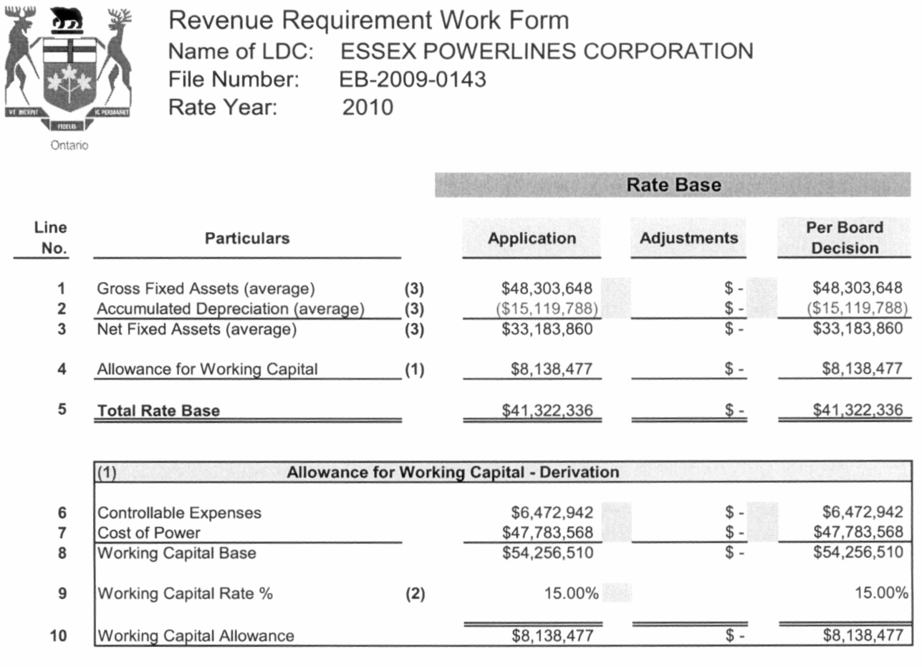
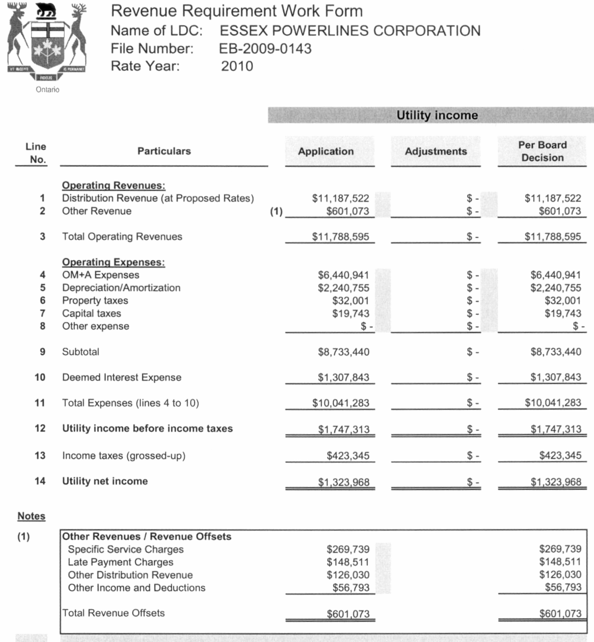
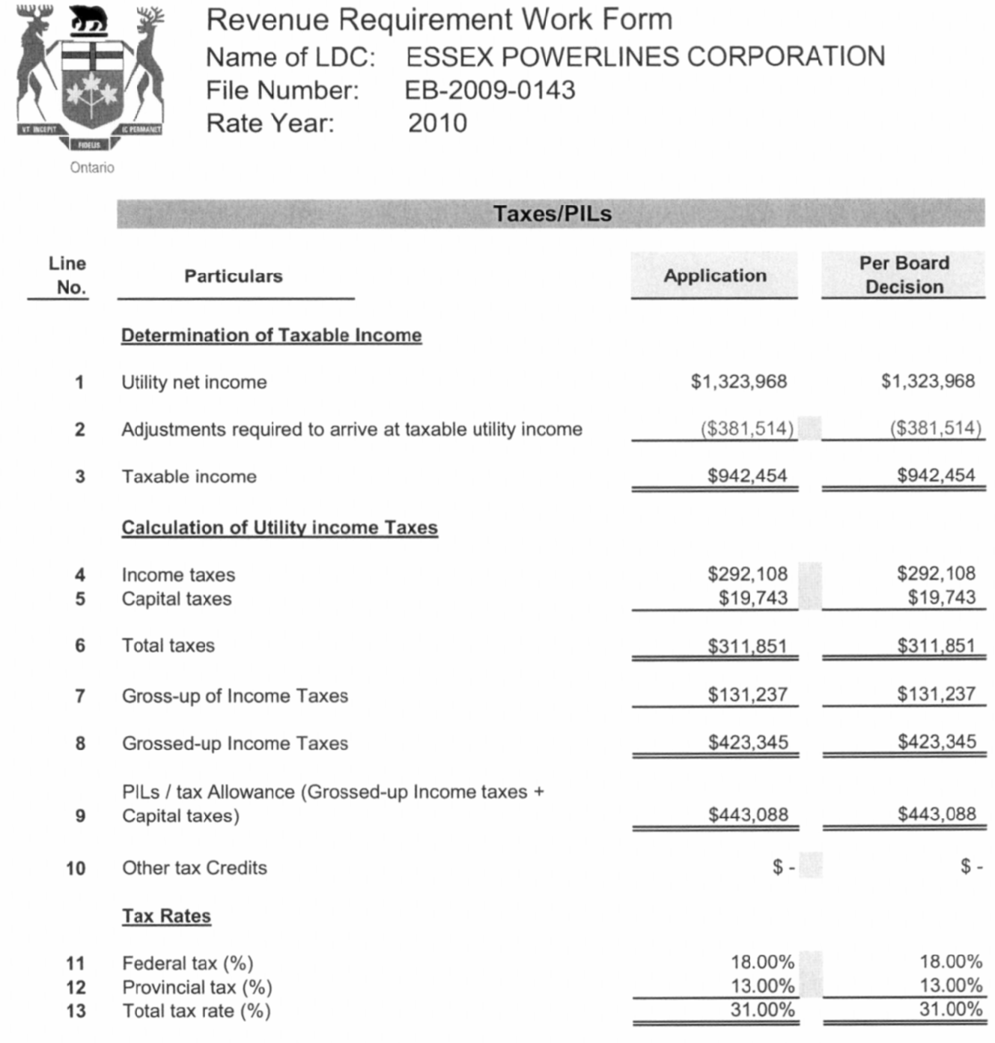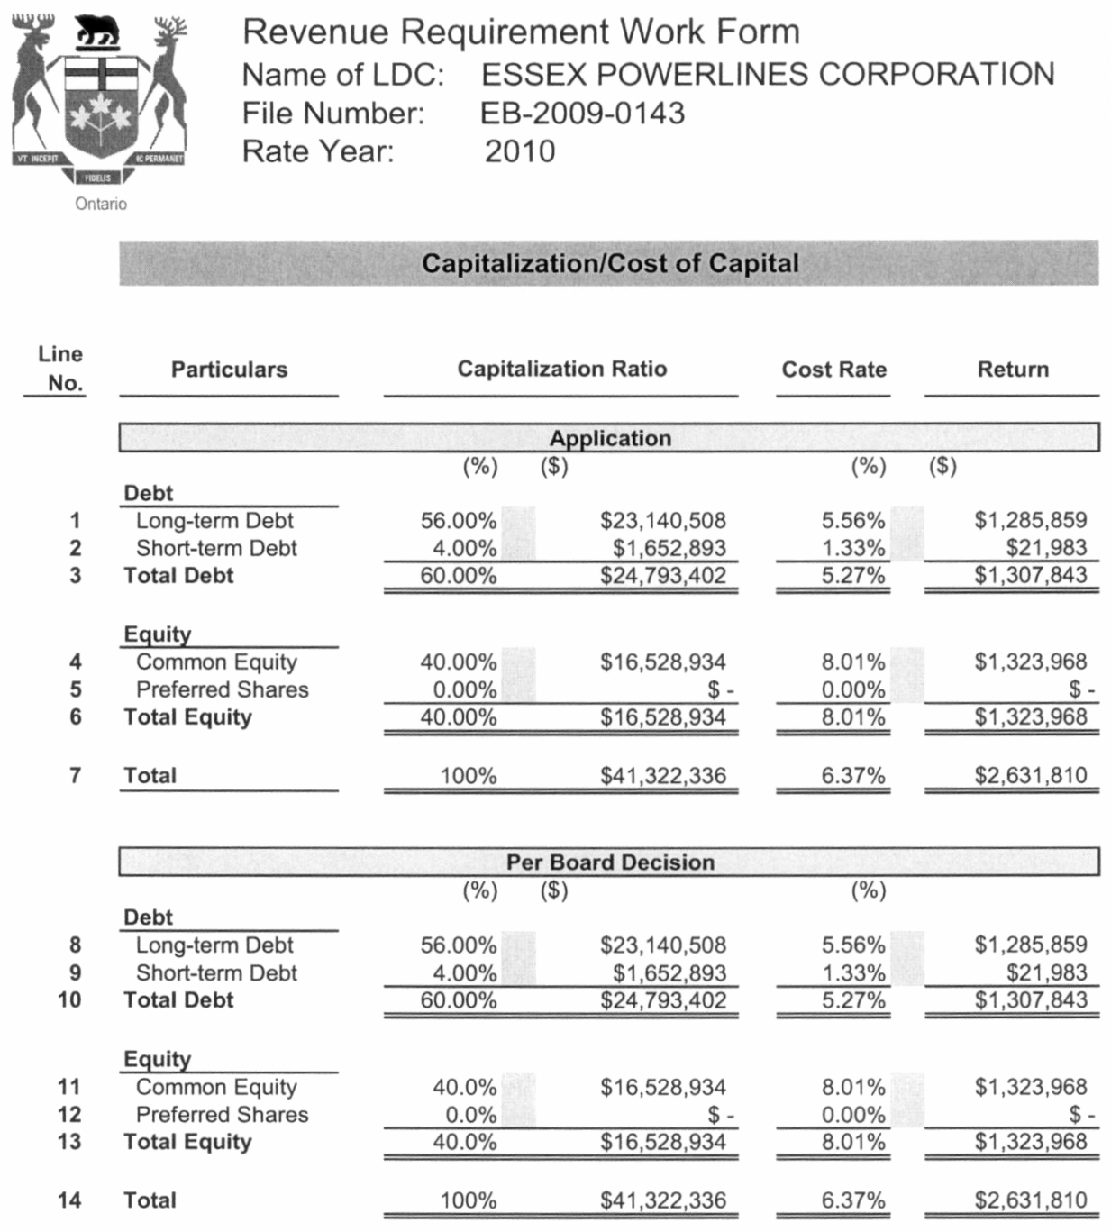

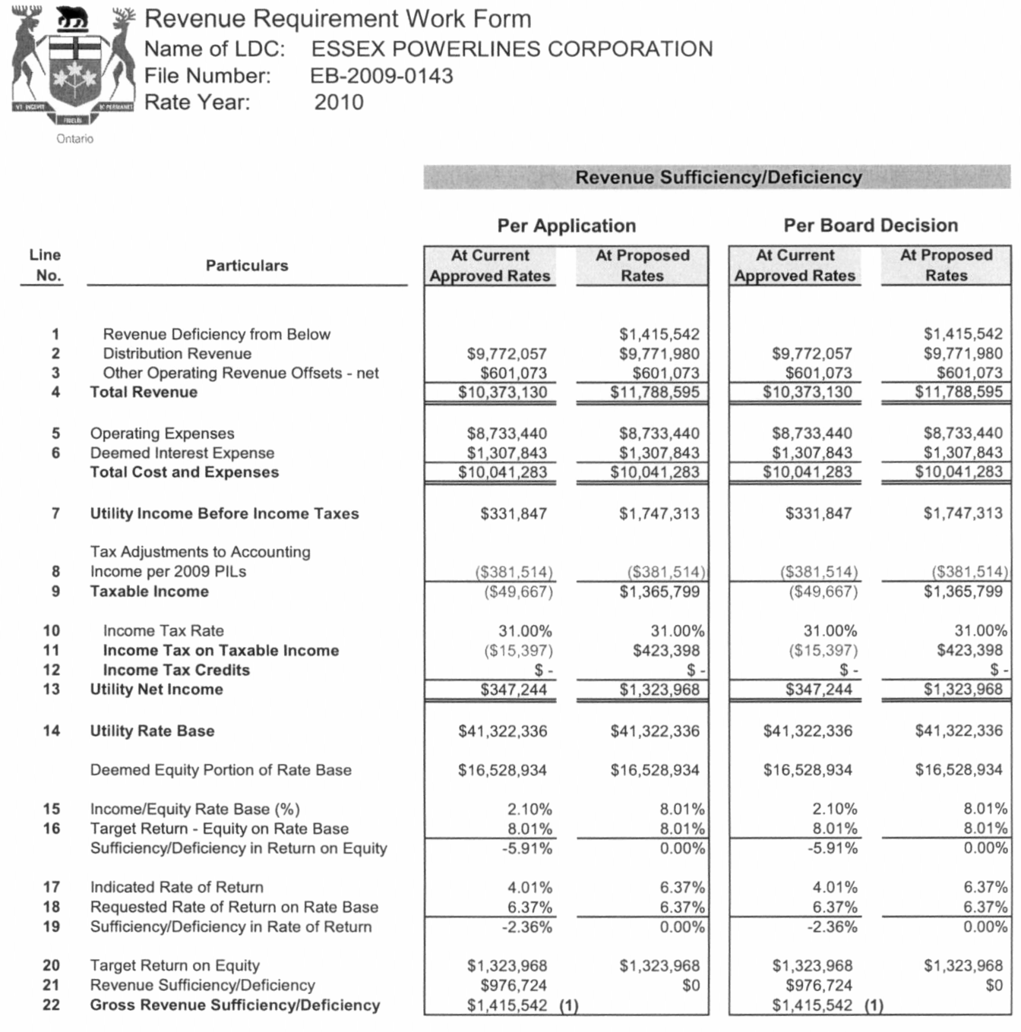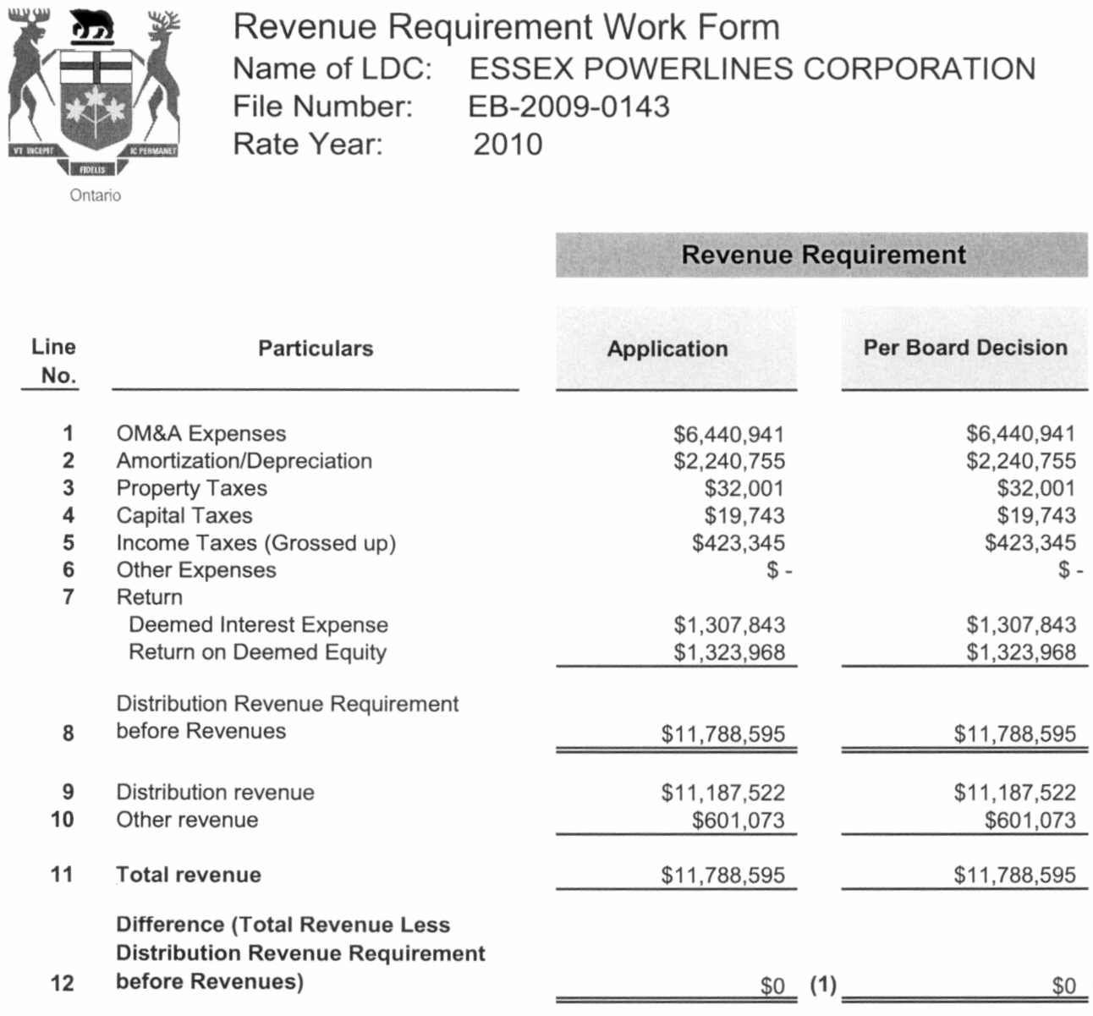
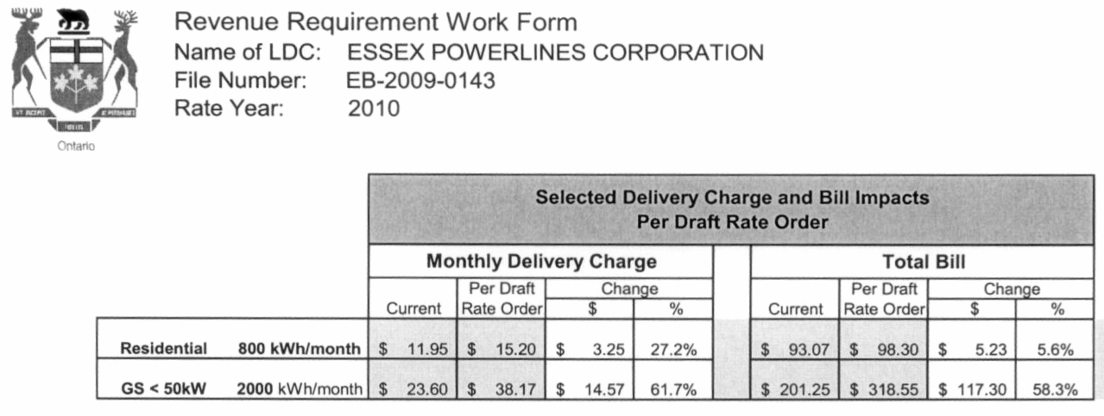

REVISED RESPONSES TO BOARD STAFF INTERROGATORY #32 & 47

Response:

Revised Response:
32. Ref: Exhibit 9 / Tab 2 / Sch. 1 – Accounts 1588

- On October 15, 2009, the Board’s Regulatory Audit & Accounting group issued a bulletin related to Regulatory Accounting & Reporting of Account 1588 RSVAPower and Account 1588 RSVAPower Sub-account Global Adjustment. Please confirm whether or not Essex plans on making any changes to its filing with respect to Account 1588.

Original Response:

Essex has re-filed it’s figures for the changes as per the Boards Regulatory Audit & Account group bulletin. Essex was only affected by the RPP requirements and made the necessary changes to reallocate the RPP to the correct accounts.

Revised Response;

Essex will be refilling its figures filed per above response due to an error in the allocation between sales of RPP and non-RPP customers. There is no change to the account totals it is between sub accounts only.

- Please identify separately, the balance associated with the Global Adjustment sub-account in Account 1588 Power, as of December 31, 2008 for the principle balance and April 30, 2010 for carrying charges.
Response:

December 31, 2008 balance - Global Adjustment sub account $5,884,623.76
April 30, 2010 interest balance $745,332.41.

Revised Response:

December 31, 2008 balances:
Global Adjustment Sub-Account ($390,446)
Interest Balance - $81,203

- Please provide an allocation of the December 31, 2008 balance of the Global Adjustment sub-account (plus interest to April 30, 2010) based on the 2008 kWhs for non-RPP customers.
Deferral / Variance Account | Total  Recovery Amount | Allocation Basis | Residential | General Service Less Than 50 kW | General Service 50 to 2,999 kW | General Service 3,000 to 4,999 kW | Unmetered Scattered Load | Sentinel Lighting | Street Lighting
1588-RSVAPOWER | 5,884,624 | non-rpp kwhrs | 1,051,041 | 250,478 | 3,566,302 | 960,405 | 7,155 | 1,012 | 48,231
Total Recoveries Required (1 years) | 5,884,624 |  | 1,051,041 | 250,478 | 3,566,302 | 960,405 | 7,155 | 1,012 | 48,231
Annual Recovery Amounts | 5,884,624 |  | 1,051,041 | 250,478 | 3,566,302 | 960,405 | 7,155 | 1,012 | 48,231
Annual Volume |  |  | 47,176,081 | 11,242,714 | 160,073,778 | 43,107,877 | 321,161 | 45,416 | 2,164,849
Proposed Rate Rider |  |  | $0.0223 | $0.0223 | $0.0223 | $0.0223 | $0.0223 | $0.0223 | $0.0223
per |  |  | kWh | kWh | kW | kW | kWh | kW | kW
Response:

Revised Response:
C7 Rate Riders
Deferral / Variance Account | Total  Recovery Amount | Allocation Basis | Residential | General Service Less Than 50 kW | General Service 50 to 2,999 kW | General Service 3,000 to 4,999 kW | Unmetered Scattered Load | Sentinel Lighting | Street Lighting
1588-RSVAPOWER | (312,106) | Non-RPP kwhrs | (55,677) | (13,269) | (189,297) | (50,876) | (379) | (54) | (2,555)
Total Recoveries Required (1 years) | (312,106) |  | (55,677) | (13,269) | (189,297) | (50,876) | (379) | (54) | (2,555)
Annual Recovery Amounts | (312,106) |  | (55,677) | (13,269) | (189,297) | (50,876) | (379) | (54) | (2,555)
Annual Volume |  |  | 271,379,498 | 72,012,960 | 467,092 | 19,537 | 1,605,371 | 1,076 | 18,024
Proposed Rate Rider |  |  | ($0.0002) | ($0.0002) | ($0.4053) | ($2.6041) | ($0.0002) | ($0.0499) | ($0.1418)
per |  |  | kWh | kWh | kW | kW | kWh | kW | kW

Deferral and Variance Accounts

47. Ref: Exhibit 9 / Tab 2 / Sch. 2 – Calculation of Rate Rider
Ref: Board Staff IR # 31, 32, 34, 35, 36

b) Please calculate the proposed rate riders to dispose of the December 31, 2008 balances plus carrying charges to April 30, 2010 over a four-year period, for deferral and variance accounts excluding the Global Adjustment sub-account of Account 1588.
Response:

C7 Rate Riders
Allocate recoveries of deferral / variance account balances
 | Deferral / Variance Account | Total  Recovery Amount | Allocation Basis | Residential | General Service Less Than 50 kW | General Service 50 to 2,999 kW | General Service 3,000 to 4,999 kW | Unmetered Scattered Load | Sentinel Lighting | Street Lighting
 | 1518-RCVARetail | 6,696 | Number of Customers | 6,185 | 442 | 53 | 0 | 4 | 10 | 1
 | 1548-RCVASTR | (6,730) | Number of Customers | (6,216) | (444) | (53) | (0) | (4) | (10) | (1)
 | 1550-LV Variance Account | 109,736 | Transmission Connection Revenue | 58,212 | 14,520 | 33,916 | 1,656 | 324 | 63 | 1,044
 | 1572-Extraordinary Event Costs | 48,839 | Distribution Revenue (existing rates) | 34,197 | 2,929 | 10,059 | 877 | 301 | 35 | 441
 | 1580-RSVAWMS | (3,034,410) | kWh's | (1,408,417) | (373,736) | (1,019,216) | (191,905) | (8,332) | (2,029) | (30,775)
 | 1584-RSVANW | (1,248,480) | kWh's | (579,480) | (153,770) | (419,347) | (78,958) | (3,428) | (835) | (12,662)
 | 1586-RSVACN | (815,018) | kWh's | (378,289) | (100,382) | (273,753) | (51,544) | (2,238) | (545) | (8,266)
 | 1588-RSVAPOWER | (2,481,916) | kWh's | (1,151,978) | (305,688) | (833,641) | (156,964) | (6,815) | (1,660) | (25,172)
 | Sub-Total for recovery | (7,421,284) |  | (3,425,787) | (916,130) | (2,501,983) | (476,837) | (20,187) | (4,970) | (75,390)
 | 1590-Recovery of Regulatory Asset Balances (residual) | (331,340) | Per 2006 Reg Asset rate rider calculation | (268,446) | (33,755) | (33,428) | 2,780 | (1,048) | (296) | 2,853
 | Total Recoveries Required (4 years) | (7,752,625) |  | (3,694,233) | (949,885) | (2,535,411) | (474,057) | (21,235) | (5,267) | (72,537)
 | Annual Recovery Amounts | (1,938,156) |  | (923,558) | (237,471) | (633,853) | (118,514) | (5,309) | (1,317) | (18,134)
 | Annual Volume |  |  | 271,379,498 | 72,012,960 | 467,092 | 19,537 | 1,605,371 | 1,076 | 18,024
 | Proposed Rate Rider |  |  | ($0.0034) | ($0.0033) | ($1.3570) | ($6.0661) | ($0.0033) | ($1.2236) | ($1.0061)
 | per |  |  | kWh | kWh | kW | kW | kWh | kW | kW

Revised Response:
C7 Rate Riders
Deferral / Variance Account | Total  Recovery Amount | Allocation Basis | Residential | General Service Less Than 50 kW | General Service 50 to 2,999 kW | General Service 3,000 to 4,999 kW | Unmetered Scattered Load | Sentinel Lighting | Street Lighting
1518-RCVARetail | 6,696 | Number of Customers | 6,185 | 442 | 53 | 0 | 4 | 10 | 1
1548-RCVASTR | (6,730) | Number of Customers | (6,216) | (444) | (53) | (0) | (4) | (10) | (1)
1550-LV Variance Account | 109,736 | Transmission Connection Revenue | 58,253 | 14,549 | 33,852 | 1,653 | 324 | 63 | 1,042
1562-Deferred Payments in Lieu of Taxes | 0 | Distribution Revenue (existing rates) | 0 | 0 | 0 | 0 | 0 | 0 | 0
1565-Conservation and Demand Management Expenditures and Recoveries | 0 | Distribution Revenue (existing rates) | 0 | 0 | 0 | 0 | 0 | 0 | 0
1566-CDM Contra Account | 0 | Distribution Revenue (existing rates) | 0 | 0 | 0 | 0 | 0 | 0 | 0
1572-Extraordinary Event Costs | 48,563 | Distribution Revenue (existing rates) | 34,004 | 2,912 | 10,002 | 873 | 299 | 35 | 439
1580-RSVAWMS | (3,034,410) | kWh's | (1,408,417) | (373,736) | (1,019,216) | (191,905) | (8,332) | (2,029) | (30,775)
1584-RSVANW | (1,248,480) | kWh's | (579,480) | (153,770) | (419,347) | (78,958) | (3,428) | (835) | (12,662)
1586-RSVACN | (815,018) | kWh's | (378,289) | (100,382) | (273,753) | (51,544) | (2,238) | (545) | (8,266)
1588-RSVAPOWER | 3,714,814 | kWh's | 1,724,225 | 457,539 | 1,247,754 | 234,936 | 10,200 | 2,484 | 37,676
Sub-Total for recovery | (1,224,830) |  | (549,737) | (152,891) | (420,710) | (84,945) | (3,174) | (827) | (12,546)
1590-Recovery of Regulatory Asset Balances (residual) | (331,340) | Per 2006 Reg Asset rate rider calculation | (268,446) | (33,755) | (33,428) | 2,780 | (1,048) | (296) | 2,853
Total Recoveries Required (4 years) | (1,556,171) |  | (818,183) | (186,647) | (454,137) | (82,165) | (4,222) | (1,123) | (9,693)
Annual Recovery Amounts | (389,043) |  | (204,546) | (46,662) | (113,534) | (20,541) | (1,055) | (281) | (2,423)
Annual Volume |  |  | 271,379,498 | 72,012,960 | 467,092 | 19,537 | 1,605,371 | 1,076 | 18,024
Proposed Rate Rider |  |  | ($0.0008) | ($0.0006) | ($0.2431) | ($1.0514) | ($0.0007) | ($0.2610) | ($0.1344)
per |  |  | kWh | kWh | kW | kW | kWh | kW | kW

c) Please calculate the proposed rate riders to dispose of the December 31, 2008 balance plus carrying charges to April 30, 2010 over a four-year period, for the Global Adjustment sub-account of Account 1588 based on non-RPP customers load.

Response:
C7 Rate Riders
Allocate recoveries of deferral / variance account balances
Deferral / Variance Account | Total  Recovery Amount | Allocation Basis | Residential | General Service Less Than 50 kW | General Service 50 to 2,999 kW | General Service 3,000 to 4,999 kW | Unmetered Scattered Load | Sentinel Lighting | Street Lighting
1588-RSVAPOWER | 6,650,963 | Non-RPP Customer kwhrs | 5,321,061 | 1,268,083 | 22,788 | 1,848 | 36,224 | 55 | 904
Total Recoveries Required (4 years) | 6,650,963 |  | 5,321,061 | 1,268,083 | 22,788 | 1,848 | 36,224 | 55 | 904
Annual Recovery Amounts | 1,662,741 |  | 1,330,265 | 317,021 | 5,697 | 462 | 9,056 | 14 | 226
Annual Volume |  |  | 271,379,498 | 72,012,960 | 467,092 | 19,537 | 1,605,371 | 1,076 | 18,024
Proposed Rate Rider |  |  | $0.0049 | $0.0044 | $0.0122 | $0.0237 | $0.0056 | $0.0128 | $0.0125
per |  |  | kWh | kWh | kW | kW | kWh | kW | kW

Revised Response:
C7 Rate Riders
Deferral / Variance Account | Total  Recovery Amount | Allocation Basis | Residential | General Service Less Than 50 kW | General Service 50 to 2,999 kW | General Service 3,000 to 4,999 kW | Unmetered Scattered Load | Sentinel Lighting | Street Lighting
1588-RSVAPOWER | (312,106) | Non-RPP kwhrs | (55,677) | (13,269) | (189,297) | (50,876) | (379) | (54) | (2,555)
Total Recoveries Required (4 years) | (312,106) |  | (55,677) | (13,269) | (189,297) | (50,876) | (379) | (54) | (2,555)
Annual Recovery Amounts | (78,027) |  | (13,919) | (3,317) | (47,324) | (12,719) | (95) | (13) | (639)
Annual Volume |  |  | 271,379,498 | 72,012,960 | 467,092 | 19,537 | 1,605,371 | 1,076 | 18,024
Proposed Rate Rider |  |  | ($0.0001) | $0.0000 | ($0.1013) | ($0.6510) | ($0.0001) | ($0.0125) | ($0.0354)
per |  |  | kWh | kWh | kW | kW | kWh | kW | kW

