2730 Highway #3, Telephone (519) 737-9811
Oldcastle, ON N0R 1L0 Fax (519) 737-7064


February 24, 2010

Kirsten Walli
Board Secretary
Ontario Energy Board
2300 Yonge St.
Suite 2700, P.O. Box 2319
Toronto, ON M4P 1E4

Dear Ms. Walli

Re: Ontario Energy Board File no: EB-2009-0143
Essex Powerlines Corporation
Electricity Distribution Rate Application
Proposed Settlement Agreement

Please find accompanying this letter, pursuant to the Settlement Conference that was convened on February 3, 2010, two copies of a Proposed Settlement Agreement for Board approval. Copies have been provided electronically to intervenors on record.

Should there be any questions, please contact me at the number below.

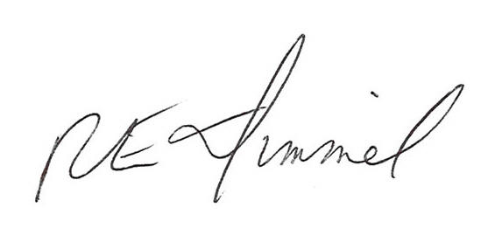

Richard Dimmel
General Manager
Essex Powerlines Corporation
519-737-9811 ext. 14
rdimmel@essexpowerlines.ca

