Harten Consulting a Division of the Harten Group
1232 Kingston Road, Toronto, Ontario, M1N 1P3
T: 416-691-4167 F: 416-691-8112 h.tenenbaum@hartengroup.ca

March 15, 2010

BY EMAIL

Kirsten Walli
Board Secretary
Ontario Energy Board
2300 Yonge Street
27th Floor, P.O. Box 2319
Toronto, ON M4P 1E4
boardsec@oeb.gov.on.ca

Re: The response of Aird and Berlis to the cost submission of Harten Consulting concerning the application of Enbridge Gas Distribution Inc. for leave to construct
Board File No. EB-2009-0187

Aird and Berlis take issue with the “legal consulting fees claimed” by Harten. The consulting fees claimed are not legal consulting fees, but rather claims under analyst/consultant with over 20 years of relevant experience.

Harten has stated that under 6.03, it has established by its interrogatories and responses that the costs claimed were incurred “directly and necessarily for the party’s participation in the process”

Harten has conducted its participation in the process entirely focussed on the issues relevant to the leave to construct application, and not on any aspects of the proposed generating station. The Board has made it clear that the generating station was not to be included in the review.

Harten has participated responsibly in the process in its interrogatories and responses, and the question of repetitive evidence is not a factor since there were no other active interveners. Our intervention has hopefully contributed to a broader perspective on the relevant issues.

Those issues raised by Harten are substantive, and but for Harten’s participation may not have been brought to the attention of the Board.

Harten has not lengthened the process, as the time guidelines issued by the Board have been adhered to. The questions raised by the Board have been addressed by Harten, but some in considerably more detail than others. For example:

- is there a need for the pipeline?

As we stated, there was only a need for the pipeline if there was going to be a gas generator at the other end, and since the Board has made it clear that the gas generator was not a part of these proceedings, and one must assume the generator will be built.

On the matter of question (4):

Enbridge has repeatedly stated that there are not likely to be any land owner issues since construction will occur on right of ways. Harten has stated that in the event private properties are involved, the current documentation as submitted by Enbridge does not include consent from mortgage holders of the affected land, who may very well have a vested interest, and should be considered.

Aird and Berlis have stated that our reviews concentrated on issue (3): “what are the environmental impacts associated with the proposed pipeline, and are they acceptable?” Harten has examined this question in considerable detail, bearing in mind environmental impacts include related health and safety issues.

There are no details of the tasks performed because the work has been done in an overlapping and interconnected manner, which would be impossible to accurately assess as fragmented components. Our review was intended to be comprehensive, encompassing, and several aspects have been worked on simultaneously. The hours billed by Harten are an accurate and conservative number.

The billing rate is appropriate for Mr. Tenenbaum, based on his 20+ years of experience and expertise in the fields of business and natural sciences. Aird and Berlis, has alleged areas of unsubstantiated evidence. The York Durham Sewage System was only stated to be an example of the potential effects of dewatering that must be considered when installing a pipeline, particularly in wetland areas.

In stating that the pipeline poses “a far greater risk,” the comparison is intended for the vast majority of existing pipelines because few would operate at a pressure of 3240 kPa, and while the volume was typographically mistated by us at 186,000 m³/hr, (it should have been 136,000 m³/hr), the fact is that such a high pressure pipeline with those volumes of gas passing through floodplains and areas vulnerable to seismic occurrences, coupled with an absence of the municipal amenities needed to fight major fires, merit special consideration. Harten has never stated that the OPA was a party to the proceedings, but rather, that the OPA is the original proponent of this project.

Harten’s environmental references are in direct response to question (3). The environmental questions posed by the Board are in an area of acute public concern and growing awareness that merit close scrutiny. It is essential to ensure that the proposed pipeline complies with the intent of protective legislation since the pipeline traverses extremely sensitive greenbelt and other areas.

Harten believes that all its statements, interrogatories, and submissions have been relevant to the issues, and Harten has met the onus for cost awards in all respects.

Respectfully Submitted
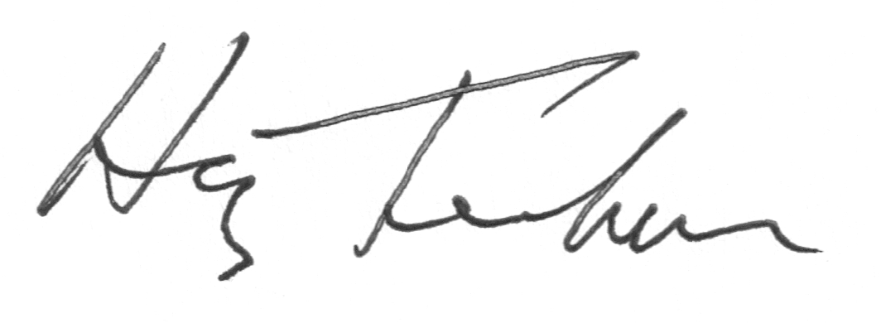
Harten Consulting
Harvey Tenenbaum

Cc: Scott Stoll (sstoll@airdberlis.com)

