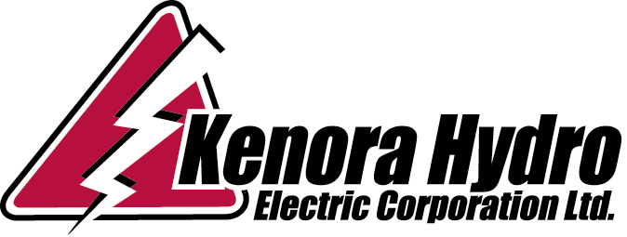

Ontario Energy Board March 23, 2010
P.O. Box 2319
27th Floor
2300 Yonge Street
TORONTO, ON M4P 1E4

Attention: Board Secretary

Re: Board File EB-2009-0200 2010 IRM Application

Dear Ms. Walli:

In response to the Board Staff Submission dated March 15, 2010, Kenora Hydro submits an updated calculation of the requested customer rate increases to the Network and Line Connection Retail Transmission Service Rates in response to the increase in the UTR’s based on the Decision and Rate Order of the Board in the EB-2008-0272 proceeding, Rate Order issued January 21, 2010.

Kenora Hydro requests a 26% increase in customer rates for the Network Service charge to maintain the variance account level through December, 2011. The 26% increase will be applied equally to all customer classes.

Kenora Hydro requests a 20% increase in customer rates for the Line Connection Service charge to maintain the variance account level through December, 2011. The 20% increase will be applied equally to all customer classes.

This application contains 2 paper copies of the revised working papers detailing the projected Network and Line Connection variance account changes and request for increased rates which will minimize changes in the variance accounts.

The Excel file has been e-mailed to Boardsec@oeb.gov.on.ca as of the date of this letter.

Sincerely,

Janice Robertson
Manager of Finance & Regulatory Affairs
Kenora Hydro Electric Corporation Ltd.
Ph (807) 467-2014
Fax (807) 467-2068
jrobertson@kenora.ca

Encls.

Box 2680-215 Mellick Avenue, Kenora, Ontario P9N 3X8 Phone (807) 467-2075 Fax (807) 467-2068

