
200 – 395 Centre St N, Huntsville, ON P1H 2M2
Phone (705) 789-5442 Toll Free 1-888-282-7711
Fax (705) 789-3110 service@lakelandpower.on.ca

April 8, 2010

VIA MAIL and E-MAIL
Ms. Kirsten Walli
Board Secretary
Ontario Energy Board
P.O. Box 2319
2300 Yonge Street
Toronto, ON
M4P 1E4

Dear Ms. Walli:

RE: Lakeland Power Distribution Ltd.
EB-2009-0234
2010 IRM3

Lakeland Power Distribution Ltd is submitting its confirmation that the draft Tariff of Rates and Charges in the Board’s Decision and Order dated March 31, 2010, is complete and accurate.

Lakeland will notify its customers of the rate changes no later than with the first bill reflecting the new rates.

Respectfully submitted,

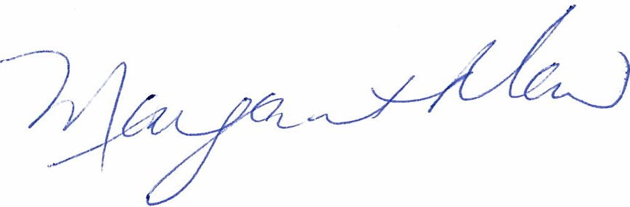

Margaret Maw
CFO
Lakeland Holding Ltd.

