
May 5, 2010

Ms. Kirsten Walli
Board Secretary
Ontario Energy Board
P.O. Box 2319
2300 Yonge St.
Toronto, ON
M4P 1E4

Dear Ms. Walli

Re: Ontario Energy Board File no: EB-2009-0143
Essex Powerlines Corporation
Electricity Distribution Rate Application
Responses to Intervenor Cost Award Submissions

Essex Powerlines has received and reviewed the cost award submissions for Energy Probe, Vulnerable Energy Consumers Coalition and School Energy Coalition. Essex does not object to the amounts submitted by the intervenors.

Respectively submitted,
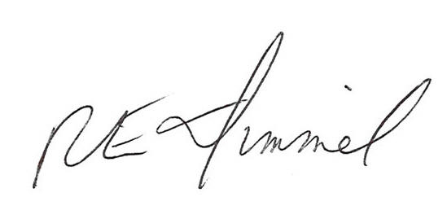

Richard Dimmel
General Manager
Essex Powerlines Corporation
519-776-8900 ext. 487
rdimmel@essexpowerlines.ca

