

June 30, 2010

Board Secretary

Ontario Energy Board

2300 Young Street, 26th Floor

Toronto, On

M4P 1E4

Dear Kristen:

RE: Cost of Service Distribution Rate Application for West Perth PowerEB-2009-0121 and Clinton Power EB-2009-0262

We wish to make the following amplification to our applications:

* In our application we state that the effective date would be 1 May 2010, we would concede that this date should be effective 1 July 2010 due to our filing timeline.

We hope that this clarifies this issue.

Sincerely

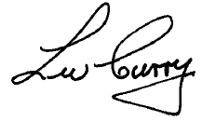

Wally Curry

President

West Perth Power &

Clinton Power Corporation