

July 27, 2010,

Board Secretary

Ontario Energy Board

2300 Young Street, 26th Floor

Toronto, On

M4P 1E4

Dear Kristen:

RE: Cost of Service Distribution Rate Application for West Perth PowerEB-2009-0121 and Clinton Power EB-2009-0262.

We wish to object in the matter of the School Energy Coalition as an Intervenor as it relates to West Perth Power. We note that in the documents filed with us that they represent the Ontario Education Services Corporation c/o Ontario Public School Boards Association. There are currently no Public Schools in the town of Mitchell or Dublin that are billed by West Perth Power. There are Public Schools in Mitchell but they are in the Hydro one area.

We do concede that there are schools in the Clinton Power Corporation territory and we accept that there is just cause for the School Energy Coalition to be granted intervenor status in the Clinton rate application.

Sincerely

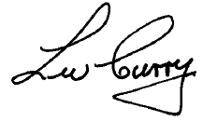

Wally Curry

President

West Perth Power &

Clinton Power Corporation