Garden River First Nation
Interrogatories

IN THE MATTER OF the Ontario Energy Board Act, 1998, C.
S.O. 1998, c.15 (Sched. B); of electricity.

IN THE MATTER of an Application by Algoma Power Inc. EB-2009-0278, for an Order or Orders approving just and reasonable rates and other service charges for the distribution of electricity effective May 2010.

July 29th, 2010

INTERROGATORIES
0f the
GARDEN RIVER FIRST NATION

Item 1. Ehibit 8, Tab 1, Schedule 1, Page 4 of 4

RRRP Payment Excerpt

Paragraph 5 of Section 2 of the RRRP Regulation sets out the eligibility criteria applicable to API for rural rate protection. This paragraph provides that:

5. Consumers, (i) who are treated as residential-rate class consumers under Ontario Regulation 445/07 (Reclassifying Certain Classes of Consumers as Residential-Rate Class Customers: Section 78 of the Act) made under the Act, or (ii) who occupy residential premises in an area served by a distributor where,

A. the distributor is licensed to serve the consumers

B. the area is not less than 10,000 kilometres in size, and

C. the average customer density for the distributor is less than seven customers per kilometre of distribution line.”

Based on this provision and paragraph 3 of subsection 4(4) of the RRRP Regulation, all of API’s newly re-classified Residential customers are eligible for rural rate protection. This protection does not currently extend to Seasonal and Street Lighting customers. Paragraph 3 of subsection 4(4) of the RRRP Regulation states as follows:

“4(4) 3. The Board shall take reasonable steps to ensure that an amount equal to the amount calculated under subsections (2) and (3.1) for the year is used to provide rate protection to consumers who are in the class described in paragraphs 4 and 5 of section 2.”

Because not all of API's customers are eligible to receive rate protection through the RRRP payment, only a portion of the funds available for rate assistance determined according to subsection 4(3.1) listed above
would be used for the RRRP payment. As a result, the determination of rate assistance is a two step process:

1. the determination of funds available for rate assistance; and
2. the allocation of a part of those available funds to eligible customers as a RRRP payment.

The application of this two step process with respect to API is set out in the following sections.

a. Are the criteria for protection under the Rural or Remote Electricity Protection program interdependent or individual? Is Garden River protected under this program?

b. Please explain what is meant in 1. “the determination of funds available for rate assistance;” and 2. “the allocation of a part of those available funds to eligible customers as a RRRP payment.” Does unavailability of funds occur often? Give example.

c. Is Garden River First Nation charged for street lighting? Please provide Garden River with locations of street lights charged for?

Item 2. Notice of Garden River First Nation Intervention Letter

Haida Nation v. British Columbia (Minister of Forests), [2004] 3 S.C.R. 511, 2004 SCC 73

Third parties cannot be held liable for failing to discharge the Crown’s duty to consult and accommodate. The honour of the Crown cannot be delegated, and the legal responsibility for consultation and accommodation rests with the Crown. This does not mean, however, that third parties can never be liable to Aboriginal peoples.

The Crown’s obligation to consult the Haida on the replacement of T.F.L. 39 was engaged in this case. The Haida’s claims to title and Aboriginal right to harvest red cedar were supported by a good prima facie case, and the Province knew that the potential Aboriginal rights and title applied to Block 6, and could be affected by the decision to replace T.F.L. 39. T.F.L. decisions reflect strategic planning for utilization of the resource and may have potentially serious impacts on Aboriginal rights and titles. If consultation is to be meaningful, it must take place at the stage of granting or renewing T.F.L.’s. Furthermore, the strength of the case for both the Haida’s title and their right to harvest red cedar, coupled with the serious impact of incremental strategic decisions on those interests, suggest that the honour of the Crown may also require significant accommodation to preserve the Haida’s interest pending resolution of their claims.
The Ontario Energy Board Act, 1998, outlines the mandate of the Ontario Energy Board with respect to electricity and natural gas regulation.
d. Garden River First Nation is a sovereign nation and signatory of the 1850 Robinson Huron Treaty. The Chief and Council are the governing body whose mandate is to create economic development and sustainable jobs, promote higher education, promote and ensure health and well-being, promote the dignity and respect and ensure the territory is preserved by way of protecting resources and environment.

e. Garden River and Great Lakes Power have an existing relationship via Great Lakes Power and Her Majesty the Queen, Indian Affairs, Lease Agreement executed 1996, in which same expires 2026. Agree ment leases land to Great Lakes for it poles.

- Based on the requirement or moral duty of the Crown to accommodate and consult with First Nations concerning issues impacting First Nations, third parties moral duty to consult, Garden River’s requirement to consult and accommodate with Garden River on issues impacting lands, resources and members as well as the and the established relationship between Garden River and Algoma Power (Great Lakes) – why was dialogue with Garden River overlooked and how can this be addressed in the future, so that First Nations can be a participant at the onset of such issues/applications/ decisions?

Item 3. First Nation Housing Conditions

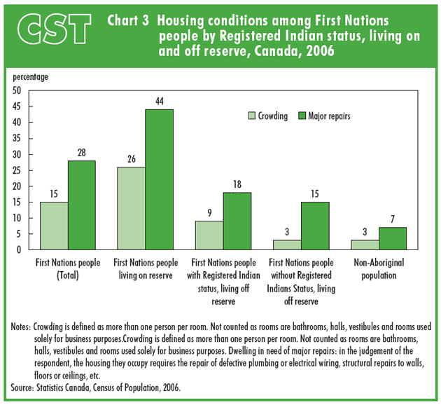

- Statistics Canada 2006 reported many First Nations’ housing is in need of “major” repairs, which can be said is true for Garden River. Heat loss is a major issue. Has Algoma Power taken into consideration the conditions of First Nations housing? What types of programs does Algoma Power have or can introduce that would assist First Nations housing or poor housing conditions overall that would reduce cost in this area for consumers? For example, heat loss audits etc.

Item 4. Electricity Distribution Licence, ED-2009-0072, Algoma Power Inc., Valid Until
May 4, 2029 - EB-2009-0278, Exhibit 2, Tab 1, Schedule 1, Appendix A, Page 1 of 4

Algoma Power Inc. owns and operates the electricity distribution system in portions of the district of Algoma, serving approximately 11,720 customers located in a number of townships and First Nations territory.

h. Please confirm if there are any issues with distribution system on land poles cross. If so, please disclose and provide detail.

End of document.

Janine Zack, EA/CC
7 Shingwauk Street
Garden River, Ontario
P6A 6Z8
Tel: (705) 946-6300
Fax: (705) 945-1415

jzack@gardenriver.org

