Harten Consulting a Division of the Harten Group
1232 Kingston Road, Toronto, ON M1M 1P3
T: 416-691-4167 F: 416-691-8112 h.tenenbaum@hartengroup.ca

November 2, 2010. Ref: EB-2010-0310

IN THE MATTER OF AN APLICATION BY Enbridge Gas
Distribution Inc. Board File No: EB-2010-0310

IN THE MATTER OF the Ontario Energy Board Act, 1998,
S.O. 1998, c. 15, (Schedule B) pursuant to Section 90(1);

AND IN THE MATTER OF an application by Enbridge Gas
Distribution Inc. for an Order varying a condition of approval
of the Decision and Order EB-2009-0187 by which the
Ontario Energy Board granted leave to construct a natural
gas pipeline in the Region of York.

This is a request by Harten Consulting, who are listed as a registered intervenor in this proceeding to be eligible for cost awards. The reason for cost eligibility is based on the fact that Harten has participated in the preceeding hearing EB-2009-0187 and is knowledgeable in matters pertaining to this file. Harten can make an important contribution in this case acknowledging that the matter is restricted to Enbridge’s request for an extension of time respecting the Leave to Construct, excluding for consideration other areas referenced by the Board.

Harvey Tenenbaum, a principal of Harten Consulting has resigned as a member of the Hunters’ Green Ratepayers’ Association since the Board ruled that such affiliation was a detriment to Harten’s being paid in connection with its efforts and submissions on file EB-2009-0187.

Yours truly,
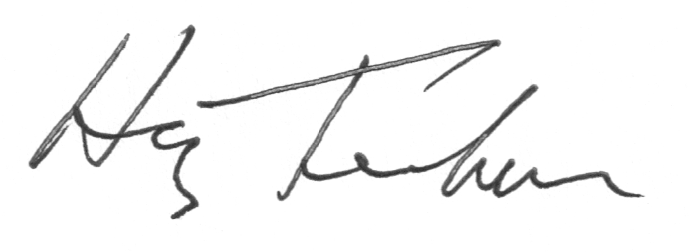

Harten Consulting
Per: Harvey Tenenbaum

HC:jt

2
cc:

The Board: The Applicant
Ontario Energy Board Enbridge Gas Distribution Inc.
P.O. Box 2319 500 Consumers Road
27th Floor Willowdale ON M2J 1P8
1300 Yonge Street
Toronto ON M4P 1E4 Attention: Mr. Norm Ryckman
Director, Regulatory Affairs
Attention: Board Secretary E-mail:
E-mail: boardsec@oeb.gov.on.ca egdregulatoryproceedings@enbridge.com
Tel: 1-888-632-6273 Tel: 416-495-5499 or 1-888-659-0685
Fax: 416-440-7656 Fax: 416-495-6072

Counsel of the Applicant:

Mr. Scott Stoll
Aird & Berlis LLP
Suite 1800, Box 754
Brookfield Place, 181 Bay Street
Toronto ON M5J 2T9

E-mail: sstoll@airdberlis.com
Tel: 416-865-4703
Fax: 416-863-1515

DATED at Toronto, November 2, 2010

HARTEN CONSULTING

Original signed by

Harvey Tenenbaum
President

