INCLUDEPICTURE "cid:image001.jpg@01CADA58.FA465150" \* MERGEFORMATINET 

November 8th, 2010

Board Secretary
Ontario Energy Board
2300 Young Street, 26th Floor
Toronto, On
M4P 1E4

Dear Kristen:

RE: West Perth Power & Clinton Power’s 3rd Generation IRM applications

We are still in the process of finalizing our Cost of Service Distribution Rate Application for West Perth Power EB-2009-0121 and Clinton Power EB-2009-0262. The settlement conference was held on the 4th of November 2010 and the settlement is presently being drafted for everyone’s approval. Once the settlement is approved by the parties it will be forwarded to the Board for their consideration and approval. Upon approval we will commence our 3rd generation IRM application.

Please do not hesitate to contact me if I can be of further assistance.

Sincerely

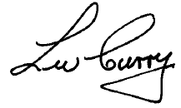

Wally Curry
President
West Perth Power &
Clinton Power Corporation

