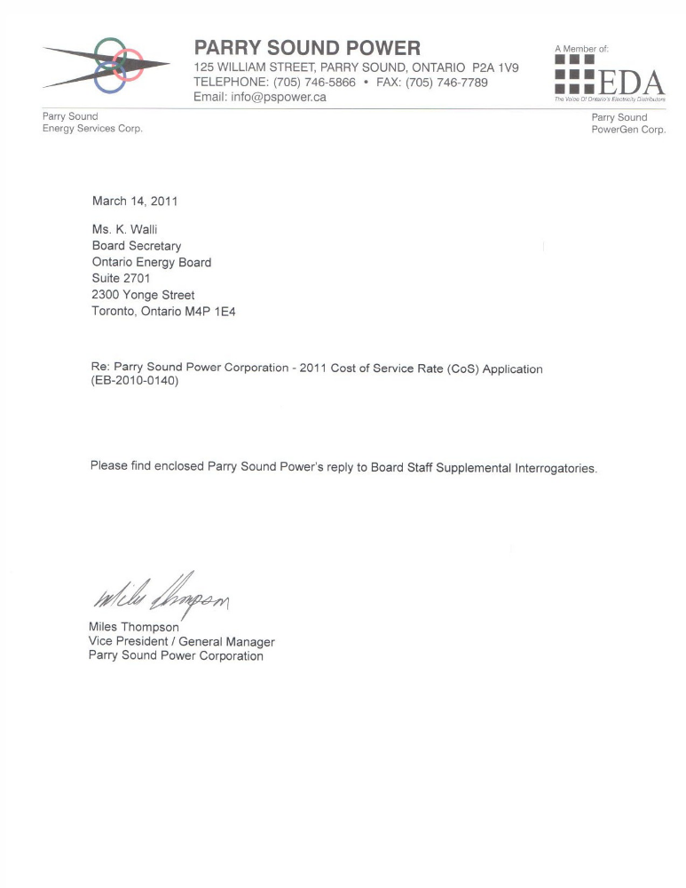

BOARD STAFF SUPPLEMENTAL INTERROGATORIES
Parry Sound Power Corporation
2011 Electricity Distribution Rates Application
EB-2010-0140

FEBRUARY 25, 2011

GENERAL

Ref: Response to Board Staff Interrogatory #2
1. Parry Sound Power has provided revised bill impact tables which show a total bill impact of 16% for a residential customer using 800 kWh per month. Please provide an analysis/scenario of the steps Parry Sound Power could take to reduce this bill impact to less than 10%. Please include all relevant assumptions.

Response: PSP could allocate the Deferral V&A over a 4year period. The resulting bill impact on residential customer using 800 kWh monthly would decrease to 10.63% shown in table 1 below. This has an immediate effect on PSP cash flow. To reach the less than 10% impact PSP would also need to reduce the revenue requirement for the Residential class by $28,000 in the test year, which has an additional cumulative result of $112,000 none inflation adjusted dollars over the 4 year rate period – shown in table 2 below.

Table 1
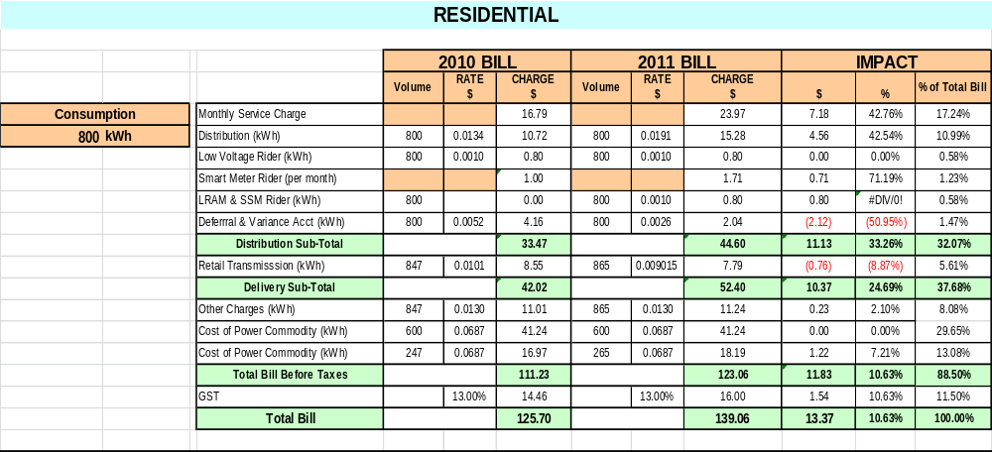

Table 2
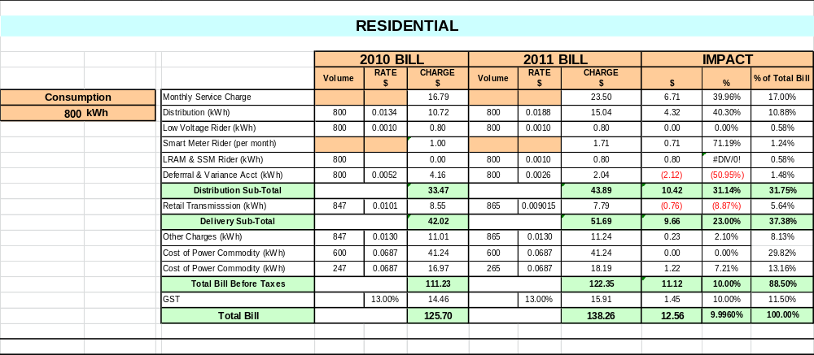

OPERATIONS AND MAINTENANCE EXPENSES

Ref: Response to Board Staff Interrogatory #10
2. Parry Sound Power has provided a revised cost per customer table which shows Parry Sound Power’s OM&A cost per customer rising by 25% in the test year to $529/customer. Has Parry Sound Power compared its cost per customer to the other utilities in its cohort as determined in the Board’s EB-2006-0268 report? For instance, in 2007 Parry Sound Power is 5th in its cohort at $306/customer. Please provide a comparison to the other LDCs in the cohort: Algoma (GLP), Chapleau, Atikokan, Sioux Lookout, Northern Ontario Wires, Espanola, Fort Francis, Renfrew and West Nipissing.
Response: PSP provides the comparison in table format below. As the table indicates from 2002 until 2009 (last data year) PSP remains in the same ranking. The increase in OMA per customer in 2010 bridge and 2011 test is representative of the cost of operating in today’s regulated environment which includes ARC compliance, Asset Management Plans, cost of service filings, etc. These costs are real to all LDCs regardless of the customer base.

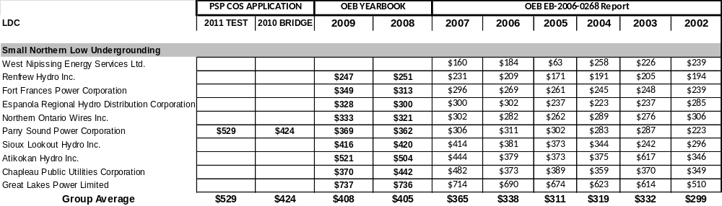

Ref: Response to Board Staff Interrogatory #11
3. This response indicates that 2010 OM&A spending was below planned by approximately 50%. While some explanation is provided for the variances, please provide more detail on significant specific variances such as accounts 5120, 5125, 5130, 5135, 5150 5160.

Response: Parry Sound Power provided a reconciliation to the original Board Staff # 11 IR, which outlined the key drivers of the differences between the YTD actual and applied for budget 2010 values, for the maintenance accounts. PSP has provided the details in response to Board Staff IR#11. The 2010 variances from actual to budget are resource driven. PSP does not anticipate the same issue with the test year values resulting from staff now being dedicated to the LDC to comply with the Affiliate Relationship Code. For all maintenance accounts (5100 series identified above in Supplemental IR # 3) Parry Sound did not have its full labour complement during 2010 (loss time due to injury and more time spent on affiliate work) and as a result, not all maintenance programs were completed as scheduled. This lower work level also drives lower V&E and material costs.

The response also refers to adjustments to be made later in the rate setting process. Does Parry Sound Power anticipate forecast budgets in 2011 to change as a result of this under-spending in 2010? Why or why not?

Response: Parry Sound Power does not anticipate any changes to the 2011 CoS budget or rate application related to 2010 under spending. The 2011 budget for the CoS application is based on our resource pool being fully allocated in 2011 on AMP projects (including unplanned maintenance not included in the AMP). As we don’t anticipate using a higher level of outsourced resources for construction or maintenance projects the dollar values applied for will not be adjusted for the 2010 under spending.

If Parry Sound Power feels that adjustments are required, please file these adjustments in this response.

Response: The AMP is a living document and very new to the rate setting process. As such PSP does not anticipate any changes to the test year values.

Ref: Response to Board Staff Interrogatory #17
4. This Interrogatory inquired about an increase in General Administrative Salaries and Expenses and the response cites the fact that some positions which were once shared are no longer shared with affiliates; with 100% of the cost now the responsibility of Parry Sound Power. A new staff member is also included.

If the management staff now has no responsibilities to the affiliate, why is another staff person required?

Response: To augment the “no responsibilities to the affiliate” means the senior managers can now devote the proper amount of resource to the utility’s needs. The prior allocation of costing was based on an older methodology of senior management time allocation across all companies, not necessarily the need. The reality of change and regulation sees an increase in the senior manager’s time actually spent on LDC related business. The 100% costing now allocated to PSP not only references ARC compliance (under new corporation) but also relates closer to the actual resource requirement to manage an LDC. The planned staffing addition at $65,000 annual (plus OH) is needed to assist management with administrative functions: 30% admin, 20% billing & collecting and 50% regulatory. The ability to plan future resource needs combined with a very large learning curve and the geographical area PSP serves makes succession planning a must. Management feels the need to grow this type of resource by acquiring an additional staff member immediately which will assist with the ever increasing workload PSP’s managers are faced with. This workload needs to be offset by additional staffing.

Ref: Response to Board Staff Interrogatory #18
5. This Interrogatory inquired about Administration and General Account 5620 – Office Supplies and Expenses, where the increase from 2010 to 2011 is 21% after a 112% increase in 2010. The response provides more detail and indicates that these office supplies were once shared with affiliates.

If these supplies are no longer shared and are used by only one entity, Parry Sound Power, why do the expenses not drop to reflect that while Parry Sound Power is now responsible for the total cost, the total cost should be lower?

Response: The budgeted costs allocated to USoA 5620 represent the true cost of PSP doing business. The synergies from shared service such as office equipment maintence, fax, postage machine, internet etc. (as shown in the table Board Staff IR#18) disappear under the reorganized ARC compliant LDC. The end result is the LDC will have higher operating costs.

Ref: Response to Board Staff Interrogatory #20
6. This Interrogatory inquired about Administration and General Account 5670 – Rent and the response deals with the fact that the building will no longer be shared so the entire cost will be borne by Parry Sound Power. Has Parry Sound Power considered renting out the now surplus space to another entity, thereby offsetting this cost for ratepayers?

Response: PSP has considered renting out partial space to offset costs. However the building age, condition and size limits any tenant arrangement. The building, used as an Ontario Hydro Area Office in the past, has been under maintained and has not been updated for several years. The office and garage layout, without considerable renovations, does not suit the sharing of space model. PSP does however plan to renovate the building to update and enlarge both the garage and office area following OEB approval of this rate application. We will also include more energy efficient lighting, windows and HVAC system.

Ref: Response to Board Staff Interrogatory #21
7. Regarding this Interrogatory response dealing with Administration and General Account 5655 – Regulatory Expenses it appears that the amount provided for Regulatory Labour (to be split with Finance) quoted at $65,000 annually should actually be $74,622 so that all costs add to the $210,929 total. In addition, if this position is to be split with Finance, why is the entire cost borne under Regulatory?

Response: PSP apologises for not clarifying the reply to OEB IR# 21. The $65,000 plus 25% OH costs of the new hire are allocated 50% to regulatory. The table below shows the other budget amounts not included in PSP’s response to Board Staff IR #21.
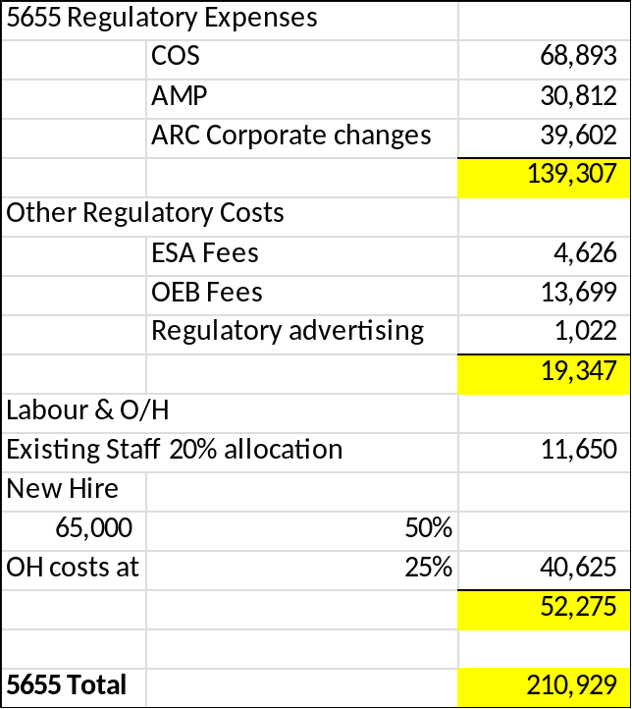

STAFFING and COMPENSATION

Ref: Response to Board Staff Interrogatory #25
8. Regarding this response which provides employee numbers and compensation for historic years, please provide a detailed explanation for the increase in total compensation of over 48% from bridge to test year (up $346,733) , considering that employee numbers only grow 26% (from 9.94 to 12.52). What are the components that make up the additional $346,733?

Response: PSP has explained the $346,733 in table shown below. The table outlines the inflation adjustment, new hire, plus the change in total labour costs relating to Wires Only business.
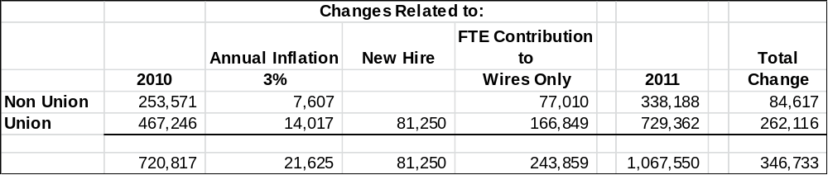

Ref: Response to Board Staff Interrogatory #28
9. Regarding this response which indicates that previously the Affiliate covered and charged the overhead costs of labour and that the increase in the OMERS cost is not considered in the test year. How are the OMERS costs treated in the test year and where do they appear?

Response: PSP based the overhead costs as 25 percent of direct labour. The OMERS expense forms a portion of the overhead. The increase in OMERS for 2011 -2013 has not been taken into consideration in this application. The table below shows the related costs for OMERS increase based on 2011 labour estimates PSP should have included
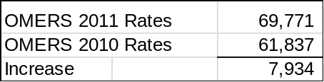

SHARED SERVICES

Ref: Response to Board Staff Interrogatory #32
10. Regarding this response which indicates that the cost increase estimate due to restructuring of $262,000, was only incremental labour costs. Please provide a detailed breakdown of all cost increases in the test year that Parry Sound would attribute to the restructuring. Please include all assumptions and qualifications to the estimates provided.

Response: Parry Sound has produced the 2011 budget used in the 2011 CoS rate application, as the test year, as a stand-alone utility. We did not produce a hypothetical 2011 budget reflecting restructuring initiatives only.

Included in the 2011 budget are increases for the new corporate structure (labour force increases, associated V&E costs, and shared office expenses), escalations, new staffing costs, changes in rate base, and changes in rates of return.

The $262,000 value referenced, was a high level analytical tool developed during the ARC exemption process that was solely intended to reflect incremental labour costs to aid in the exemption decision and has limited connection to the 2011 CoS application (e.g. was based on 2009 not 2011 labour costs).

Parry Sound has identified the following key cost categories related to restructuring (note: this will not be an exhaustive list), however we have not quantified the impacts:
- Labour
  - Management
    - Increase due to reduction of responsibilities for affiliate companies (2011 = 100% allocation of 2 FTEs)
    - Labour rate increases since 2009
  - Inside
    - Increase from 3 (2009) to 5.5 (2011) FTEs due to efficiency losses associated with restructuring
  - Outside
    - Increase from 2.3 (2009) to 5.0 (2011) FTEs for outside work force due to loss of efficiency associated with restructuring
      - Under the 2009 model, PSPC had access to 4 linemen plus supervisor to provide emergency response and on-call functions. When not occupied with LDC work, these employees also performed work (costs recovered from affiliates) for affiliates services
      - Under 2011 model, PSPC directly employees 4 linemen plus supervisor to provide all LDC services and no longer has the option of recovering some of these costs from the non-PSPC affiliated companies
      - The AMP requires the total hours available from the 4 person outside workforce plus supervisor
- V&E
  - PSPC transferred assets used for LDC operations from the affiliated company (rolling stock, misc. tools & equipment) in 2010
  - PSPC also intends to purchase replacement and new vehicles in 2011 (formerly funded by non-regulated affiliate)
  - Impact is to increase rate base, depreciation and corresponding rate of return included in rates
- A&G
  - In 2009 some A&G activities were cost shared (e.g. billing costs, postage costs, etc…) with the non-regulated affiliates
  - In 2011 these costs are directly attributed to the LDC and no longer includes efficiencies gained in past years
- Other Support Assets
  - Similarly to V&E costs, Office furniture and equipment assets were transferred to the LDC in 2010
  - additional expenditures have been identified for 2011
  - Impact is to increase rate base, depreciation and corresponding rate of return included in rates
- Rate of Return on Working Capital (result of higher OM&A costs)
  - The higher OM&A costs resulting from restructuring drives an increase in working capital allowance and associated rate of return

CAPITAL EXPENDITURES

Ref: Response to Board Staff Interrogatory #34
11. In this response, Parry Sound Power indicates that it intends to update the 2010 Bridge Year and 2011 forecast to reflect actual 2010 activities. Please provide this update.
Response: Parry Sound has prepared the table below to reflect the actual 2010 activities.
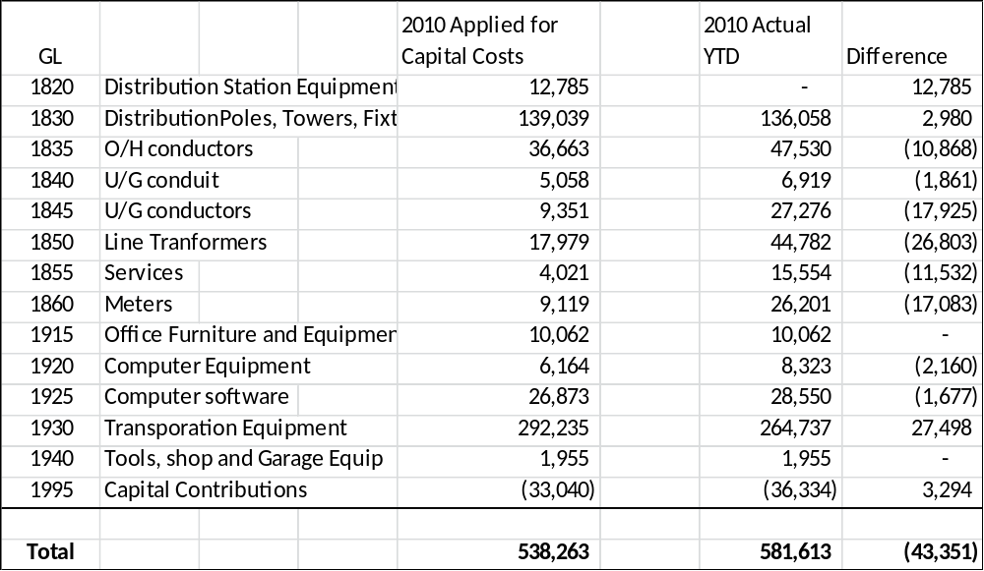

Ref: Response to Board Staff Interrogatory #40
12. In this response, Parry Sound Power mentions the purchase of a pick-up truck in 2010, yet in the response to Board Staff Interrogatory #34, it is stated that the 2010 pick up truck purchase was delayed to 2011. Please reconcile these two responses.

Response: There are two separate pick-up trucks required for PSPC.

One truck was transferred from PSES in 2010.

A second pick-up truck, which was originally intended to be purchased in 2010, was delayed until 2011

OTHER REVENUE

Ref: Response to Board Staff Interrogatory #43
13. What are the financial instruments and the interest rates that pertain, that make up the $5,505 estimate for 2010 and 2011 Interest and Dividend Income?

Response: PSP based the budget amounts on 5 months actual interest from 2010 extrapolated to an annual value. This represents interest only.

COST ALLOCATION and RATE DESIGN

Ref: Response to Board Staff Interrogatory #50 b)
14. The Board Directions on Cost Allocation Methodology (EB-2005-0317) describe three alternative approaches to billing Unmetered Scattered Load customers, at page 87:

- A separate account and invoice for each connection
- A separate account for each connection and a single summary bill produced by an off-line process
- A single bill, aggregated within the billing system.

It specifies that the allocation of billing costs are to be allocated using the number of bills issued to USL customers based on the invoicing approach being used. Parry Sound Power has confirmed in its response to # 50(a) that it uses the first method. The default weighting in the Board’s cost allocation model is 5.0, compared to the reference point of 1.0 per residential customer invoice.

Does Parry Sound Power agree that a weighting factor of greater than 1.0 would make sense for methods b) and c), but that changing the weighting factor from the default to an amount close to 1 would make sense for method a)?

Response Parry Sound Power submits if a change is made to the original default number relating to the weighted billings for unmetered scattered load, it would be prudent to evaluate all default numbers to determine if changes are required to other classes. However, based on three alternative approaches to billing unmetered scattered load customers, there should likely be a change to the weightings dependent upon the alternative selected. Without completing a relativity study to determine the proper weighting for unmetered scattered load customers compared to a base of 1.0 for residential customers, Parry Sound is not prepared to agree that the weighting factor for billing unmetered scattered load customers be close to 1.0 although it does make some sense that it should not be as high as 5.0. Parry Sound is aware the Board has initiated a Cost Allocation Consultation which will hopefully address this and other model issues identified since the Cost of Allocation Informational Filings were submitted.
Parry Sound Power has prepared the following table showing the allocated costs and the revenue to cost ratios for three alternatives:

- As filed in the 2011 Cost of Service rate Application with Default Factors
- Reducing the Unmetered Scatter Load Weighted Factor - Billings from 5.0 to 1.0
- Reducing the GS > or < or both,50kW Weighted Factor – Billings from 2.0 to 1.0 and reducing the Unmetered Scatter Load Weighted Factor - Billings from 5.0 to 1.0
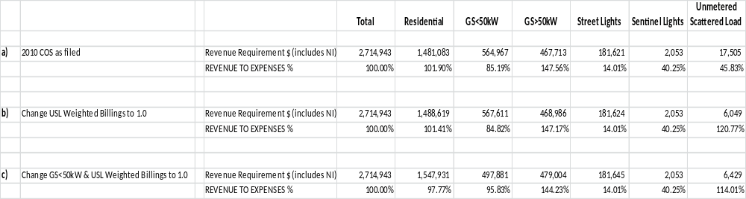

The table shows that significant impacts in the revenue to cost ratios are observed when the weighted factors are adjusted. It is for this reason that those Default Factors should not be arbitrarily adjusted without fully supported data.

Ref: Response to Board Staff Interrogatory #50 c)
15. Please confirm that with a weighting factor of 1.0 for USL bills, the cost allocated to the USL class would fall from $17,505 to $6049, and the revenue to cost ratio would increase from 45.83% to 120.77%.

Response: Parry Sound confirms that a Weighting Factor – Billings of 1.0 changes the allocated costs and revenue to cost ratios from $17,505 to $6,049 and 45.83% to 120.77%, respectively. Those changes can be seen in the table provided with response to Board Staff IR #14 above.

DEFERRAL AND VARIANCE ACCOUNTS

Ref: Response to Board Staff Interrogatory #55 b)
16. In this response, Parry Sound Power indicated that its financial system does not currently support tracking the ITC, and, as a result, PSPC has not recorded in account 1592 savings due to incremental ITC related to HST. Please provide an explanation of how Parry Sound Power plans to comply with the Board direction for Parry Sound Power to record the incremental input tax credits it received on distribution revenue requirement items that were previously subject to PST and which became subject to HST.

Response: Parry Sound has taken into consideration the incremental ITC savings related to HST in both the Bridge and Test Years for the appropriate periods in the 2011 Cost of Service Rate Application.
Parry Sound has decided to track the HST ITCs on a transactional basis commencing July 1, 2010 following receipt of the guidance provided in OEB FAQs December 2010. This will provide a record of the incremental input tax credits received on distribution revenue requirement items that were previously subject to PST.

Ref: Response to VECC Interrogatory #12 b)
17. In this response, Parry Sound Power showed the rate riders calculated over a 2 year recovery period. However, in the rate impact tables, it appears that the reduced rate riders were not applied. Please provide the rate impact tables that reflect the reduced rate riders. Also please provide a similar analysis of the rate riders calculated over a 4 year recovery period, with accompanying rate impact tables.

Response:
Parry Sound apologizes for submitting the Bill Impact Tables using the one year rate riders in error.
The following table provides the Deferral and Variance Account rate riders over a two year period followed by the Bill Impact Tables:

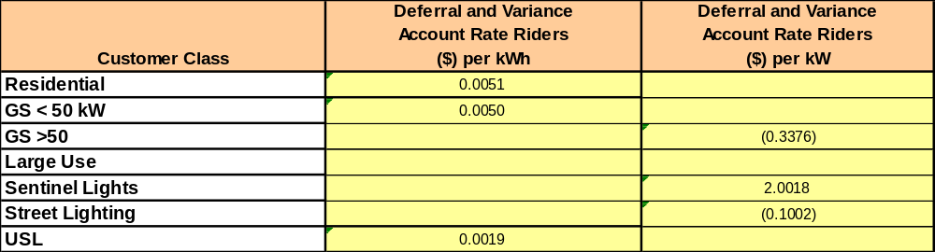

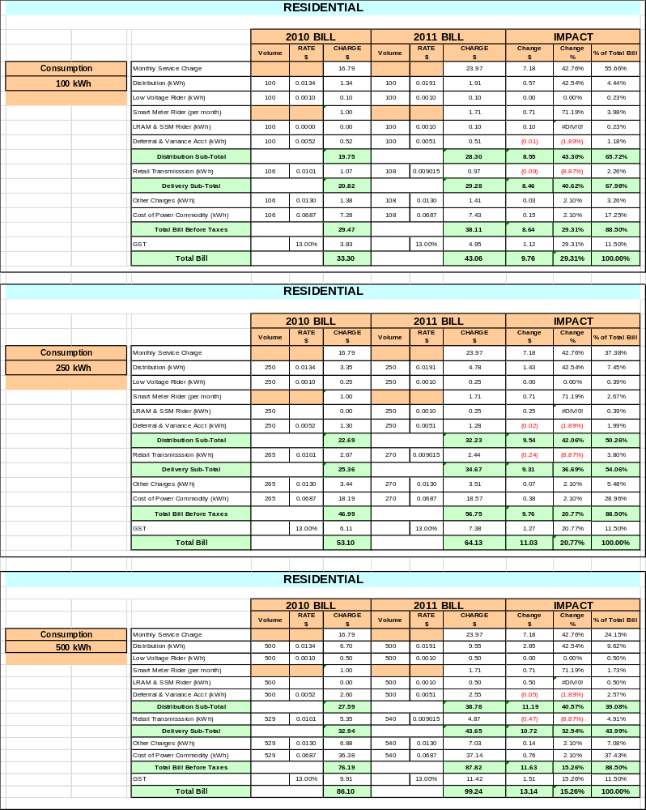

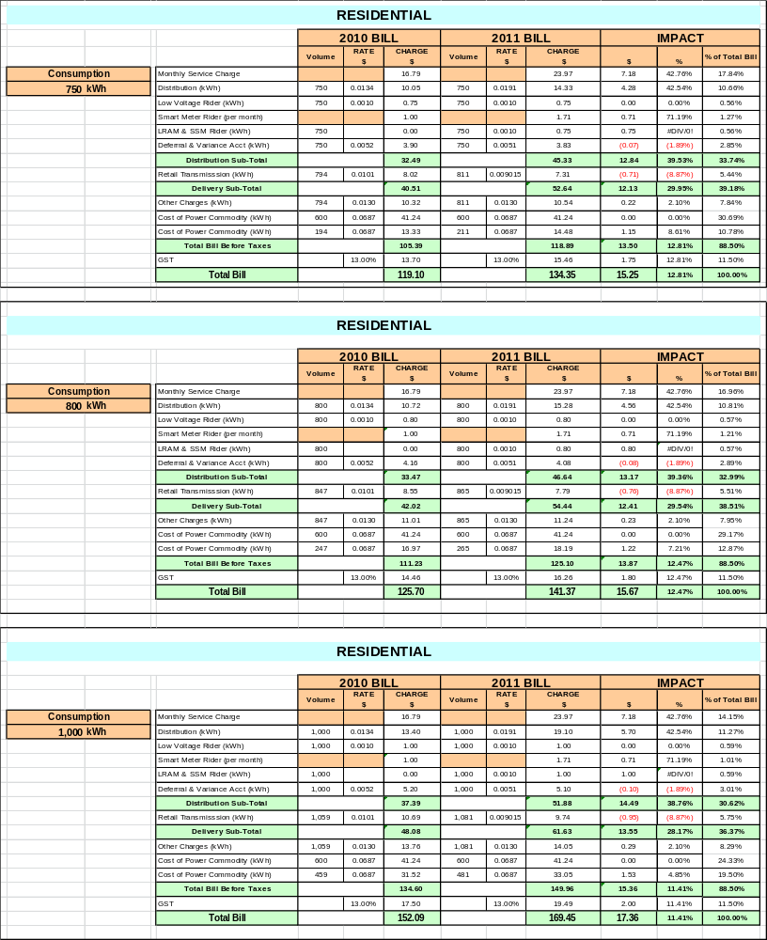

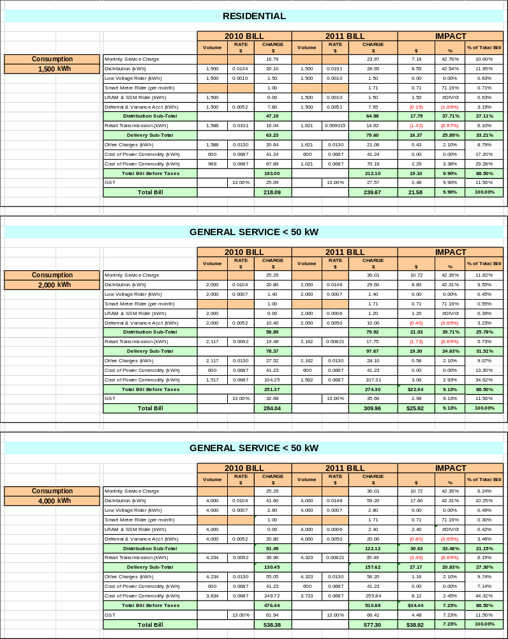

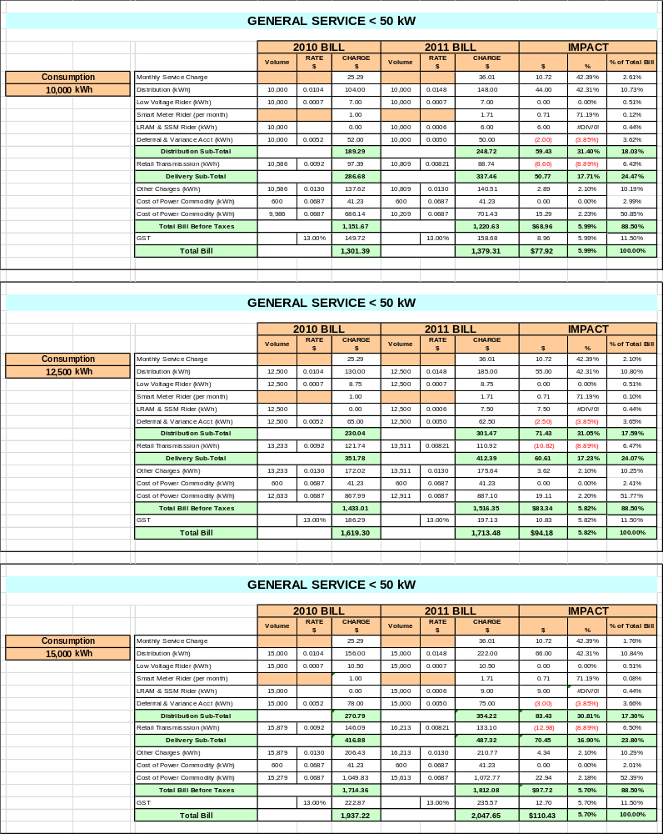

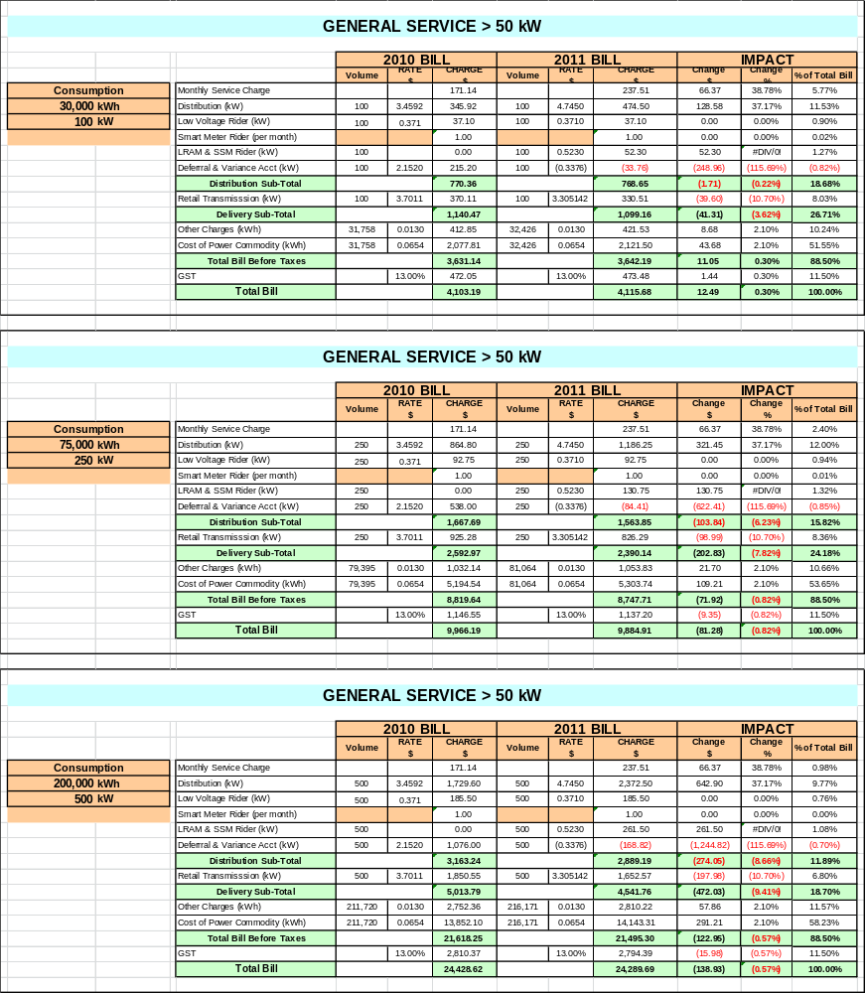

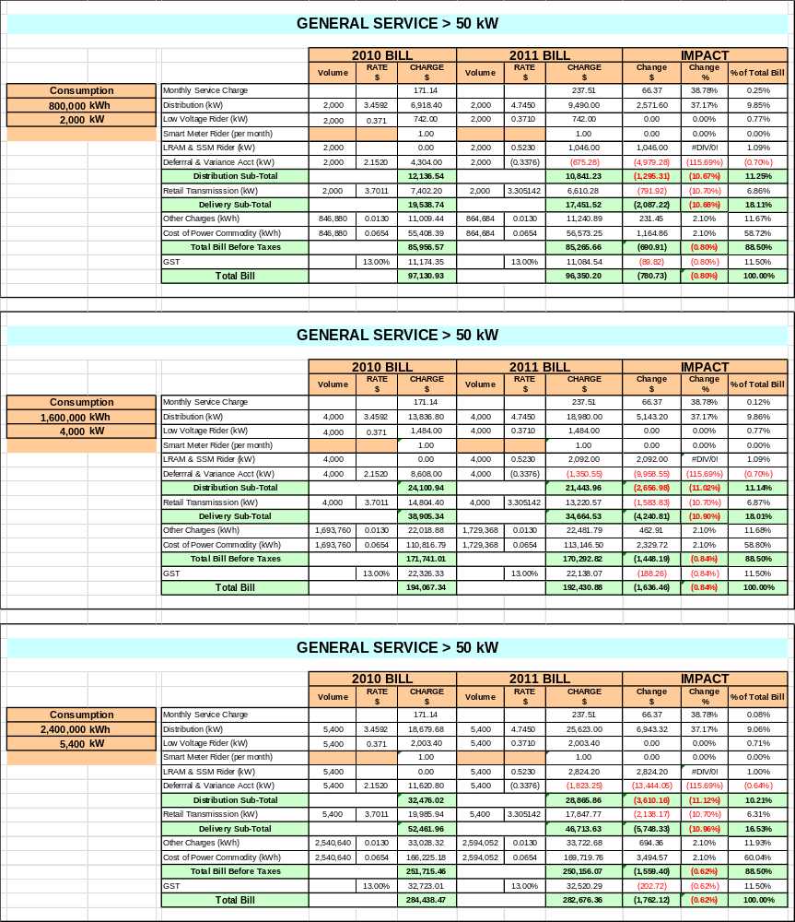

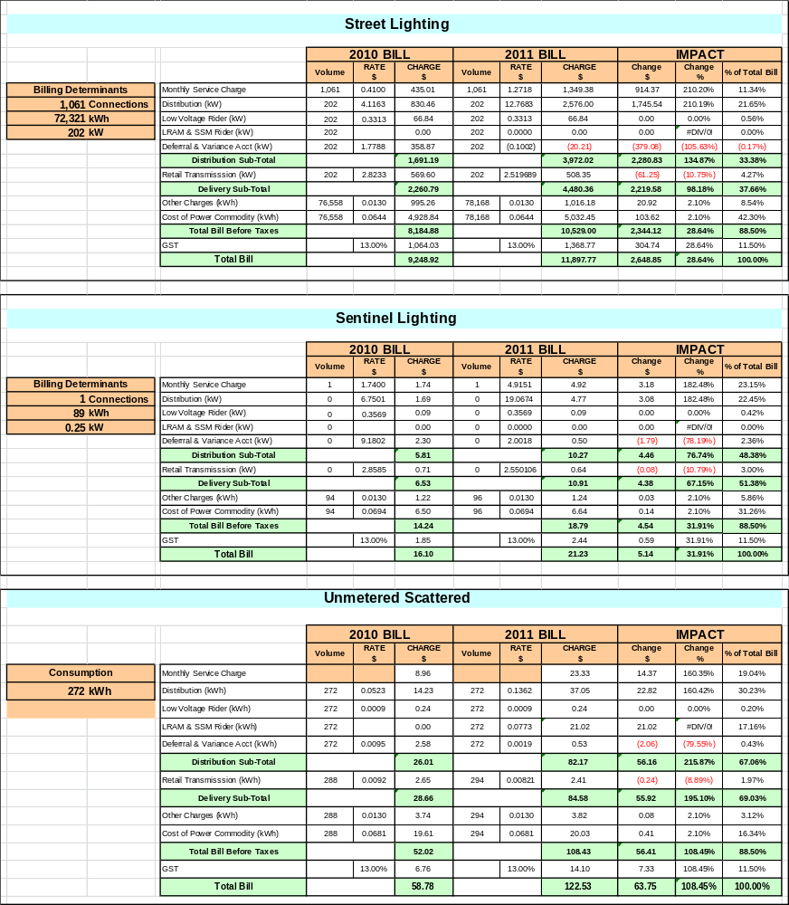

The following table provides the Deferral and Variance Account rate riders over a four year period followed by the Bill Impact Tables:


