2730 Highway #3 Telephone (519) 737-9811
Oldcastle, ON N0R 1L0 Fax (519) 737-7064


March 24, 2011

Kirsten Walli
Board Secretary
Ontario Energy Board
2300 Yonge St.
Suite 2700, P.O. Box 2319
Toronto, ON M4P 1E4

Dear Ms. Walli

Re: Ontario Energy Board File no: EB-2010-0082
Essex Powerlines Corporation
2011 3rd Generation Rate Application

Essex Powerlines has reviewed the draft Tariff of Rates and Charges set out in Appendix A of the Decision received on March 17, 2011 and has found no inaccuracies.

Should there be any questions, please contact me at the number below.

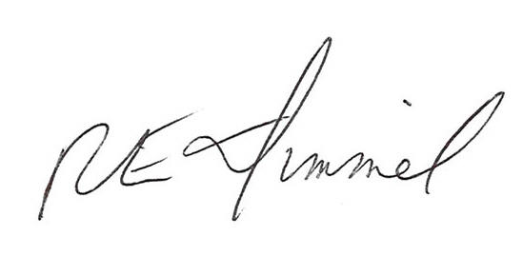

Richard Dimmel
General Manager
Essex Powerlines Corporation
519-737-9811 ext. 14
rdimmel@essexpowerlines.ca

