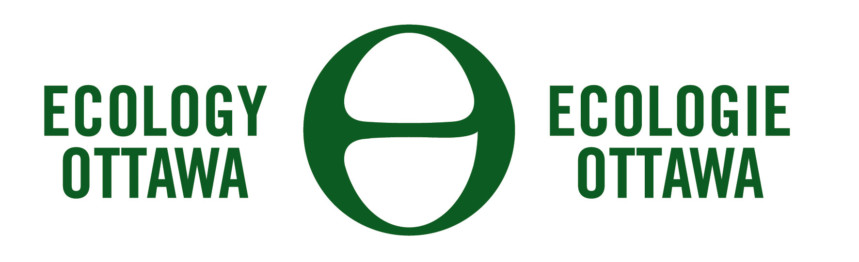

Board Secretary Board File Number: EB-2011-0054
Ontario Energy Board
27 – 2300 Yonge Street
Box 2319
Toronto, ON M4P 1E4 22 July 2011

Dear Secretary,

Please be advised that Ecology Ottawa hereby applies for intervenor status in the proceeding noted above.

Founded in 2006, Ecology Ottawa directly represents the interests of its over 5,000 active supporters and 1,000 individual donors in Ottawa, notably with regard to fair and reasonable electricity rates and their access to clean energy sources. Its supporters, and the other organizations that it works with in Ottawa would be directly affected by any changes in the electricity distribution charges of Hydro Ottawa Limited.
On behalf of its members and the broader community, Ecology Ottawa also encourages the adoption of best practices in energy efficiency, renewable energy generation, green job creation and community education among organizations, institutions, municipalities and businesses in Eastern Ontario. The focus is on institutional change within municipalities, business, property developers, local electricity distribution companies, and academic institutions.
As a non-profit organization, Ecology Ottawa intends to apply for recovery of its costs reasonably incurred in the course of its intervention in this matter. Ecology Ottawa is eligible for a cost award because it “primarily represents the interests of consumers in relation to regulated services” in Ontario, notably with regard to energy.

Yours truly,



Graham Saul
Chair, Steering Commmittee

