February 25, 2008

Ms. Kirstin Walli
Board Secretary
Ontario Energy Board
P.O. Box 2319
2300 Yonge Street, 27th Floor
Toronto, ON M4P 1E4

Re: EB-2007-0881 Chatham-Kent Hydro Inc. 2008 Incentive Rate Mechanism

Dear Ms. Walli:

Please find enclosed a request from the Ontario Energy Board Staff, Chatham-Kent Hydro Inc. has provided an updated 2008IRM Residential file. Board Staff has requested that the Harmonized rate be implemented into the approved 2008IRM model opposed to the customized model that was previously submitted November 1, 2007.

As Board staff requested the harmonized rate of $11.83 (was originally calculated excluding the smart meter adder) plus the pervious smart meter adder of $2.44 (from the 2007IRM) was included on the sheet 3 – Tariff sheet of the approved model and also Smart Meter adder was updated on sheet 4 of the Model to $2.42 in the 2008IRM column.

Should there be any questions, please contact me at the number below.

Yours truly,
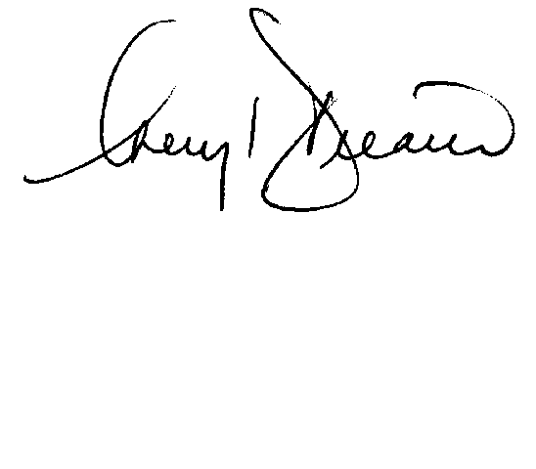

Cheryl Decaire
Co-ordinator of Regulatory and Rates
(519) 352-6300 ext 405
Email: cheryldecaire@ckenergy.com

CC: Jim Hogan, Chief Financial Officer

