VIA E-MAIL, RESS & COURIERED TO THE BOARD

December 2, 2011

Ontario Energy Board
Attn: Kirsten Walli, Board Secretary
P.O. Box 2319
27th Floor
2300 Yonge Street
Toronto ON M4P 1E4

Re: EB-2011-0327 UNION GAS DSM PLAN 2012 - FRPO INTERROGATORIES

Please find attached the interrogatories of the Federation of Rental-housing Providers of Ontario (FRPO) in the Union Gas DSM proceeding EB-2011-0327.

Submitted on Behalf of FRPO,

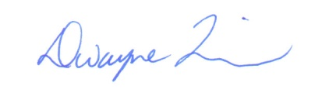

Dwayne R. Quinn
Principal
DR QUINN & ASSOCIATES LTD.

c. M. Redford - Union
Interested Parties EB-2011-0327
V. Brescia - FRPO

