INTERROGATORIES
FROM
DONALD RENNICK
TO THE NORTH BAY HYDRO DISTRIBUTION LIMITED
OEB FILE NO: EB-2011-0187

Manager’s Summary – 9) Tax Changes (page 12 of 13)

1. NBHDL intends to use account number 1595 - Recovery of Regulatory Asset Balances to record the difference resulting from the change in the corporate tax rate for 2012. Please indicate the name and number of the other account(s) involved in this entry.

Manager’s Summary – 4) LRAM/SSM Cost Claims

1. What was the cost of the report prepared by IndEco Strategic Consulting Inc?

2. What is the estimate of the cost for staff time over the years 2008 – 2010 to assemble, calculate and record the information used by IndEco to verify the LRAM/SSM claims made by NBHDL?

3. Have the carrying charges of $4,433 included in this claim been recorded in NBHDL records and if they have when were they recorded and what accounts were involved?

Manager’s Summary – 6) Deferral and Variance Account Rider – Page 4 of 13

a) Account 1562 – Deferred PILs

1. What was the cost of the report prepared by IMBSI?

2. It is my understanding that the deferred PILS account is intended to track a series of differences between what customers pay (PILS embedded in rates) and the actual taxes paid by the LDC.
Appendix 1 - Monthly Continuity Report prepared by IMBSI which arrives at the total principal and interest claim by comparing monthly PILs entitlement included in the rates and the PILs collected from customers on a monthly basis but does not appear to reference any actual liability or payments for income taxes. Please explain how the continuity report provides the result intended of tracking the differences between what customers pay and the actual taxes paid. Have the carrying charges been recorded in the NBHDL records and if they have when were they recorded and what accounts were involved?

c) Group 1 Accounts

1. Please explain how the write off of carrying charges can result in an increase in the closing interest amount balances due from ratepayers.
For example, the North Bay_2012_IRM_Rate_Generator_20111014.xls - Tab 9 – Column BA shows an increase in closing interest amounts for Account # 1588 of $543,960. This is the amount of carrying charges, shown in the Manager’s summary – Table 6, to be written off following the Board’s decision to disallow certain Group 1 and Group 2 balances. Please explain and indicate the accounts affected in recording this entry.

2012 IRM3 Shared Tax Savings Workform.xls – Z Factor Tax Changes tab

1. The 2012 tax payable amount resulting from applying the 2012 Federal and Provincial tax rates to the 2010 COS taxable income figure has been grossed up to calculate the difference tax savings between 2010 and 2012.
It is counterintuitive that a reduction of almost 4% in the tax rate would result in higher taxes. Please provide details of NBHDL’s reasoning behind the rationale for grossing up the tax impact figure. The explanation given in the Manager’s summary (page 12 of 13) is not clear.

My calculation of a tax saving of $112,570 follows.

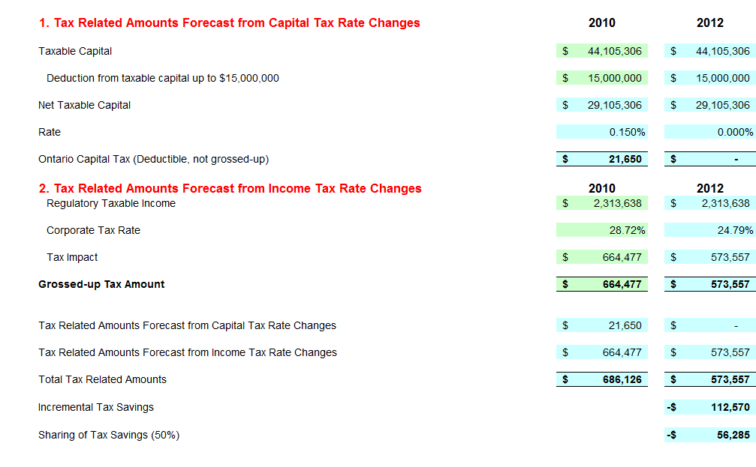

Appendix K – LRAM – 3rd Party Review - IndEco Strategic Consulting Inc.

1. Appendix A - Please explain how the LRAM (2012$) amounts in this appendix were calculated from the figures supplied in the other columns.

2. Presuming the “Measure life” column in this appendix is expressed in years; please explain the line item on page 13 of the report that indicates that Air conditioner/Furnace filters installed in 2008 with a measure life of 1 year continue to produce KWh savings in 2012. Additionally, a number line items on page 24 and page 28 of the report indicate that measures were installed in 2009 with measure lives of 1 year and are also shown as producing KWh savings in 2012.

