Board Staff Interrogatories
2012 IRM3 Electricity Distribution Rates
Essex Powerlines Corporation
EB-2011-0166

General

1) Ref: EB-2009-0143, E3-T1-S2
Ref: Shared Tax Savings Workform, Sheet 3
Ref: Revenue to Cost Ratio Workform, Sheet 3
Ref: IRM3 Rate Generator, Sheet 10

Shared Tax Savings Workform, Sheet 3
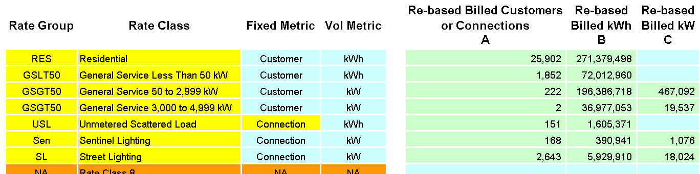

Board staff was unable to reconcile the customers/connections, billed kWh, and billed kW for Sentinel Lighting and Street Lighting classes entered by Essex in the Shared Tax Savings Workform, Revenue to Cost Ratio Workform, and Rate Generator with those established in the load forecast in Essex’s last COS application.

Board staff notes that the approved figures were the following:

Load Forecast for 2010
 | Connections | kWh | kW
Sentinel Lighting | 325 | 382,018 | 1,051
Street Lighting | 7,681 | 5,929,159 | 18,021

- Please confirm that the figures entered by Essex for the customers/connections, billed kWh, and billed kW for Sentinel Lighting and Street Lighting classes in the referenced models were errors. If so, Board staff will make the necessary corrections to the models.

Essex Powerlines Response:

Essex does not know where Board Staff found the figures provided. Essex pulled the figures used from the Rate Generator, Tab C1 – Load Data and Forecast which is located on the OEB Distribution Rate Filing Website.

- If not, please provide support for Essex’s use of the above noted figures that diverge from those established in it’s last COS application.
Essex Powerlines Response:

Not Applicable
Shared Tax Savings

2) Ref: Shared Tax Savings Workform, Sheet 5
Ref: EB-2009-0143, Revenue Requirement Workform
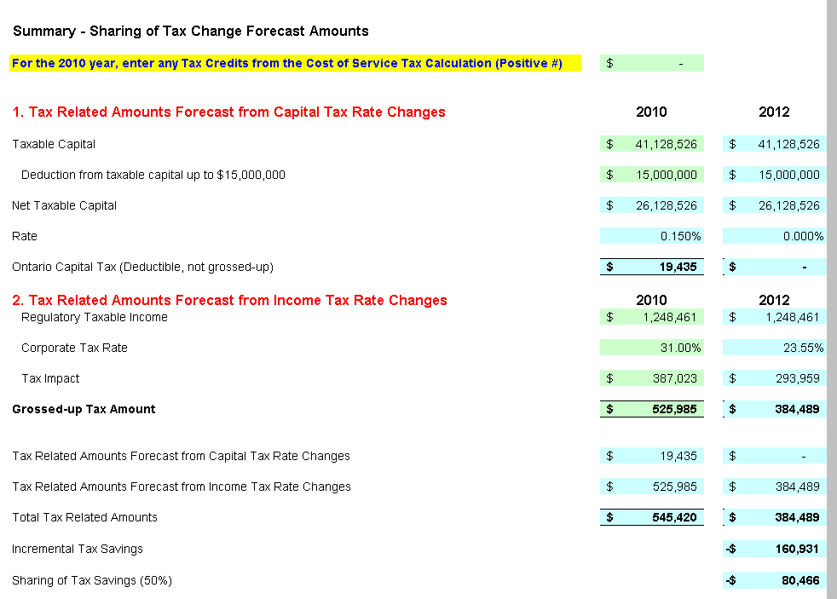

Board Staff was unable to reconcile Taxable Capital entered in Sheet 5 of the Shared Tax Savings Workform with Essex’s previous COS Application (EB-2009-0143). The Taxable Capital established in that application was $41,119,713.

- Please confirm that the correct Taxable Capital to be entered in the Shared Tax Savings Workform is $41,119,713. If Essex confirms, Board staff will make the necessary correction.

Essex Powerlines Response:

Essex confirms that the correct Taxable Capital to be entered in the Shared Tax Savings Work form is $41,119,713 and requests that Board Staff make the necessary corrections.

- If not, please provide support for using $41,128,526 for Taxable Capital.

Essex Powerlines Response:

Not Applicable
Revenue to Cost Ratio Adjustment

3) Ref: Revenue to Cost Ratio Adjustment Workform, Sheet 6
Ref: EB-2010-0082, Decision and Order
Ref: EB-2009-0143, Proposed Settlement Agreement

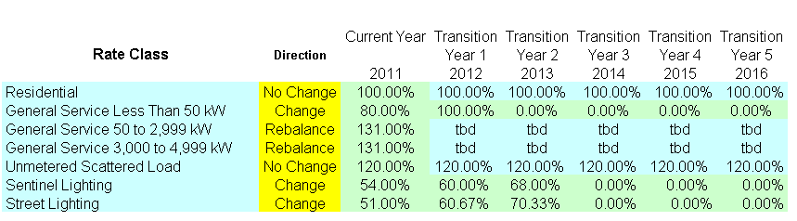

Board staff was unable to reconcile the current year Revenue to Cost Ratio for Street Lighting class entered in Revenue to Cost Ratio Adjustment Workform with those approved by the Board in Essex’s last rates application (EB-2010-0082). The Revenue to Cost Ratio for Street Lighting class established in that application was 50.7%.

- Please confirm that the correct current year Revenue to Cost Ratio for Street Lighting class is 50.7% instead of 51%. If Essex confirms, Board staff will make the necessary correction.

Essex Powerlines Response:

Essex confirms that the correct current year Revenue to Cost Ratio for Street Lighting class is 50.7% not 51% and requests that Board Staff make the necessary changes.

- If not, please provide support for using 51% instead of 50.7% for the above noted Revenue to Cost Ratio.

Essex Powerlines Response:

Not Applicable

- Board staff notes that under Transition Year 2 (2013), Essex has entered Revenue to Cost Ratios for Sentinel Lighting and Street Lighting of 68% and 70.33% respectively. In Essex’s previous COS application all parties had reached an agreement that the Revenue to Cost Ratios for both these classes would be adjusted to 70% by 2013. Please provide an explanation for why Essex entered Revenue to Cost Ratios of Sentinel Lighting and Street Lighting for 2013 that are not 70%.

Essex Powerlines Response:

Essex agrees that these figures should be set to the approved 70% for both categories and requests that Board Staff make the necessary corrections.

RTSR Adjustment

4) Ref: Manager’s Summary
Ref: RTSR Adjustment Workform, Sheet 4
Ref: 2010 Year End RRR 2.1.5

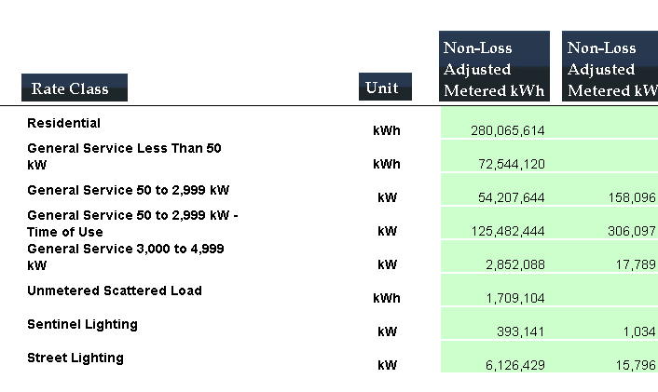

In the Manager’s Summary, Essex notes that the billing determinants filed for the RRR Data include kWhs for five General Service 50 – 2,999 Interval Metered customers and one General Service 3,000 to 4,999 customer which are not charged RTSR since they are Hydro One customers. Essex therefore removed the kWhs associated with these customers.

Board staff confirms that the kWhs entered for the GS >50 classes in Sheet 4 of the RTSR Adjustment Workform are 52,299,434 kWh less than reported in 2010 RRR 2.1.5. Board staff also notes that the kW entered in the model reconcile fully with those in the RRR.

- Please elaborate on why the consumption data of Hydro One customers was included in Essex’s RRR filing.

Essex Powerlines Response:

Essex included Hydro One usage in the RRR filing of 2.1.5 as Hydro One is billed other charges on these kwhrs just not billed RTSR. Since the file in question is to determine RTSR rates Essex felt it was correct to remove the kwhrs from the RRR filing figures and file the numbers excluding Hydro One usage.

- Please confirm that the 52,299,434 kWh subtracted from the RRR data for GS>50 class was the consumption of the GS>50 Hydro One customers that were accidentally included in Essex RRR filing.

Essex Powerlines Response:

Essex confirms that the 52,299,434 kwhrs subtracted from the RRR data relate to GS>50 Hydro One customers. However, Essex does not feel they were accidentally included in the RRR filing – we believe they belong there as they are billed other charges on these kwhrs.

- Please explain why the kW entered for GS>50 classes in the RTSR adjustment model were not adjusted for the exclusion of the Hydro One customers as the kWh were.

Essex Powerlines Response:

This was an error on Essex’s part. The corresponding kWs which should
have been removed from the RTSR adjustment model are 133,722.39 kW.
Essex asks that Board Staff make the necessary adjustments to the model.
Rate Generator

5) Ref: IRM3 Rate Generator, Sheet 9
Ref: 2010 RRR 2.1.7
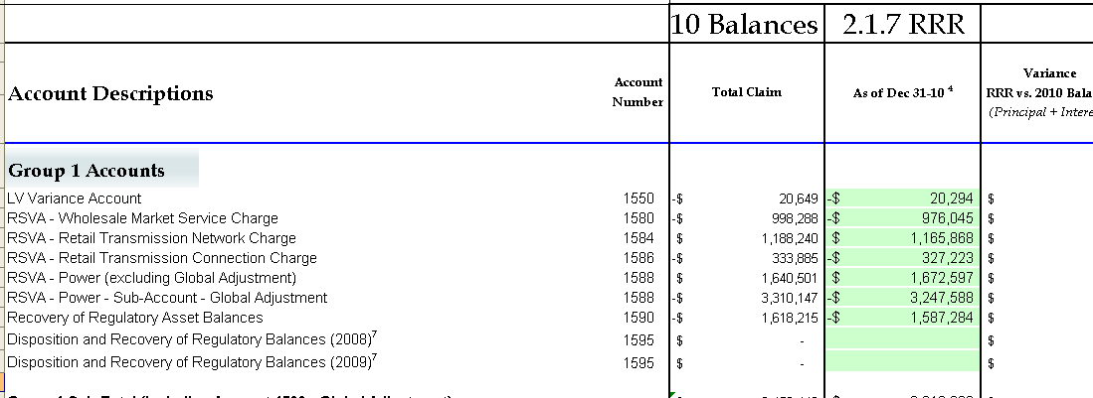

Board staff was unable to reconcile the sum of Account 1588 as entered by Essex in column BW of Sheet 9 of the Rate Generator with the value reported in RRR 2.1.7. The sum of 1588 entered in the model is ($1,574,991), however the value in RRR is ($1,575,022). Using the value in the RRR would yield a variance between RRR and the 2010 Balance for 1588 of ($31).

- Please confirm that the figures entered by Essex for 1588 Power (excluding Global Adjustment) and for 1588 Power – Sub Account – Global Adjustment are errors. If so, please provide the correct values and Board staff will make the necessary corrections.

Essex Powerlines Response:

The figure in column BD of the Rate Generator should have been entered as $74,999 not $74,969 as entered. Essex asks that the Board staff make the necessary changes to the model.

- If Essex confirms a), please provide an explanation for the resulting ($31) variance between RRR and the 2010 Balance for 1588.

Essex Powerlines Response:

Not Applicable

- If not, please provide support for the use of figures for 1588 in column BW that diverge from those reported in RRR 2.1.7.

Essex Powerlines Response:

Essex entered an erroneously figure in column BW of the Rate Generator. The correct figure should be 1,672,566.52 as per the RRR 2.1.7. Essex asks that the Board staff make the necessary changes to the model.

6) Ref: IRM3 Rate Generator, Sheet 10
Ref: EB-2009-0143, Cost Allocation Model, Sheet O1

Rate Generator, Sheet 10
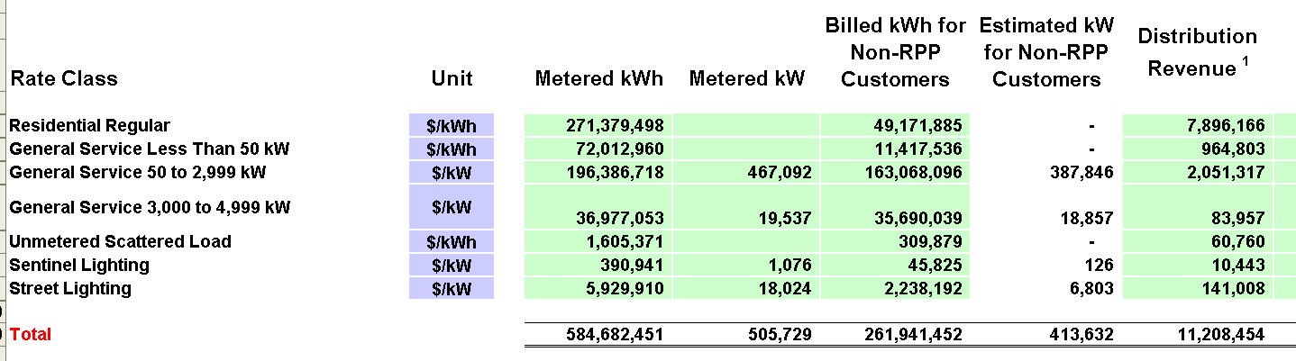

Cost Allocation, Sheet O1

Board staff was unable to reconcile the Distribution Revenue (total and allocation across classes) entered by Essex in Sheet 10 of the Rate Generator with that established in Essex’s last COS application.

- Please confirm that the figures entered by Essex for distribution revenue in Sheet 10 of Rate Generator model were errors and the correct figures should be those established in Essex last COS application (as seen above under Cost Allocation, Sheet O1). If so, Board staff will make the necessary corrections.

Essex Powerlines Response:

Essex used the Distribtion Revenue (proposed rates) found in tab C7-Rate Riders of the Rate Maker to complete this column in Sheet 10 of the Rate Generator.

Essex has no problem changing these figures to the figures found in the Cost Allocation on Sheet O1 and asks Board Staff to make the necessary corrections.

- If not, please provide support for the use of figures for distribution revenue that diverge from those established in Essex’s last COS application.

Essex Powerlines Response:

Not Applicable

Account 1521 – Special Purpose Charge (“SPC”)

7) Ref: Manager’s Summary

Essex indicated a debit balance in account 1521 of $89,343.39 at December 31, 2010. The unaudited balance as of September 30, 2011 was $10,123.83. Essex noted it reserves the right to dispose of this balance in a future COS application or IRM application.

According to the Board letter addressed to all licensed electricity distributors, dated April 23, 2010,

“In accordance with section 8 of the SPC Regulation, you are required to apply to the Board no later than April 15, 2012 for an order authorizing you to clear any debit or credit balance in “Sub-account 2010 SPC Variance”. The Board expects that requests for disposition of the balance in “Sub-account 2010 SPC Variance” and “Sub-account 2010 SPC Assessment Carrying Charges” will be addressed as part of the proceedings to set rates for the 2012 rate year, except in cases where this approach would result in non-compliance with the timeline set out in section 8 of the SPC Regulation.”

- Please confirm Essex’s SPC assessment amount and provide a copy of the original SPC invoice.

Essex Powerlines Response:

Essex paid $213,435.00 in respect of the Special Purpose Charge. A copy of the invoice received and paid is below:
- Please provide Essex’s reasons for not disposing of account 1521 in this IRM application.

Essex Powerlines Response:

Essex’s reason for not disposing of account 1521 in this 2012 IRM was because the sunset date of the recovery of this account was April 30, 2011. Essex felt that applying for recovery of the audited balance in the variance account at December 31, 2010 was unnecessary. At December 31, 2010 Essex balance in the SPC variance account was $89,786.31, after the next several months of recovery the balance at December 31, 2011 was $10,692.25. If the Board would like to accept the unaudited balances of December 31, 2011, Essex would be agreeable to submitting those amounts for disposition in the 2012 IRM.

- If granted approval not to dispose of account 1521, when does Essex expect to file an application to address the disposition of account 1521?

Essex Powerlines Response:

Essex would expect to file an application to address the disposition of account 1521 with its 2013 IRM filing.

- Please complete the following table related to the SPC.

SPC Assessment (Principal balance) | Amount recovered from customers in 2010 | Carrying Charges for 2010 | December 31, 2010 Year End Principal Balance | December 31, 2010 Year End Carrying Charges Balance | Amount recovered from customers in 2011 | Carrying Charges for 2011 | Forecasted December 31, 2011 Year End Principal Balance | Forecasted December 31, 2011  Year End Carrying Charges Balance | Forecasted  Carrying Charges for 2012  (Jan.1 to Apr.30) | Total for Disposition (Principal & Interest)
213,435.00 | 123,648.69 | 0 | 89,786.31 | 0 | 80,472.90 | 1,378.84 | 9,313.41 | 10,692.25 | 45.39 | 10,737.64

Smart Meter Funding Adder (“SMFA”)

8) Ref: Manager’s Summary

The following example is relevant to Essex’s request in this application. The Board’s Decision and Order with respect to Festival’s 2011 IRM Rates Application, issued April 21, 2011, states at page 5:

Since the deployment of smart meters on a province-wide basis is now nearing completion, the Board expects distributors to file for a final prudence review at the earliest possible opportunity following the availability of audited costs. For those distributors that are scheduled to file a cost of service application for 2012 distribution rates, the Board expects that they will apply for the disposition of smart meter costs and subsequent inclusion in rate base. For those distributors that are scheduled to remain on IRM, the Board expects these distributors to file an application with the Board seeking final approval for smart meter related costs. In the interim, the Board will approve the requested SMFA of $1.52 per metered customer per month from May 1, 2011 to April 30, 2012. This SMFA adder will be reflected in the Tariff of Rates and Charges, and will cease on April 30, 2012. Festival Hydro’s variance accounts for smart meter program implementation costs, previously authorized by the Board, shall be continued. [Emphasis added]

Similar wording was contained in the Board’s decisions for many rates applications in 2011.

- Please provide the sunset date that Essex would propose for its Smart Meter Funding Adder (“SMFA”).

Essex Powerlines Response:

Essex has reconsidered its position and therefore the sunset date for its smart meter adder will be April 31, 2012.

- Essex’s existing SMFA of $1.96 per metered customer was first approved effective May 1, 2010. By December 31, 2012, this SMFA will have been in effect for over 2 years. The SMFA is not intended to be fully compensatory for the revenue requirement for installed smart meters in the historical period. At the same time, the SMFA was envisioned as providing partial recovery for costs until such time as the utility made application for seeking the Board’s approval for the disposition and full recovery of costs incurred for smart meter deployment. The SMFA has been allowed to increase in part to recognize the increase in the revenue requirement as smart meter have been deployed. An increased SMFA will also help to reduce the deferred revenue requirement that will remain to be recovered upon disposition.

  - If its proposal to continue the SMFA past April 30, 2012 is approved, please provide Essex’s views as to whether the current SMFA of $1.96 is adequate as partial recovery of the revenue requirement for installed smart meters in order to avoid a significant deferred revenue requirement recovery when Essex makes application for disposition.

  - Please fill out the attached draft Board staff Smart Meter model to calculate an updated SMFA for the 2012 rate year.

Essex Powerlines Response:

See response to a) above.

Account 1562 – Deferred PILs

Ref: Continuity Schedule – Essex_ED Disposition 1562 Balance_11032011.xls/
Amounts Billed to Customers

9) Unmetered Scattered Load (USL)
Ref: Continuity Schedule – Essex_ED Disposition 1562 Balance_11032011.xls/

Unmetered scattered load is listed as one of the components of the billing and recovery in the Excel spreadsheet. Essex filed a separate 2002 RAM model to calculate the rate amounts related to USL. In the Board’s decision for 2002 and 2004, the USL class volumetric rate was expressed in kWh. However, in the 2004 RAM, Essex used the large user class to calculate the USL rate and the volumetric rate was expressed in kW and not kWh. In the Board’s decision for 2005, the USL class volumetric rate was expressed in kW.

Essex appears to have used an USL kWh volumetric rate in each of the worksheets to calculate PILs recoveries for 2002 through March 2005. The billing determinant for volumes appears to be kWh and not kW. In Tab C1.7 Essex has made a negative adjustment of -2,543,389 kWh and -$12,010.

- Please explain why Essex did not use the PILs rate slivers and the billing determinants it calculated in each of the applications for 2002, 2004 and 2005 rates.

- If Essex agrees that the original data should be used, please confirm and refile the corrected information. If Essex disagrees, please explain why.

Essex Powerlines Response:

The models provided to Essex for its filing in 2002 to 2004 did not provide for a separate class for unmetered scattered load so the Large User class was utilized and designated with the words “Large use – unmetered scattered load”. The kwh’s were used in 2004 not kw to determine rates. Note that in the filing the kwh’s were put in both the kw and kwh columns but only the kwh’s were used as the determinant. In Tab C1.7, the negative adjustment in 2006 was a billing adjustment for overbilling in 2005 – see tab C1.6 where there is 4,169,651 kwh’s billed but if you refer to C1.2, this shows a more typical year which reflects kwh’s of 1.3 million.

b) If Essex agrees that the original data should be used, please confirm and refile the
corrected information. If Essex disagrees, please explain why.

Essex Powerlines Response:

See response above to a)

10) Tabs C1.3 and C1.5 Billed Volumes
Ref: Continuity Schedule – Essex_ED Disposition 1562 Balance_11032011.xls/

In the period January to March 2004 Essex disclosed billed volumes that are much greater than those used in the period January to March 2005.

- Please explain why the volumes billed in 2005 are so much lower than for the same period in 2004.

Essex Powerlines Response:

During 2005, Essex changed billing systems effective April 1. The billings were delayed resulting in old rates (2004) being billed in periods beyond April 1, 2005. The billing stats do not specifically identify the old rates and the associated kwhr’s or kw’s. The usage shown is a calculation based on the dollars divided by the rate in the model and would create the appearance of this usage variance between years. Also, refer to the response to IR#9 above, as the billing error for unmetered scattered load also affected the comparative usage. The dollars for PILs collected are correct.

11) Billing Frequency
Ref: Continuity Schedule – Essex_ED Disposition 1562 Balance_11032011.xls/

- Did Essex bill monthly or bi-monthly during the period from 2002 to 2006?

Essex Powerlines Response:

Essex billed monthly during the period from 2002 to 2006.

- Why are the billing statistics for PILs recoveries for customer counts, kWh and kW so low for 2002?

Essex Powerlines Response:

2002 is a partial year since rates were effective March 1.

- How were the numbers of customers determined in each of the years in the recovery worksheets?

Essex Powerlines Response:

The customer count was determined from the total dollars collected. The total dollars collected is correct. See also response to 10 a) above.

12) Unbilled Revenue Accrual
Ref: Continuity Schedule – Essex_ED Disposition 1562 Balance_11032011.xls/

Essex stated in Exh.3/Tab1/Sch.1/pg2/ln-13 that,

“Collections from customers have been defined as the amounts billed to customers. Essex Powerlines confirms that amounts which at the time would have been included in unbilled revenue accruals have now been included in collections.”

- Please explain how Essex determined the PILs amounts associated with unbilled revenue accrual as at April 30, 2006 and how this was included in the various Excel worksheets.

Essex Powerlines Response:

Unbilled revenue would have been calculated in the same manner as we normally do at year end. The change from the previous year end to April 30, 2006 for PILS would have been adjusted in the PILs collected from customer’s field. The data to support this however is no longer available.

13) Ref: 2001 SIMPIL

The fourth quarter 2001 is a short tax year. As such, the tax items must be pro-rated by 92/365. The 2001 PILs proxy reflects the pro-ration. However, the pro-rations required for the true-up variance calculations for Ontario capital tax (OCT) and large corporation tax (LCT) were not made in the cell range TAXCALC E150-E180. This results in an incorrect true-up to ratepayers of $47,956 for LCT and $53,375 for OCT since there should be no amounts to true up.

- Please correct the formulas for the necessary pro-rations and resubmit the 2001 SIMPIL.

Essex Powerlines Response:

Essex verified with Board staff that the reference in the IR is for the PILs disposition model and not the SIMPIL model. Essex has confirmed that this is an input error that has been corrected and the revised model included.

14) Ref: 2001 SIMPIL

Interest expense appears on the income statement but no actual interest was entered on sheet TAXCALC. According to Essex’s financial statements, interest expense consists of interest on long-term debt and bank charges and interest expense.

- Please explain why actual interest was not entered for the true-up calculation on TAXCALC.

- If Essex agrees that actual interest should be used, please correct and refile the SIMPIL model.

- If Essex disagrees, please explain why.

Essex Powerlines Response:

Interest expense was included in the TAXCALC sheet but the period in question was not a full year and therefore only a portion of the interest would apply. Essex produced internal financial statements for the stub year. The amount of interest on these financials was the amount reflected in TAXCALC.

14) Ref: 2002 SIMPIL

Essex has used 38.62% in the SIMPIL sheet TAXCALC to calculate the true-up amounts. In form TAXREC, Essex has shown 36.97% as its tax rate in cell C151.

- Please explain why Essex chose to use 38.62% rather than 36.97% to calculate the tax impacts on sheet TAXCALC.

Essex Powerlines Response:

Essex Powerlines was required to use a loss carry forward in 2002 which lowered its tax payable and believes that it would have incurred the maximum tax rate otherwise. Essex Powerlines has therefore used the maximum tax rates.

15) Interest Expense

Interest Portion of True-up – 2001 to 2005 SIMPIL - TAXCALC
When the actual interest expense, as reflected in the financial statements and tax returns, exceeds the maximum deemed interest amount approved by the Board, the excess amount is subject to a claw-back penalty and is shown in sheet TAXCALC as an extra deduction in the true-up calculations.

- For the tax years 2001 to 2005:

- Did Essex have interest expense related to liabilities other than debt that is disclosed as interest expense in its financial statements?

Essex Powerlines Response:

Yes, interest on customer deposits was included in addition to debt interest.

- Did Essex net interest income against interest expense in deriving the amount it shows as interest expense in its financial statements and tax returns? If yes, please provide details to what the interest income relates.

Essex Powerlines Response:

No, Essex did not net interest income against interest expense.

- Did Essex include interest expense on customer security deposits in interest expense for purposes of the interest true-up calculation?

Essex Powerlines Response:

Yes

- Did Essex include interest income on customer security deposits in the disclosed amount of interest expense in its financial statements and tax returns?

Essex Powerlines Response:

Yes

- Did Essex include interest expense on IESO prudentials in interest expense?

Essex Powerlines Response:

Yes.

- Did Essex include interest carrying charges on regulatory assets or liabilities in interest expense?

Essex Powerlines Response:

No, Essex did not include interest carrying charges on regulatory assets or liabilities in interest expense.

- Did Essex include the amortization of debt issue costs, debt discounts or debt premiums in interest expense? If the answer is yes, did Essex also include the difference between the accounting and tax amortization amounts in the interest true-up calculations? Please explain.

Essex Powerlines Response:

No, Essex did not incur debt issue costs, debt discounts or debt premiums.

- Did Essex deduct capitalized interest in deriving the interest expense disclosed in its financial statements? If the answer is yes, did Essex back the capitalized interest to the actual interest expense amount for purposes of the interest true-up calculations? Please explain.

Essex Powerlines Response:

Essex did not capitalize interest.

- Please provide Essex views on which types of interest income and interest expense should be included in the excess interest true-up calculations.

Essex Powerlines Response:

Essex’s view is that the only type of interest that should be included would be interest on long term debt, security deposit interest and letter of credit interest.

- Please provide a table for the years 2001 to 2005 that shows all of the components of Essex interest expense and the amount associated with each type of interest.

Essex Powerlines Response:

Detailed data for years 2001 to 2004 is no longer accessible due to a financial system change effective January 1, 2005.

 | Interest Expense Components 2001-2005
Year | Long Term Debt | Consumer Deposits | Letter of credit/line of credit | Total Interest Expense
2001 | Not available | Not available | Not available | $ 598,687
2002 | Not available | Not available | Not available | $ 795,569
2003 | Not available | Not available | Not available | $ 853,433
2004 | Not available | Not available | Not available | $ 828,466
2005 | $ 523,402 | $ 29,700 | $ 232,069 | $ 785,171

16) Treatment of Regulatory Assets and Liabilities in the Tax Returns

It appears from the evidence that Essex retained regulatory assets and liabilities on the balance sheet and did not adjust the tax returns for the annual movements or changes in the balances of regulatory assets and liabilities.

- Please explain why the Ministry of Finance allowed this tax treatment for Essex.

Essex Powerlines Response:

Essex has not received any objection or concern from the Ministry of Finance with its tax filing. All assessments have been received and no reassessments have been issued.

17) Tax Years – Statute-barred

- Please confirm that all tax years from 2001 to 2005 are now statute-barred.

Essex Powerlines Response:

Essex confirms that all assessment notices have been received for the years 2001 to 2005 and are now statute-barred.

18) Ref: 1562 Balance Reported in RRR

Essex has reported the balance in account 1562 to be a debit or receivable from customers of $157,430 at the end of December 2010 in its RRR filing 2.1.7. The 2010 balance according to the PILs continuity schedule tab E1.1 is a debit balance of $101,760 consisting of principal of $38,914 and interest of $62,846.

- Please explain the reasons for the differences between the 2010 RRR balance and the evidence filed in this case.

Essex Powerlines Response:

Please reference #6 in Essex’s Manager’s summary:

“6. Deferred Payment in Lieu of Taxes (PILs)

EPLC has reviewed the evidentiary record of the combined proceeding EB-2008-0381, as well as EB-2010-0132 and the letter from the Board dated September 13, 2011 regarding disposition of PILs. EPLC has completed the SIMPIL models.

For account 1562, EPLC is showing a variance in cell BX40 of Sheet 9 in the IRM Rate Generator Model vs. the RRR reporting value for December 31, 2010. This variance reflects the differences between the methodology approved in the combined proceeding as compared with the methodology used by EPLC during the period of 2001 and 2005, which was believed to be consistent with the required methodology of the time.”

It was Essex’s understanding that there were errors in the Board’s SIMPIL models that were outlined in the combined proceeding that were required to be corrected. Essex made these corrections which created this variance of $55,670.

Lost Revenue Adjustment Mechanism
19) Ref: 2006 to 2012 LRAM Report, September 25, 2011
Elenchus notes that the LRAM claim of $508,029.80 includes energy and demand savings that result from 2006–2010 programs, some of which continue through to the end of the filing period which is April 30, 2012.
- Please confirm that Essex used final 2010 program evaluation results from the OPA to calculate its LRAM amount.
Essex Powerlines Response:

Essex Powerlines received the final 2010 evaluation results on November 15, 2011. The final report effectively changes the amount requested. Elenchus has concluded that Essex Powerlines electricity rates should be adjusted to reflect an LRAM claim of $509,319.25 (originally calculated at $508,029.80).

- b) If Essex did not use final 2010 program evaluation results from the OPA, please explain why and update the LRAM amount accordingly.

Essex Powerlines Response:

See a) above. Updated LRAM report attached. The following are the updated rate riders requested.

c) Please confirm when Essex’s last load forecast was approved by the Board.

Essex Powerlines Response:

Essex Powerline’s last approved load forecast by the Board was in its 2010 COS EB-2009-0143.

d) Please identify the CDM savings that were included in Essex’s last Board approved load forecast for CDM programs deployed from 2006 to 2010 inclusive.

Essex Powerlines Response:

There were no direct CDM savings from OPA programs included in Essex Powerlines’ load forecast.

e) Please provide a table that shows the LRAM amounts requested in this application by the year they are associated with and the year the lost revenues took place, sorted by rate class within each year. Use the table below as an example and continue for all the years requested (i.e. 2006- April 30, 2012):

Essex Powerlines Response:

f) Please confirm that Essex has not received any of the lost revenues requested in this application in the past. If Essex has collected lost revenues related to programs applied for in this application, please discuss the appropriateness of this request.

Essex Powerlines Response:

Essex Powerlines’ confirms that it has not claimed LRAM amounts in previous applications.

