2730 Highway #3, Telephone (519) 737-9811
Oldcastle, ON N0R 1L0 Fax (519) 737-7064



Board Secretary
Ontario Energy Board
27th Floor
2300 Yonge Street
Toronto, ON M4P 1E4

April 11, 2012

Dear Ms. Walli,

Re: Essex Powerlines Corporation
Board File Number EB-2011-0166
Draft Rate Order Submission

Please find attached Essex Powerlines Corporation’s Draft Rate Order Submission.

As set out in the filing requirements, Essex Powerlines has included two paper copies and one CD with an electronic copy of the files, together with an electronic copy to VECC. Essex has also filed through the Ontario Energy Board web portal.

Sincerely,

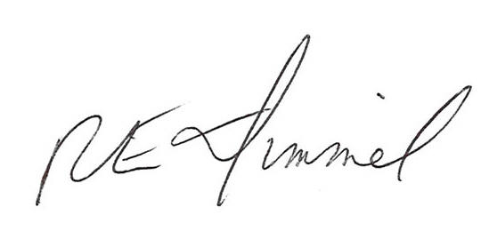

Richard Dimmel
General Manager
Essex Powerlines Corporation
rdimmel@essexpowerlines.ca

Cc: Vulnerable Energy Consumers Coalition
Mr. Michael Buonaguro, Counsel for VECC

Essex Powerlines Corporation
EB-2011-0166
Draft Rate Order Submission

Review and Disposition of Account 1562 Deferred Payments in Lieu of Taxes (“PILs”)

The Board directed Essex to use the 2006 EDR volumetric billing determinants for the GS>50 kW Class in order to calculate the PILs collections for 2003, 2004, 2005 and the four months of 2006. Essex has completed these changes in its model but would like to clarify the amounts used for the four months of 2006.

Board Staff proposed to Essex to use the first 3 months of 2005 as a proxy for the first four months of 2006. Essex proposed to use 4/12ths of the total 2004 kW consumption of 2004 as a better indicator of the usage in this time period. This provided billing determinant values of 165,439 kW for GS>50 and 6,253 kW for GS>3,000 to 4,999.

Upon further investigation, Essex was able to determine the monthly billing data that matched the 2004 billing data submitted for the 2006 rate filing for these rate classes except this information does not included unbilled revenue for the period ending April 2004. The unbilled adjustment for this period was estimated to be 10% of the April billing data. This is provided in a chart below. Essex has used this data to determine the first four months estimated amount to use which is 164,029 kW for GS>50 and 3,090 kW for GS>3,000 to 4,999.

ESSEX POWERLINES CORPORATION
TOTAL RETAIL UNITS BILLED-2004
 | GS > 50 KW | GS >3000 to 4999
 | KW | KW
Jan-04 | 45,231.0 | 825.7
Feb-04 | 39,647.3 | 824.8
Mar-04 | 37,579.7 | 389.7
Apr-04 | 37,791.5 | 954.7
May-04 | 38,241.5 | 630.4
Jun-04 | 40,923.1 | 841.3
Jul-04 | 44,769.5 | 2,512.4
Aug-04 | 43,758.5 | 616.6
Sep-04 | 43,344.5 | 4,110.1
Oct-04 | 45,530.8 | 3,998.4
Nov-04 | 42,842.8 | 2,976.5
Dec-04 | 36,655.5 | 79.4
Totals | 496,315.7 | 18,760.0
For 2006 | Total GS>50 | GS >3000 to 4999
 | KW | KW
Jan | 45,231.0 | 825.7
Feb | 39,647.3 | 824.8
Mar | 37,579.7 | 389.7
Apr | 37,791.5 | 954.7
Change in Unbilled - estimate for April 10% | 3,779.1 | 95.5
Total to be used for 2006 | 164,028.7 | 3,090.4
GS>50 - the unbilled adjustment is estimated to be 10% as customers are billed by demand (kW)
and if billing is more than 15 days, it is assumed that peak occurred during the unbilled month
Unbilled is the change in the unbilled opening balance for Jan less the unbilled for Apr
so the difference would be the net effect. In 2004, unbilled for GS>50 was 1,708 kW.
therefore the 10% is reasonable.

