2730 Highway #3, Telephone (519) 737-9811
Oldcastle, ON N0R 1L0 Fax (519) 737-7064



Board Secretary
Ontario Energy Board
27th Floor
2300 Yonge Street
Toronto, ON M4P 1E4

April 23, 2012

Dear Ms. Walli,

Re: Essex Powerlines Corporation
Board File Number EB-2011-0166
Draft Rate Order Submission

Please find attached Essex Powerlines Corporation’s responses to Board Staff comments on the Draft Rate Order Submission.

As set out in the filing requirements, Essex Powerlines has included two paper copies and one CD with an electronic copy of the files, together with an electronic copy to VECC. Essex has also filed through the Ontario Energy Board web portal.

Sincerely,

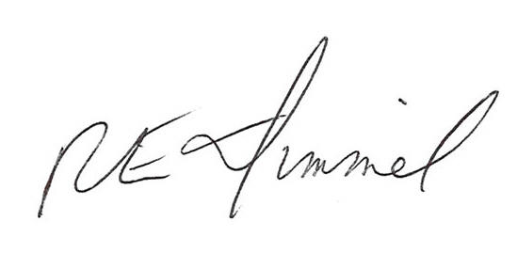

Richard Dimmel
General Manager
Essex Powerlines Corporation
rdimmel@essexpowerlines.ca

Cc: Vulnerable Energy Consumers Coalition
Mr. Michael Buonaguro, Counsel for VECC
Essex Powerlines Corporation
EB-2011-0166
Draft Rate Order Submission

Lost Revenue Adjustment Mechanism (LRAM)

The Rate Generator Model and the draft Tariff of Rates and Charges have been corrected to reflect the rate riders as outlined in Table 1 as per Board staff’s comments.

Review and Disposition of Account 1562 Deferred Payments in Lieu of Taxes (“PILs”)

All of the recommended changes in items 1 through 6 have been made in the 1562 Disposition model.

Item 7 was an unknown error in the model that did not affect the final disposition calculations in the tab, Request for Disposition G1.1. This tab has been removed from the model.

For item 8, the billing determinants have been corrected according to the Board staff recommendations but Essex would like to point out that the requested changes have produced a revised disposition amount of a credit balance of $109,924. This amount varies from the Board staff amount of a credit balance of $122,770 by a reduction of $12,846 for the following reasons:

- Board staff calculations included 17,220 kW for the 2004 billing determinant for the GS>50 kW Intermediate class and Essex corrected this to the actual 2004 billing determinant of 18,760 kW for an increase of $881.00 as recommended in Board staff item #4. (tabs C1.3 & C1.4)
- Board staff calculations included 196,221 kW for the GS>50 kW class for the period Jan 1 to April 30, 2006 and Essex corrected this to the amount of 165,439 kW as recommended in Board Staff item 5 a). (tab C1.7 in the disposition model) This decreased the recovery amount by $15,048.
- Board staff calculations included 5,630 kW for the GS>50 kW Intermediate class for the period Jan 1 to April 30, 2006 and Essex corrected this to the amount of 10,195 kW as recommended in Board Staff item 5 b). This increased the recovery amount by $3,034. (tab C1.7 in the disposition model)

These changes reduced the interest amount by $1,714 for a total variance amount of $12,846 as a reduction in the overall amount to be refunded to customers for a total refund to customers of $109,924.

