February 7, 2007

Ontario Energy Board
27th Floor
2300 Yonge Street
Toronto, Ontario
M4P 1E4

ATT: Ms. Kirsten Walli, Board Secretary

Dear Ms. Walli,
EB – 2007 – 0587
2006 EDR RP-2005-0020 EB-2005-0430
OEB Licence Number ED – 2002– 0511
2007 Incentive Rate Mechanism Adjustment Application
Wellington North Power Inc.

In accordance with instructions released on January 29, 2007 of the Report of the Board on Cost of Capital and 2nd Generation Incentive Regulations, Wellington North Power Inc. requests a final order reflecting a smart meter rate adder of .30 cents per month in the following classes.
- Residential
- General Service <50kW
- General Service >50 kW Non-Time of Use
- General Service>50 kW Time of Use

Although Wellington North Power Inc. has been identified, as “inactive” the company is purchasing smart meter equipment and wishes to continue in 2007.

This request is respectfully submitted for the Board’s consideration. If there are any questions please do not hesitate to contact the undersigned.

Yours respectfully,
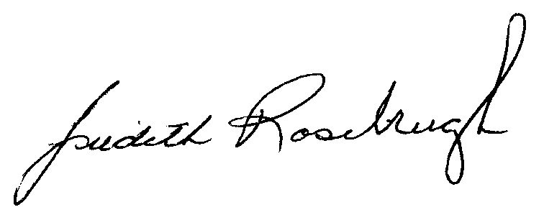
Judith Rosebrugh
Wellington North Power Inc.

