April 3, 2008

Ontario Energy Board
P.O. Box 2319
2300 Yonge Street
26th Floor
Toronto, Ontario
Attn: Ms. Kirsten Walli
Board Secretary

Dear Ms. Walli

Re: OEB File No. EB-2007-0530: Norfolk Power Distribution Inc. Application to the Ontario Energy Board (the “OEB”) for Electricity Distribution Rates and Charges as of May 1, 2008 – Final Submission

With respect to Procedural Order No. 3, dated February 28, 2008, which states that if Norfolk Power Distribution Inc. wishes to respond to a submission, the response must be filed with the Board and delivered to Intervenors by March 31, 2008.

Norfolk Power Distribution Inc. wishes to advise the Board that due to unforeseen events, it is unable to meet the filing requirement date. We have been working diligently to complete our final submission and have determined it will not be ready to file until April 9, 2008.

If you have any questions, please contact the undersigned at 519-426-4440, extension 2264.

Yours truly,
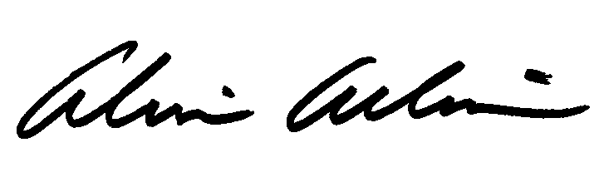

Alvin E. Allim
Manager of Finance
PO BOX 588, 70 VICTORIA STREET • SIMCOE, ONTARIO • N3Y 4N6
Phone: 519-426-4440 • Fax: 519-426-4514

