200 – 395 Centre St N, Huntsville, ON P1H 2M2
Phone (705) 789-5442 Toll Free 1-888-282-7711
Fax (705) 789-3110 service@lakelandpower.on.ca

August 17, 2012

Ontario Energy Board
P.O. Box 2319
2ih Floor, 2300 Yonge Street
Toronto, Ontario
M4P 1E4
Attention: Ms. K. Walli, Board Secretary

Re: Lakeland Power Distribution Ltd. 2013 Cost of Service Application, OEB-2012-0145

Dear Ms. K. Walli:

Lakeland Power Distribution Ltd.(LPDL) is scheduled to file a Cost of Service Rate Application for 2013 Electricity Distribution Rates and remains committed to submitting a complete application that conforms to the most recent filing requirements issued by the Board.

As of today’s date, LPDL is not yet in a position to file its 2013 Cost of Service Application. The 2013 IFRS deferral and related MIFRS issues as well as the late July release of the OEB Cost of Service Models have contributed to the delay.

In order to prepare a thorough application LPDL sincerely regrets that we will not be able to meet the August 31, 2012 filing deadline. LPDL will continue to work diligently to submit the application on or before September 28, 2012.

Respectfully Submitted,

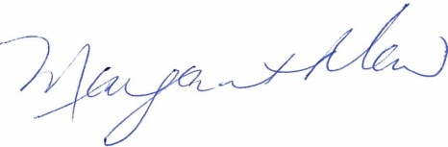

Margaret Maw
Chief Financial Officer
Lakeland Power Distribution Ltd.

