

Proposal for MDM/R Integration and TOU Billing to Erie Thames Power

June 30, 2010

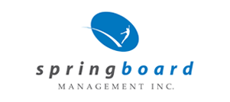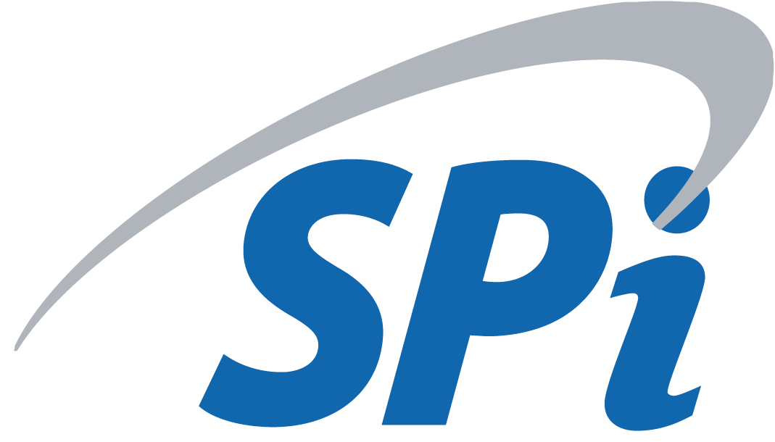

Confidentiality Statement
The material contained in this document is proprietary to The ERTH Group of Companies. This material may not be disclosed, duplicated, or otherwise revealed, in whole or in part, to any party other than Goderich Hydro, without prior written consent. In no event shall The ERTH Group of Companies be liable to anyone for special, incidental, collateral, or consequential damages arising from the use of this information.
This information has been provided in confidence to Goderich Hydro for the purpose of evaluating a proposed services offering.
Table of Contents

Executive Summary 4
Understanding of Goderich Hydro’s Requirements 4
Deliverables included in Proposal 6
Test Planning – Test Matrices and Test Data 6
Requirements Documentation 6
System Readiness 6
Test Execution 6
MDM/R Cutover 7
Customer and Customer Service Representatives Portal Implementation 7
Software used for Project Management 7
Business Process Re-engineering 8
AS2 Software Configuration 8
Staff Training and Customer Communication 9
Project Team Profile 9
Pricing 11
Appendix A - Corporate Overviews 12
ECALIBER Inc. 12
The SPi Group Inc. 12
Springboard Management Inc. 13
Appendix B - Proof of Ability (Qualifications and Client References) 15

Executive Summary
The ERTH Group of Companies (ERTH) submits the following proposal for all MDM/R integration activities and rollout of TOU Billing for Goderich Hydro. The ERTH Group of Companies are in a unique position to deliver a complete turn key solution for MDM/R Integration. Each of the companies brings their core expertise and experience in Harris customer information system (CIS), meter data Management and repository (MDM/R) implementation, business process re-engineering and test planning and execution.
This detailed document will provide an in-depth description of the services being proposed.

Project Management activities will continue to be provided as per the E360 proposal dated May 7, 2009, however such services will be delivered by Jay Lee of the SPi Group Inc. Jay is currently the Project Manager for West Perth Power and Erie Thames Powerlines therefore I’m confident that you will be pleased with his qualifications and experience in this area.

The following document will provide a detailed overview of the services being proposed. ECALIBER will be responsible for execution of all system and patch upgrades, setups and test execution. The SPi Group Inc. (SPi) will provide system modification assessments, test plans, as well as resources that will assist with all facets of testing, including unit testing, system integration testing and qualification testing. E360 will assist Goderich Hydro with customer communication and staff training. Springboard Management Inc. (Springboard) will take the lead on business process reengineering that will be a requirement as Goderich Hydro demonstrates readiness to the IESO. Additionally, ERTH will be utilizing the Springboard software products to ensure visibility of the project activities and rollout of training to staff. By using ERTH services, Goderich Hydro will ensure the full integration to the IESO’s provincial MDMR, thereby ensuring that Goderich Hydro is compliant with the provincial regulations related to the smart metering initiative.

ERTH has developed a methodology to allow for cost sharing amongst Goderich Hydro, Erie Thames Powerlines, Clinton Power, and West Perth Power. We feel that leveraging a shared services model will allow Goderich Hydro to benefit from the expertise being learned from the West Perth pilot program and a reduced cost by utilizing similar business processes and implementations. By working together, we can develop the best method of handling the forthcoming changes in a time and cost effective manner.

This proposal reflects system upgrade costs as well as resources to deliver a turn key solution. The total cost of the proposed solution is $25,500 Canadian plus applicable taxes.

The following proposal outlines our understanding of Goderich Hydro’s needs and our project deliverables.

Understanding of Goderich Hydro’s Requirements
The Ontario government has mandated MDM/R integration and TOU billing by June, 2011. In order to accomplish this, the following objectives must be achieved:
- Develop and document revised business processes encompassing all daily activities involving meter to cash with the existing systems and metering infrastructure
- Identify any further systems, programs, processes or resources required
- Execute CIS system upgrades required for MDM/R integration
- Successfully complete all testing required for MDM/R integration, including unit testing, SIT, QT and Cutover
- Install and configure AS/2 for MDM/R connectivity
- Select technologies and vendors for bill and data presentment customer portal
- Implementation of all new business processes
- Billing from MDM/R
- Billing using TOU rates

Deliverables included in Proposal

Test Planning – Test Matrices and Test Data
SPi has experienced Business and Quality Assurance Analysts that are currently leading the effort in developing test plans for Oshawa PUC and the ERTH LDCs for the MDM/R enrollment process. The test plans include test matrices, automated processes and test data. The test plans also cover many aspects of both the System Integration Testing and the Qualification Testing such that, when a utility goes through these tests with the IESO, the problems encountered are minimal to none. As part of this proposal, Goderich Hydro will have access to these test plans.

Requirements Documentation
SPi has performed an evaluation of MDM/R integration requirements and compiled an assessment of the system requirements for MDM/R connectivity. As part of this proposal, the Requirements Document will be available to Goderich Hydro.

System Readiness
ECALIBER has done a thorough review of the system requirements associated with MDM/R connectivity and identified various system upgrades associated with MDM/R integration. ECALIBER will be performing a system upgrade to ensure Goderich Hydro’s readiness for MDM/R connectivity. ECALIBER will also be responsible for all new system setups and key value configurations associated with the new tables and programs within the Harris Customer Information System. Additional data directories will also be created to allow for interfaces between the CIS, AMI and MDM/R. Thorough testing will be conducted as these new system upgrades are deployed, thereby ensuring that existing business processes are not negatively impacted.

At time of TOU Rollout, ECALIBER will complete all system setups and meter configuration changes. This will include implementation of TOU buckets on the electric meter positions, rate setups, appropriate flagging on customer meters for TOU billing and bill print modifications for TOU billing.

Test Execution
Once connectivity testing is completed, SPi will coordinate the internal unit testing which will be conducted by ECALIBER and SPi resources. The purpose of the internal unit testing is to simulate production environment by sending and receiving a small subset of the various MDM/R interface files, including USDP ID requests, meter data, synchronization files, and billing quantity data.

The test execution will involve participation by staff of Goderich Hydro. SPi will facilitate meetings to review the test plan that will identify which parties involved in the various test scenarios and identify critical timing of execution of each party’s role in the testing (i.e. the next step in the test scenario depends on the completion of the previous step).

As the timelines to complete the system integration testing and the qualification testing are tight, SPi will work with all internal stakeholders and the IESO to prepare for the execution of the testing. These tests are very regimented by the IESO, and therefore it is important for SPi to ensure all parties are prepared to participate as needed.

MDM/R Cutover
Once Goderich Hydro passes qualification testing, ECALIBER will work with Goderich Hydro to develop a Cutover strategy. This strategy includes identifying the initial set of smart meters that will be enrolled with the production MDM/R (we recommend between 50 – 200 meters and ideally all meters should be on the same billing cycle). ERTH will review the Cutover strategy with the IESO, and make any adjustments as required. SPi will then coordinate all of the parties to ensure their participation in the Cutover execution.

Following Cutover, SPi will ensure that all of the vendors are available to provide support and assist Goderich Hydro in developing a plan to enroll the remaining smart meters with the MDM/R.

Customer and Customer Service Representatives Portal Implementation
The project manager will provide options currently available within the market for Goderich Hydro to select from. The costs of the software and any required development or set up work to integrate with the CIS are not included in this proposal.

Software used for Project Management
SPi will leverage Springboard’s proprietary software for our project management services. This software provides the following benefits to the project:
- Live access to the timeline and the ability to comment and ask questions online.
- Ability to capture the approval of your multi-departmental process flows and prove key stakeholders has approved the content.
- Documentation of the procedures and evidence that they have been approved and kept current throughout the entire project lifecycle.
- Communication of the requirements of the new process to staff as they need to know.
- Visibility of the level of compliance your entire staff has on the overall project.
- Live access to the issues list and ability to comment and ask questions online.
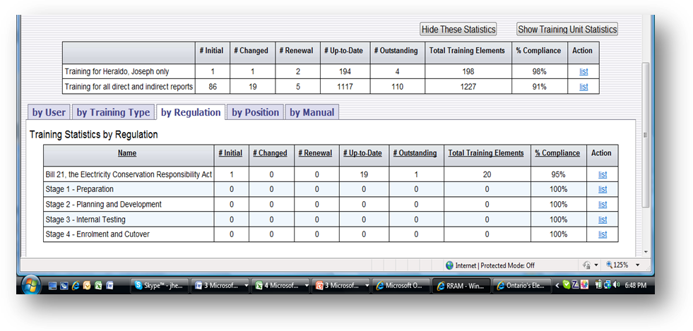
This product has been used in a number of projects including Smart Meter MDM/R integration for Oshawa PUC, Erie Thames Powerlines, and West Perth Power.

Bringing overall governance to Goderich Hydro’s MDM/R Initiative provides assurances that Goderich Hydro’s project is being completed on time and within scope. This approach allows the organization to prove diligence and be completely transparent throughout the execution of the plan and beyond.

The IESO has used this tool to view relevant information related to the MDM/R integration with previous projects and appreciates its transparency. From the acceptance of the project plan to viewing process changes, everything is tracked and auditable within the Springboard Product Suite.

Business Process Re-engineering
The business processes review is a critical component of the MDM/R integration. Springboard will leverage the business processes from previous MDM/R projects as a foundation for the pre and post improvement business process reviews and gap assessment. The ERTH Group analysis team has significant experience in this area that offers a distinct advantage on this project. The pre-improvement and post-improvement methodology to create, review and manage changes related to business processes will demonstrate to staff and the design team the before and after state of the organization’s implementation for the MDM/R integration and will serve as the tool for identifying system, program, process and resource constraints. The real value in the exercise is ensuring that all stakeholders sign off and endorse the design of new processes.

BEFORE AFTER

ERTH has an established change management methodology that ensures this level of diligence.
This infrastructure will form the basis of work instructions and procedures that speak with the appropriate level of detail to the organization’s staff. Springboard’s approach to workflow meets the intent of the IESO, and has been successfully used in other projects.

AS2 Software Configuration
ECALIBER will purchase an AS2 server and licensing and share the cost of such server and configuration across the shared services model. Ongoing hosting and maintenance fees for this server will be included in your ECALIBER billing fee. Additionally, SPi will coordinate with the IESO to execute the AS2 connectivity testing between Goderich Hydro and the various MDM/R environments (sandbox, enrollment, production, etc.) and AMI AS2 system. SPi will ensure that the appropriate configuration and test data information (various URLs, digital certificates, test files to be used during connectivity testing, etc.) are sent to the IESO prior to connectivity testing. SPi will coordinate the testing with the IESO and their vendor, IBM.

Staff Training and Customer Communication
Prior to beginning to issue bills, Goderich Hydro will need to ensure that communication takes place with its customers. Jeff Quint will work with Goderich Hydro to create a full communications plan for your customers. Jeff is currently working on this initiative and communications for Erie Thames Powerlines.

Goderich Hydro’s customer service employees will need to be well versed in TOU rates and the impact of smart meters on the average customer. Jeff will provide staff training for Goderich Hydro’s customer service specialists to facilitate response to such customer concerns.

Project Team Profile
Jay Lee –Project Manager

Jay is currently the Director of Solution Development for The SPi Group Inc. and is well known in the industry though his involvement in leading the OEB - EBT Working Group. Jay is currently the Project Manager for the MDM/R implementation work with Erie Thames Powerlines, West Perth Power Inc., Goderich Hydro Inc., and Clinton Power Inc. Jay is well versed in the MDM/R implementation processes and will provide ongoing project management to the team. In addition to project managing these projects, Jay is also a key member of a team that is working on documenting and improving West Perth Power’s business processes. Jay has attended all the important IESO workshops, including MDM/R and TOU Preparation, MDM/R Technical Series, and Business Process Development.

Laurie Palmer – Consultant

Laurie is the VP-Solutions Development for ERTH Corporation and oversees the ECALIBER division. Laurie brings expertise in business process automation, industry regulations, and utility software solutions to ERTH Corporation. Laurie earned her Bachelor of Commerce Degree in Management Economics from the University of Guelph and has devoted more than 10 years to the utility industry. During that time she served on the Market Readiness Task Force with the Ontario Energy Board, where she led retail market testing for Harris Customer Information Systems (CIS). Laurie has also led the integration efforts between the Harris CIS and Utilismart’s ODS to produce a Time of Use bill. She has attended several training sessions on Smart Meter Implementation

Kim Ellis – Customer Solutions Manager

Kim is the Customer Solutions Manager for ECALIBER and oversees the day to day billing, customer service, collections and payment processing functions for those utilities covered under this shared services model. Kim has over 18 years of experience in the utility industry, utilizing the Harris product. Kim is actively involved in the business process re-engineering activities and will be an active participant in MDM/R testing activities. Kim has attended IESO workshops, including MDM/R and TOU Preparation and Business Process Development

Dana Schneider – Support Manager

Dana oversees all system testing associated with upgrades and patches and will be actively involved in all facets of MDM/R testing including Unit Testing, SIT and QT. Dana is also responsible for all system setups and Harris integration efforts. Dana has 10 years of utility experience and is an expert user of the Harris Customer Information System. Dana has attended various IESO workshops, including MDM/R and TOU Preparation, Graphical User Interface, and Business Process Development.

Cathy Lee – Analyst

Cathy is a Senior Analyst with The SPi Group Inc. and has over 10 years experience in business analysis and quality assurance. Cathy is currently involved in MDM/R integration projects, leading the efforts in creating test plans. Cathy is also a key member of the team working on the Oshawa PUC and West Perth Power business process improvements. Cathy has attended IESO workshops, including MDM/R and TOU Preparation, Graphical User Interface, and Business Process Development.

Stephen Yen – Analyst

Stephen is a Senior Analyst with The SPi Group Inc. and has considerable utility market experience. Stephen is currently involved in MDM/R integration projects as the lead technical resource for AS2 software implementation. Stephen is also a key testing resource on these projects.
Randy Fotheringham – Business Process Consultant
Randy is responsible for checking that each process reviewed is within the scope of the project and meets the standards of ERTH and Goderich Hydro. Randy is responsible to perform interviews, fact checks and document process flows as required to fulfill the needs of the project, all the while checking these unique inputs against the known requirements of the IESO and past implementations. Randy has already reviewed most business processes with the ERTH project team and will review such processes with Goderich Hydro staff.

Pricing

Service | Price
Test Planning & Scripts | $12,000
Requirements Document | $4,000
System Readiness (inclusive of setups & upgrades) | $7,500
Test Execution | $12,000
Business Process Re-engineering & Training | $16,000
AS2 Software purchase & configuration | $3,000
Total | $58,500

* Prices quoted are in Canadian funds.
* Travel expenses for on-site meetings are not included. These costs can be reduced through WebEx and other technologies for collaboration.
* Applicable taxes are not included.

Appendix A - Corporate Overviews

ECALIBER Inc.
ERTH Corporation (formerly Erie Thames Power) was formed in 2000 from an amalgamation of seven local electric public utilities. Upon amalgamation, Erie Thames Services (rebranded in late 2008 as ECALIBER (Canada) Inc.) began providing billing and other services to its affiliate Erie Thames Powerlines which has a customer base of 14,000 customers. Since that time, ECALIBER has continued to bring on new staff and clients. ECALIBER is the largest application service provider (ASP) in the Ontario electricity market, representing more than ten percent of the LDCs and approximately 180,000 customers. ECALIBER is a progressive services company, and will continue to be dedicated to the marketplace. Our growth and ability to bring cost-effective, client-requested solutions to the market has been, and will continue to be, a key factor in our success.

In Ontario’s electricity market, ECALIBER is a leading provider of ASP and billing services to local distribution companies (LDCs). Through its partnership with Harris Computers, we have developed our services into best of class expertise. With a client base of approximately ten percent of the LDCs in Ontario and approximately 180,000 customers, we have continued to develop our knowledge of the applications and of the business aspects of a utility’s back-office. ECALIBER has grown to be the largest Harris partner with approximately 40 years of combined experience with Harris on the Management team. In addition to the above benefits, it is important for ECALIBER clients and potential clients to consider the following:

- The ECALIBER team is comprised of individuals with extensive utility backgrounds, all of whom were directly involved in market readiness in 2002, and have in-depth knowledge of all billing and customer service aspects of the electricity distribution company.
- ECALIBER is an ISO 9001:2000 registered company that embraces the concept of continuous improvement for all of its services.
- The strong partnerships that ECALBER maintains with its systems vendors results in regular improvements to the systems based on suggestions made by ECALIBER and its clients.
- With ECALIBER’s in-house technical expertise, custom queries and reports can be developed at a fraction of the cost of software development.

The SPi Group Inc.
The SPi Group Inc. (SPi) is a provider of innovative solutions that enable evolving energy markets. SPi was created in early 2002 to facilitate the deregulation of the Ontario electricity market. SPi's role in the deregulation process was to provide transaction clearinghouse services to over 70 local distribution companies and retailers (over 80% of the market by volume). On March 4, 2002, the Ontario electricity market's IT systems went live simultaneously using SPi's Electronic Business Transaction (EBT) Hub services and spoke integration products to enable market connectivity from end-to-end. SPi's clearinghouse services in Ontario process approximately 40 million transactions per year, supporting one of the largest deregulated electricity markets in North America.

Products and Services
SPi's offerings have grown since market opening to include project management, custom development, and quality assurance and testing services, retailer managed billing and settlement services for energy market participants, and products and services supporting gas and electricity markets in multiple North American jurisdictions.

SPi’s wide range of service offerings include:
- Project Management Services and Support
- Preparation and Implementation Services for the Ontario MDM/R
- Consulting and Software Development
- Ontario Electricity Market Services (EBT Hub)
- Retailer Managed Billing and Settlement Services
  - Ontario
  - US Markets
- Gas Market Services
- Technology Licensing
- OPA Demand Response Program
SPi offers a diverse set of products including:
- EBT Hub Connector (EHC)
- Gas Market Connector (GMC)
- EBT Viewer
- Account Viewer
- EBT Exception Viewer
- Customer Billing and Settlement System
- XML Generator
- EBTx Hub Client

Headquartered in Toronto, Ontario, Canada, SPi is staffed by a team of professionals with expertise in project management and custom software development, energy market development and operations, billing and settlement and transaction management.

Springboard Management Inc.
Springboard Management Inc. (Springboard) was formed and incorporated in the province of Ontario in 2004. With locations in Windsor and London, Springboard has experienced dynamic growth in its short history.

We offer the service of integrating processes and to align them with strategic needs of your business to give you a tailored process for your unique business requirements. We provide a service which integrates best practice methodologies and our expertise in academic theory combined with years of practical experience in your utility industry which enables us to deliver the very best business process for your business.

Effective business processes are essential to the success of the smart metering initiative. We give you the choice of selecting which business processes you require and develop a combined business process which suits your business.

We provide quality consulting services specializing in Management system implementation as well as regulation and risk Management solutions and process improvement. Working with our customers, Springboard develops operationally efficient solutions that allow organizations to function optimally and demonstrate compliance to regulatory requirements such as OHSAS 18001, Z1000, WSIB, ISO 9001, DWQMS, OEB Regulations, and ISO / IEC 17025.

Products and Services

In today’s competitive business environment, safety, productivity, and operational efficiency are essential to all corporate activities. In an effort to help organizations achieve these goals, Springboard has developed standardized approaches to Management system implementation and project Management. Using proven methodologies, our team offers real-world consulting services including:

- Process Improvement, baseline data collection and business process analysis
- Management system improvement and implementation
- Policy and procedure development and life-cycle Management
- Training in Management system and audit performance
- Risk assessment training and coordination
- Guidance on efficient allocation and use of corporate resources
- Coordination of corporate integration and change Management
- Process improvement and implementation of best practices
- Examples of combined business processes
- Risk and Value Management
- System Analysis and Functionality
- Asset Functionality and Risk Management
- Lean thinking and Value Engineering
- Lean thinking and Risk Management
- Asset Management & SPRINGBOARD MANAGEMENT INC. (Smart Metering Initiative implementation)

Springboard’s customer service approach recognizes that solutions must be developed in cooperation with key personnel within an organization. This methodology facilitates the design of a customized solution that meets the specific requirements of the project and corresponds with the organization’s culture and climate. As consultants, our goal is to combine our knowledge, skills, and expertise with the experience of our customers’ employees, and to provide leadership and project-specific training that meets their needs and supports long-term success.

ERTH Corporation
ERTH Corporation is a dynamic family of energy companies with a strategic vision to grow and invest in parallel businesses that all serve North America’s energy and utility industries. The group’s electricity distribution, services, consulting and software companies, service over 180,000 customers in Canada and the United States.

Appendix B - Proof of Ability (Qualifications and Client References)
Company Name | Contact Information For Reference  (Name, Phone, E-mail)
West Perth Power Inc. | Wally Curry  President & CEO  Tel: 519-348-8458  wcurry@westperth.com
Oshawa PUC | Atul Mahajan  CEO  Tel: 905-743-5210  amahajan@opuc.on.ca

