
200 – 395 Centre St N, Huntsville, ON P1H 2M2
Phone (705) 789-5442 Toll Free 1-888-282-7711
Fax (705) 789-3110 service@lakelandpower.on.ca

September 24, 2012

VIA MAIL and E-MAIL
Ms. Kirsten Walli
Board Secretary
Ontario Energy Board
P.O. Box 2319
2300 Yonge Street
Toronto, ON
M4P 1E4

Dear Ms. Walli:

RE: Lakeland Power Distribution Ltd.
EB-2012-0145
2013 Cost of Service Rate Application
Update to Fixed Monthly Charge for microFIT Generator Service Classification

Lakeland Power Distribution Ltd wishes to confirm that it is seeking to adopt the default value of $5.40 per month for the fixed monthly charge related to microFIT Generator Service Classification. The additional revenue that will be generated by this increase is $3.45 per month or $41.40 per year (currently 23 microFIT customers).

If you have any further questions, please do not hesitate to contact me.

Respectfully submitted,

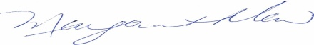

Margaret Maw
CFO
Lakeland Holding Ltd.

