Wellington North Power Inc.
290 Queen Street West, P.O. Box 359
Mount Forest, ON N0G 2L0
Phone: 519-323-1710 Fax: 519-323-2425
wnp@wellingtonnorthpower.com

March 1, 2007

Ontario Energy Board
Attention: Kristin Walli, Board Secretary
P.O. Box 2319
27th Floor
2300 Yonge Street
Toronto, ON M4P 1E4

Dear Ms. Walli,

Re: Wellington North Power Inc. 2007 Distribution Rate Applications EB-2007-0587

Wellington North Power inc. is responding to Board staff request for clarification regarding the company’s 2007 Distribution Rate Application Board File No. EB-2007-0587

(1) Monthly Rates and Charges for General Service 50 to 4,999 kW Time of Use
A review of your current 2006 Board approved Tariff of Rates and Charges indicates that the entry for Retail Transmission Rate – Network Service Rate and for Retail Transmission Rate – Line and Transformation Connection Service Rate should each include the descriptor “Interval Metered”.
Response:
Wellington North Power Inc. had the correct descriptor “Interval Metered” information in the description portion at the top of Sheet 3 for the Retail Transmission Rate – Network Service Rate and the Retail Transmission Rate – Line and Transformation Connections Service Rate. Wellington North Power would like to clarify that this was a transcription error only and was not meant to change the detail, classification or rates applied for by the distributor.

(2) Monthly Rates and Charges for Allowances
A review of your current 2006 Board approved Tariff of Rates and Charges indicates that the dimension for Transformer Allowance for Ownership should be “$”, rather than $/kW.
Response:
Wellington North Power Inc. would like to clarify that the Transformer Allowance for Ownership input on Sheet 3 of the 2007 Rate Application Model should have been a “$”. This data should not have been entered as $/kW and was a transcription error by Wellington North Power Inc.

(3) Monthly Rates and Charges for Unmetered Scattered Load
A review of your current 2006 Board approved Tariff of Rates and Charges indicates that the Service Charge should include the descriptor “(per customer)”.
Response:
Wellington North Power Inc. would like to clarify that the descriptor “(per customer)” was omitted in error from Sheet 3 of the Distribution Rate Application Model

(4) Monthly Rates and Charges for Unmetered Scattered Load
A review of your current 2006 Board approved Tariff of Rates and Charges does not indicate any Rate Rider of 0.0028 $/kWh.
Response:
Wellington North Power Inc. would like to clarify that the 0.0028 $/kWh on Sheet 3 of the 2007 Distribution Rate Model was incorrectly allocated. The rate should have been listed as a Regulatory Asset Recovery not a Rate Rider. This was a transcription error only.

(5) Monthly Rates and Charges for Unmetered Scattered Load
A review of your current 2006 Board approved Tariff of Rates and Charges indicates that the value for Regulatory Asset Recovery should be “0.0028”.
Response:
Wellington North Power Inc. would like to clarify that the 0.0028 $/kWh on Sheet 3 in the 2007 Distribution Rate Model was incorrectly allocated. The rate should have been listed as a Regulatory Asset Recovery not a Rate Rider. This was a transcription error only.

(6) Monthly Rates and Charges for Sentinel Lighting
A review of your current 2006 Board approved Tariff of Rates and Charges indicates that the Service Charge for each should include the descriptor “(per connection)”.
Response:
Wellington North Power Inc. would like to clarify the descriptor “(per connection)” was omitted in error on Sheet 3 of the 2007 Distribution Rate Model. The correct descriptor was in the detailed description at the top of Sheet 3 but missed in the lower section of the Sheet and is a transcription error.

(7) Monthly Rates and Charges for Street Lighting
A review of your current 2006 Board approved Tariff of Rates and Charges indicates that the Service Charge for each should include the descriptor “(per connection)”.
Response:
Wellington North Power Inc. would like to clarify the descriptor “(per connection)” was omitted in error on Sheet 3 of the 2007 Distribution IRM Model. The correct descriptor was in the detailed description at the top of Sheet 3 but missed in the lower section of the Sheet and is a transcription error.

The above responses are to provide clarification that the omissions in the Wellington North Power Inc. 2007 Incentive Rate Adjustment Model on Sheet 3 were simple transcription errors.

Please notify the undersigned if the Board requires the applicant to file a revised version of the 2007 IRM model or if there is a need for any further clarification.

Yours truly,
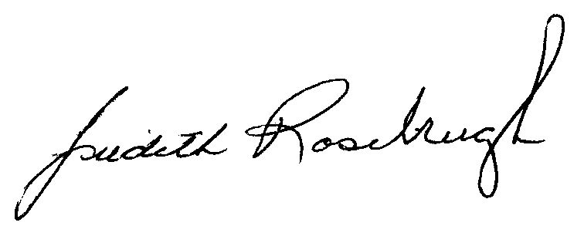
Judith Rosebrugh, Secretary-Treasurer/Administrator
Wellington North Power Inc.

cc: alison.cazalet@oeb.gov.on.ca
stephen.shields@oeb.gov.on.ca

