April 14, 2008

Ms. Kirstin Walli
Board Secretary
Ontario Energy Board
P.O. Box 2319
2300 Yonge Street, 27th Floor
Toronto, ON M4P 1E4

Re: EB-2007-0864 2008 IRM - Recovery of Low Voltage Charges

Dear Ms. Walli:

Newbury Power Inc. (NPI) had received approval from the Board in the above noted application to recover low voltage charges from their customers. The Board decision had stated that these charges were to be recovered over a one year period.

NPI has informed the Board, by way of letter dated April 4, 2008, that the low voltage charges are on going charges from Hydro One Networks Inc.

NPI is informing the Board that they will continue to maintain the low voltage variance account (Acct 1550). They will also request for continued collection of the low voltage charges in rates as part of the 2009 IRM rate setting process because they are on going charges. When NPI files for rate rebasing they will seek approval for disposition of the low voltage variance account.

Should there be any questions, please contact me at the number below

Yours truly,
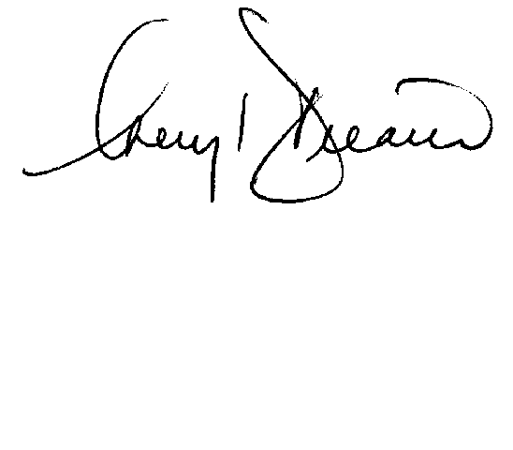

Cheryl Decaire
Co-ordinator of Regulatory and Rates
(519) 352-6300 ext 405
Email: cheryldecaire@ckenergy.com

CC: Jim Hogan, Chief Financial Officer, Chatham-Kent Energy

