January 21, 2013
Board Secretary
PO Box 2319
27th Floor 2300 Younge Street
Toronto, Ontario Canada
M4P 1E4

Dear Ms. Walli

During our year-end review, Atikokan Hydro has discovered that smart meter charges that were to stop on April 30, 2012 as per Board Decision and Order on EB 2010-0064, in fact continued until Aug 31, 2012. As a result, Atikokan Hydro over collected an amount of $23,192 from its customers, for the period of May 1, 2012 to August 31, 2012.

Atikokan Hydro is in the process of filing a standalone smart meter application, as directed in Board Decision and Order 2011-0293. Atikokan Hydro has advised the Regulatory Audit and Accounting branch of the OEB of this issue and will be working with the Regulatory Audit and Accounting group confirming that amount and the period of over collection.

Atikokan Hydro proposes that the money collected from the customers beyond April 30, 2012 be refunded to the customers as part of its standalone smart meter application.

Sincerely
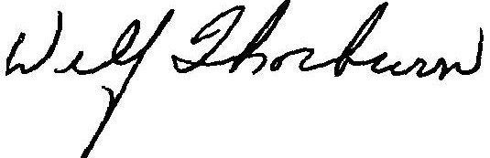

Wilf Thorburn
CEO / Sec / Treas
Atikokan Hydro Inc.

cc Daria Babaie
Regulatory, Auditing and Accounting
Ontario Energy Board

