January 21, 2013
Board Secretary
PO Box 2319
27th Floor 2300 Younge Street
Toronto, Ontario Canada
M4P 1E4

Dear Ms. Walli,

On page 31 of the Board’s Decision and Order EB-2011-0293, the Board stated:

“The Board will accept VECC’s proposal and allow for recovery of 50% of the requested smart meter costs at this time. The Board will direct the Regulatory Accounting and Audit branch of the Board to conduct an audit of Atikokan’s smart meter costs. The results of the audit will be considered by the Board with respect to the final amounts to be authorized for recovery in a future application to be filed by Atikokan no later than 6 months from the completion of the subject audit.”

The Regulatory Accounting and Audit branch of the Board have completed their audit, and Atikokan Hydro respectfully requests a file number to submit a Smart Meter application as directed.

Sincerely
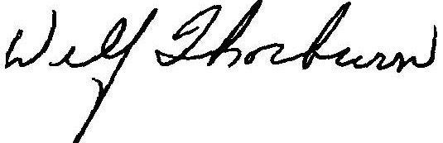

Wilf Thorburn
CEO / Sec / Treas
Atikokan, Hydro Inc.

