380 Armour Rd. Suite 264
Peterborough, ON K9H 7L7
705-743-1500

January 29th, 2013

Ontario Energy Board
P.O. Box 2319
2300 Yonge Street, 27th Floor
Toronto ON M4P 1E4
1-888-632-6273
Attention: Board Secretary
Re: EB-2013-0029
Dear Ms. Kirsten Walli,
The Ontario Waterpower Association would like to formally request the opportunity to obtain “observer” status in the proceedings for case EB-2013-0029 (NOTICE OF APPLICATION AND ORAL HEARING APPLICATION TO REVIEW MARKET RULE AMENDMENTS RENEWABLE ENERGY SUPPLY GENERATORS).

Thank you for your time and consideration.
Sincerely,
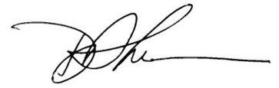
Paul Norris
President
Ontario Waterpower Association
pnorris@owa.ca

