
March 2, 2007

Kirsten Walli
Board Secretary
Ontario Energy Board
PO Box 2319, 27th Floor
2300 Yonge Street
Toronto ON M4P 1E4

Dear Ms. Walli:

RE: Middlesex Power Distribution Corporation 2007 Distribution Rate Application
Board File No EB-2007-0553

Concerning Tariff of Rates and Charges sheet 3 and sheet 10 of the 2007 IRM Model, the rating dimensions of the original file appears as $/kWh. The dimensions for the Distribution Volumetric Rate, Regulatory Asset Recovery and all Retail Transmission Rates for General Service 50 to 4,999kW, Large Use, Sentinel Lighting and Street Lighting should be $/kW.

If you have any questions or concerns, please do not hesitate to contact me.

Yours truly,
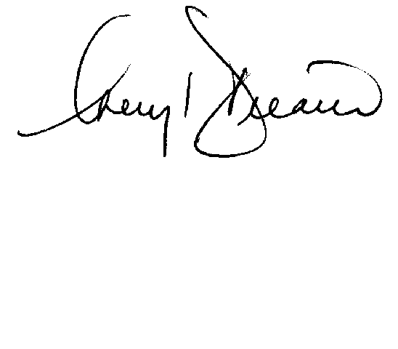

Cheryl Decaire
Coordinator Regulatory and Rates

