**Appendix E – 4, SEC #27**

**SEC #27:**

*SEC 27 [Ex. 4, P. 81.] Please provide all reports, presentations, memos or similar documents provided to senior management or to the Board of Directors related to the establishment of the Project Management Office for IT, including any business case and any amendments to it. Please provide a description of how projects were managed differently prior to the introduction of the PMO.*

**Response SEC #27:**

1. The table identifies the timeline and documents provided to senior management and to London Hydro’s Board of Directors regarding the establishment of the Project Management Office for IT.

|  |  |  |  |  |
| --- | --- | --- | --- | --- |
| **Date** | **Audience** | **Who** | **Purpose** | **Related Documentation (Attached)** |
| Sept, 14th, 2009 | Executive Presentation | PA Consulting | Present findings and recommendations. Key recommendation: “Implement and staff a Program Management Office (Enterprise PMO)” | Copy of the presentation has not been attached due to Client Confidentiality agreements however the key findings are provided in b) below |
| Dec. 22nd, 2009 | Presentation to Board | CEO | To seek approval for creation of Enterprise PMO. | Memo and Briefing to Board from CEO - see Item 1 below. |
| January 2010 | CEO | VP - HR, CEO | To hire Program Director to lead the PMO | Staff requisition - see Item 2 below |

1. We have extracted Page 15 from the PA consulting report and conducted a self-assessment to illustrate the difference after establishment of the PMO (see below).

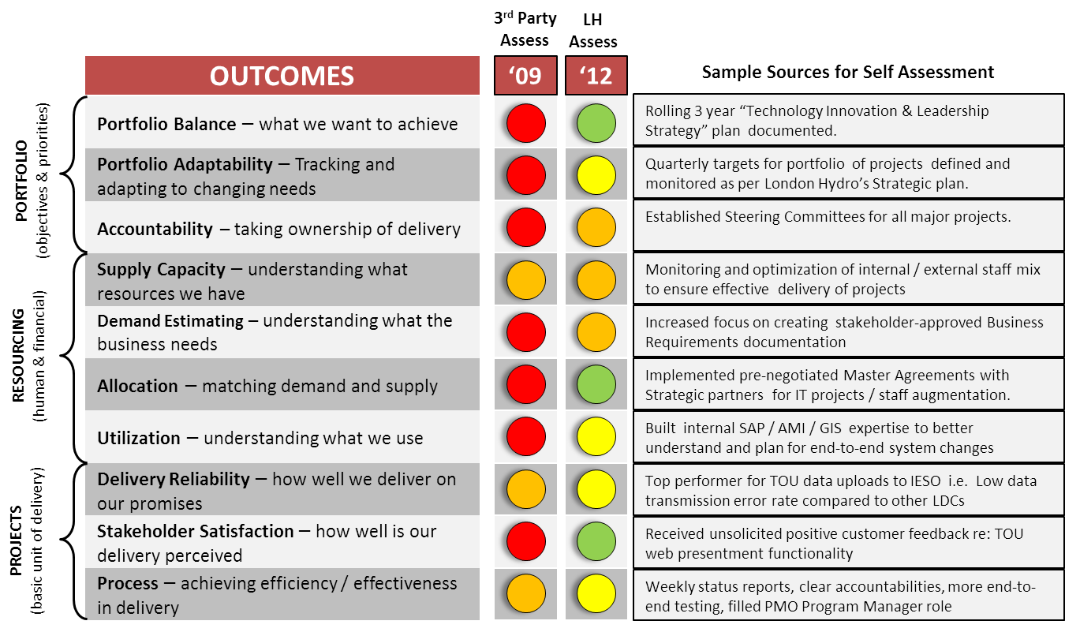



**Item 1 – Memo and Briefing to London Hydro Board of Directors**

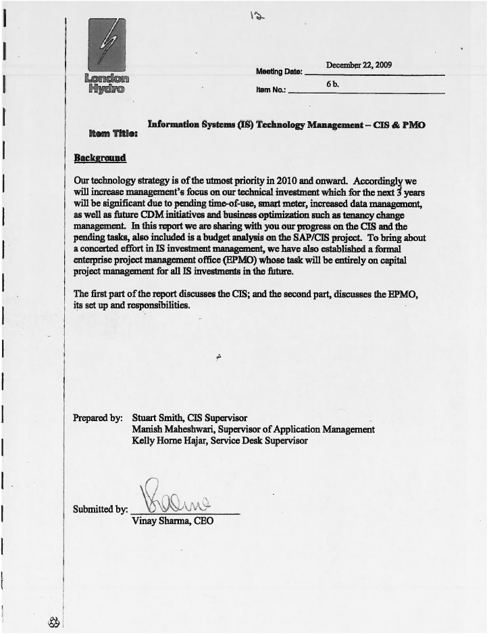

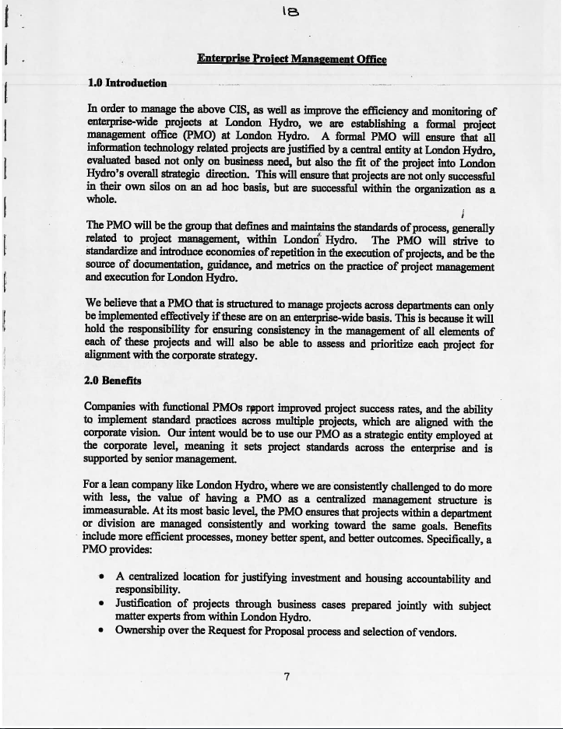

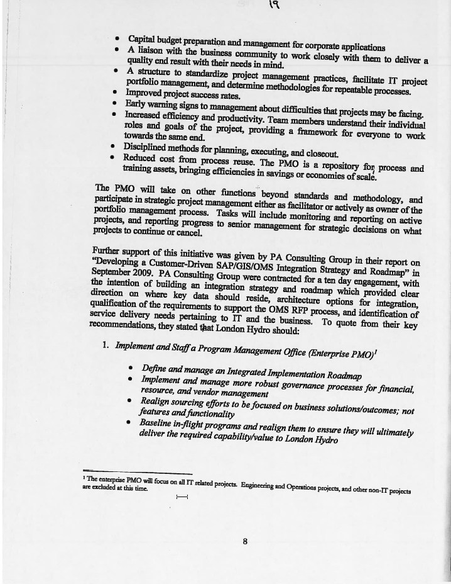

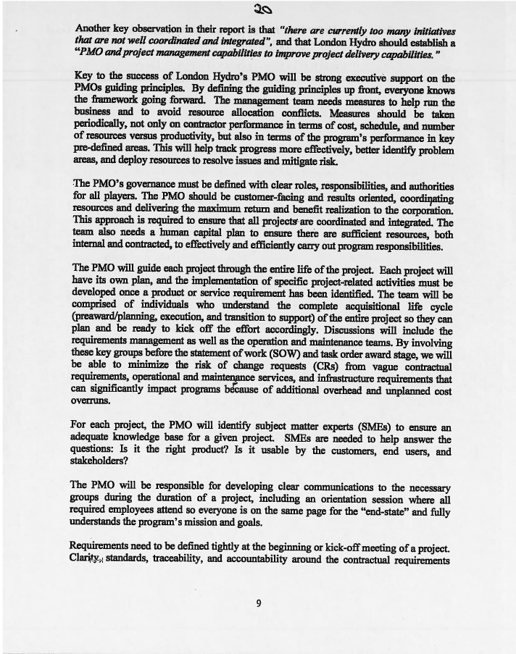

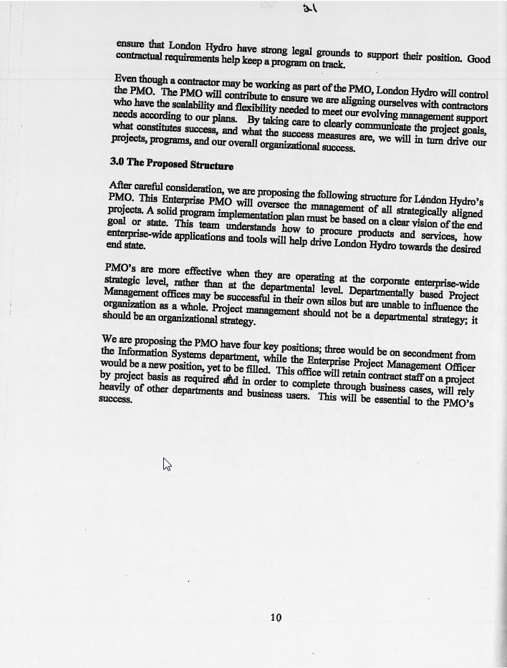

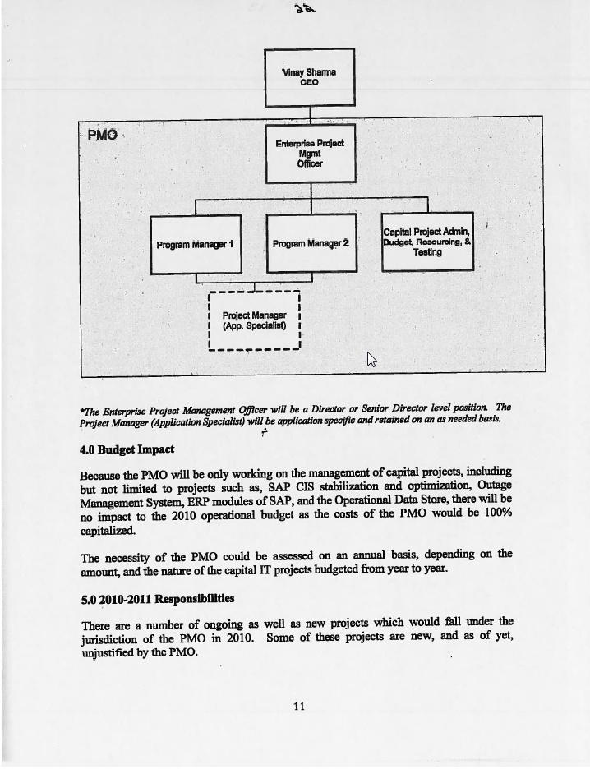

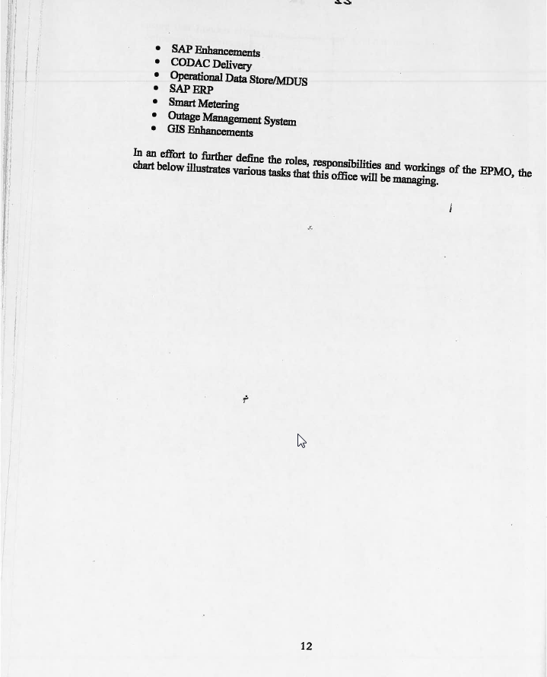

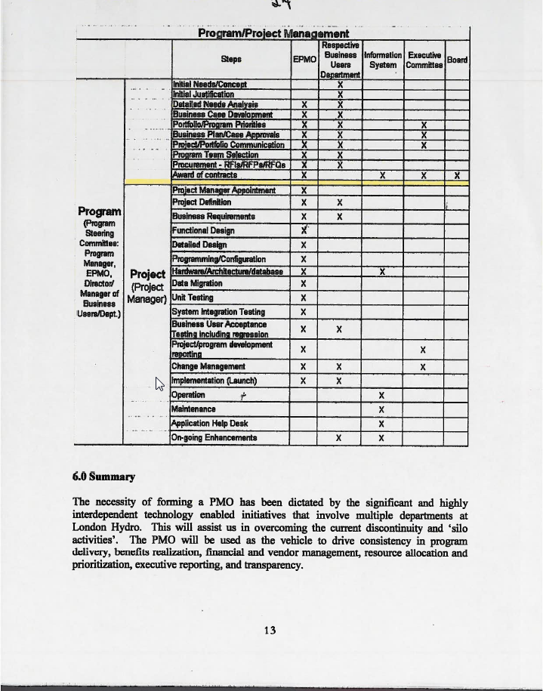



**Item 2 – Staff Requistion for Program Director**

