February 14, 2013

Ms. Kirsten Walli
Board Secretary
Ontario Energy Board
PO Box 2319
2300 Yonge Street
Toronto, ON M4P 1E4

Dear Kirsten;

Re: West Coast Huron Energy Inc.
EB-2012-0175 2013 Cost of Service Application

West Coast Huron Energy Inc. Submitted an application for 2013 Distribution Rates on November 28, 2012.

On December 17, 2012 West Coast Huron Energy received a letter from the Board indicating that based on a preliminary review of the application certain sections of the evidence did not comply with the Board’s Filing Requirements.

The attached information addresses those omissions. This information will also be filed on RESS and paper copies submitted to the Board Secretary.
If you have any questions, please do not hesitate to contact me.

Respectfully submitted,

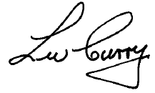

Wally Curry
Vice President of Strategic Relationships
ERTH Corp.

