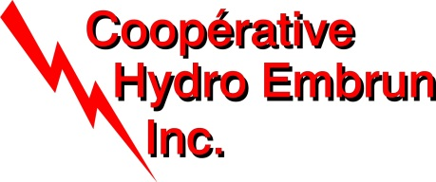

Cooperative Hydro Embrun

821 Rue Notre Dame

Embrun, ON, K0A 1W1

March 7, 2013

Ms. Kirstin Walli

Board Secretary

Ontario Energy Board

P.O. Box 2319

2300 Yonge Street, 27th Floor

Toronto, ON M4P 1E4

**Re: Request for Data to Support Empirical Work including Total Cost Benchmarking and an Ontario Total Factor Productivity Study Defining & Measuring Performance of Electricity Distributors.**

Dear Ms. Walli:

Please find attached Cooperative Hydro Embrun (“CHE”)’s information in response to the Board’s empirical work on the electricity distribution sector.

As per instructed by the Board in its February 26th letter, CHE has completed all applicable sections of the workbook specifically “Tab 2 – Smart Meter Investment Data”.

As it relates to HV and LV costs, CHE notes that it does not own any HV equipment and that its balance in USoA account 1815 is zero. CHE also notes that it was not identified as one of the 24 host distributors in the province (as listed at page 3 of the letter). As such, CHE has not completed Tab 2 and 3 of the Excel workbook.

This application is being filed pursuant to the Board’s e-Filing Services.

Should there be any questions, please do not hesitate to contact me at the number below.

Yours truly,



Benoit Lamarche

Manager

Coopérative Hydro Embrun

821 Rue Notre Dame

Embrun, ON, K0A 1W1

Tel: 613-443-5110