SENT BY RESS & COURIER
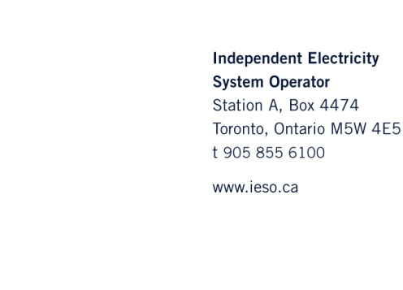
April 4, 2013

Ms. Kirsten Walli
Board Secretary
Ontario Energy Board
P.O. Box 2319
2300 Yonge Street, 27th Floor
Toronto, ON M4P 1E4

Dear Ms. Walli:

Re: Board File No.: EB-2013-0061
Notice of Intervention for the Independent Electricity System Operator (“IESO”)

Please find attached the Independent Electricity System Operator’s (“IESO”) Notice of Intervention in Board proceeding, EB-2013-0061. Two (2) hard copies of this application have been sent by courier to your attention.

Yours truly,

Original Signed by

Tam Wagner, P. Eng.
Senior Regulatory Analyst
Independent Electricity System Operator

cc (email only): Andrew Barrett, Ontario Power Generation Inc.

ONTARIO ENERGY BOARD

IN THE MATTER OF the Ontario Energy Board Act, 1998 (the “Act), S.O. 1998, thereof;

AND IN THE MATTER OF an application by Ontario Power Generation Inc. (“OPG”) seeking approval of the Reliability Must-Run agreement entered into with the Independent Electricity System Operator (“IESO”) in relation to OPG’s Thunder Bay generating station.

NOTICE OF INTERVENTION

OF THE INDEPENDENT ELECTRICITY SYSTEM OPERATOR

- The IESO received notice of the application on April 3, 2013. The IESO seeks to intervene and participate in the hearing of this matter. The IESO intends to participate by, inter alia, responding to interrogatories and participating in an oral hearing, if necessary.
- The IESO is a non-profit, non-share capital corporation established under the Electricity Act, 1998 to administer the Ontario wholesale power markets and to direct the operation and maintain the reliability of the IESO-controlled grid.
- The IESO’s responsibilities and obligations are more precisely set out in the Market Rules and the IESO’s licence (El-2008-0096) which describe, among other things, the requirements to ensure the availability of sufficient resources to provide physical services to maintain reliability of the IESO-controlled grid.
- In this proceeding, the IESO is counterparty to the Thunder Bay Reliability Must-Run agreement; thus, the IESO has a direct and substantial interest in all aspects of this proceeding.
- The IESO wishes to receive copies of all evidence filed by the applicant and intervenors. The IESO asks that copies of all filed materials be sent to the IESO at the address set out below.
- The address of the IESO is:
Independent Electricity System Operator
655 Bay Street, Suite 410
P.O. Box 1
Toronto, Ontario M5G 2K4

Ms. Tam Wagner Tel: (905) 403-4291
Fax: (905) 855-6371

Email: tam.wagner@ieso.ca

And

Ms. Reena Goyal Tel: (416) 506-2857
Fax: (416) 506-2838

Email: reena.goyal@ieso.ca
DATED at Mississauga this 4th day of April 2013.
Independent Electricity System Operator

Original Signed by

Tam Wagner
Senior Regulatory Analyst

