VIA E-MAIL & RESS

April 21, 2013

Ontario Energy Board
P.O. Box 2319
27th Floor
2300 Yonge Street
Toronto ON M4P 1E4

Attn: Kirsten Walli, Board Secretary

RE: EB-2012-0055 Enbridge 2011 Deferral Variance Accounts- FRPO Submissions

We are writing in response to Enbridge's Reply Submissions on the DRO and in support of the letter submitted by the School Energy Coalition ("SEC") both dated April 19th.

We will not re-iterate the content of the SEC letter which we adopt completely and by extension the previous submissions of the Canadian Manufacturers and Exporters ("CME"). In point of fact, unbeknownst to SEC, I personally had discussions with one of the lawyers who represents CME on April 4th. The prime focus of these discussions was concern over Enbridge's approach to the 2012 TSDA account and the appropriate response to the Board. Having reviewed the CME letter submitted April 5th, I trusted our concerns were expressed effectively and simply emailed a note of thanks to the CME author indicating our concerns were covered. Given the efficiency and effectiveness of these communications and because I did not believe that the Board needed a letter to support the CME submissions, I did not record any time allotted for cost recovery.

We trust that the relating of our experience supports SEC's letter in practical terms and informs the Board of our position in this matter.

Respectfully Submitted on Behalf of FRPO,

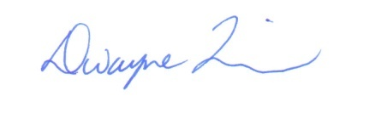

Dwayne R. Quinn
Principal
DR QUINN & ASSOCIATES LTD.

c. Interested Parties - EB-2012-0055
V. Brescia

