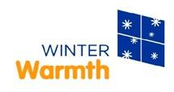

Union Gas
Winter Warmth

2012 Year End Report

Prepared by: United Way Chatham-Kent
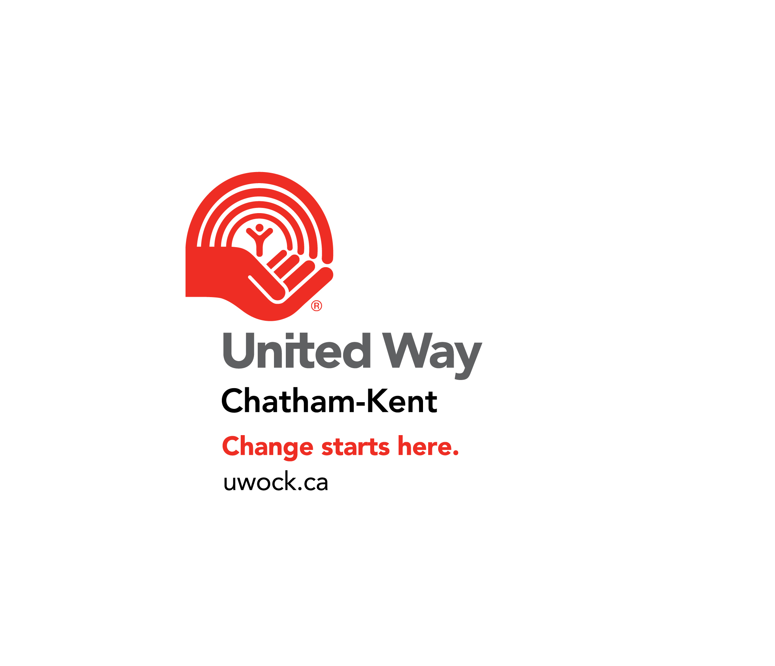



Table of Contents

Summary 1
Section A: Grant Disbursements 2
Section B: Household Composition 3
Section C: Funding Impact 4
Section D: Staffing 5
Section E: Reasons for Rejected Applications 6
Section F: Referral Source 6
Section G: Challenges/Recommendations/Comments 7
Accomplishments 7

Summary

Union Gas Winter Warmth became a year round program in 2010-2011, in order to align with LEAP (Low-Income Energy Assistance Program), as mandated by the Ontario Energy Board (OEB), and to fulfill the increased needs of low-income energy users in these difficult economic times. Although the 2010-2011 program ran for thirteen months, the 2012 Union Gas Winter Warmth Program ran for a full calendar year – January 1 to December 31. The Union Gas Winter Warmth Program is coordinated by a network of social service agencies through United Ways in 28 Union Gas catchment areas.

Winter Warmth is designed for low-income households who are experiencing temporary setbacks and have exhausted all other appropriate means of financial support. The Winter Warmth program is an important part of the community and the participating social service agencies (Intake Agencies) serve as the place where families can go for assistance.

Winter Warmth is a blessing for many customers who face a crisis or life-changing event that, in turn, creates a backload of debts, including their heating bill. It is anticipated that households receiving the grants become more financially stable and are better prepared to manage ensuing utility bills. In addition to the monetary portion of assistance, the clients are provided with the necessary referrals and information about existing programs/services available in the community and energy conservation tools and techniques through Union Gas’ Energy Savings Programs.

The Winter Warmth program helps families who have already exhausted all of their available resources and have nowhere else to turn. More specifically, Winter Warmth is able to help families stay together under one roof, lessen the impact of financial strain and help clients maintain a good credit rating without going into arrears.

In 2010-2011 the maximum individual Winter Warmth grant was increased from $450 to $500, in attempt to keep pace with other utility relief programs, and to assist as many households as possible, as much as possible. These funds are not allocated for security deposits and connection fees. Care is taken to ensure that all clients are able to sustain payments post-grant and that the specific guidelines of the program are adhered to.

The following tables will show a year over year comparison (2010-2011 vs. 2012), in order to demonstrate the impact that the Union Gas Winter Warmth Program has had on the 28 participating communities/municipalities.

Section A: Total Grants

The following table contains a comparison of grants disbursed in the Winter Warmth 2010-2011 vs. 2012 heating seasons. Keep in mind that 2010-2011 was 13 months and 2012 was 12 months in duration.

- Please refer to the end of Section A for the Table of definitions

Table 1: Total Grants

Year | Budget  ($) | Less Admin ($) | Total WW  ($) | Pay-out  ($) | Remaining  ($)
Dec. 01, 2010- Dec. 31, 2011 | $1,033,383.25 | $131,159.50 | $902,223.75 | $878,665.21 | $23,558.64
Jan. 01 – Dec. 31, 2012 | $891,487.59 | $125,901.12 | $765,586.47 | $696,694.77 | $68,891.71

Fewer dollars were paid out in Winter Warmth grants ($181,970.44) for the 2012 Union Gas Winter Warmth Program, and more dollars ($45,333.07) were left over at the end of the year. The winter of 2011-2012 (Jan. to April) was extremely mild, compared to the previous year, and winter weather did not hit Ontario until mid-late November 2012. The warmer climate may account for some of the reduced uptake, as well as the fact that the program was shorter (12 months vs. 13 months) in 2012.

Table of definitions

Budget Total funds received from the funder for one heating season (current allocation plus funds left over from previous year)
Less Admin Funds appropriated by each Intake Agency to cover admin costs; up to allowable 15% taken from total budget
Total WW Funds available to assist clients - budget minus admin fee
Pay-out Total funds spent on grants
Remaining Funds that remain after the total Pay-out is deducted from the Total WW
Section B: Household Composition

The following tables describe the total number of households assisted along with the number of individuals (adults and children) within the households.

- Please refer to the end of Section C for the Table of definitions

Table 2: Household Composition

 | Total Number of  Households  Assisted | Total Number of  Adults  Assisted | Total Number of  Children  Assisted
2010-2011 | 2,332 | 3,540 | 3,232
2012 | 1,930 | 2,896 | 2,653

Fewer households were helped with their Union Gas bills in 2012. As per the above note, this is likely a result of milder weather and a shorter program length.

Table of definitions

Total Number of Households Assisted Total number of individual households assisted with WW grants
Total Number of Adults Assisted Total number of adults within total assisted households
Total Number of Children Assisted Total number of children within total assisted households
Section C: Funding Impact

The following tables show the household size and net income in relationship to the amount of utility’s arrears.

- Please refer to the end of Section D for the Table of definitions

Table 3: Funding Impact

Year | Average # of  Individuals per  Household  (Adults & Children) | Average Monthly  Household Net  Income ($) | Average  Arrears  Amount ($) | Average  Grant  Amount ($)
2010-2011 | 3 | $1,741.89 | $517.32 | $373.90
2012 | 3 | $1,664.13 | $476.78 | $360.98

The average size of the household has not changed dramatically year over year (the number is rounded off). The average income has remained relatively flat (within $80.00), as has the average arrears (within $40.00). One might conclude that the economic situation has not improved dramatically over the past year.

Table of Definitions

Average # of Individuals per Household Total number of assisted individuals (adults and children) divided by the total number of assisted households (rounded to the nearest digit)
Average Monthly Household Net Income Total monthly net income of assisted households divided by the total number of assisted households
Average Arrears Amount Total amount of arrears divided by the total number of assisted households
Average Grant Amount Total grant amount paid to the assisted households divided by the number of assisted households
Section D: Staffing

The following table provides information on human resources required to carry out the WW program. It also contains information on total number of inquiries as well as applications that were not granted and the number of hours spent on the program.

- Please refer to the end of Section E for the Table of definitions

Table 4: Staffing

Year | Total Number  of Inquiries | Total Number  of Staff | Total Number  of Hours | Total Number of Rejected /Referred Applications
2010-2011 | 5,919 | 60 | 5,100 | 3,575
2012 | 5,402 | 57 | 6,002 | 3,480

Again, there is a relatively consistent number of calls for service, given that 2010-2011 was a 13 month program and 2012 was 12 months. More hours were logged to manage and implement the program in 2012. This may be an indicator that family situations may be more complex, and therefore take more time to review and finalize. See below, in Section E, possible reasons that clients were not assisted.

Table of definitions

Total Number of Inquiries Total number of inquiries that participating WW agency received from the public
Total Number of Staff Total number of staff involved in work on WW (on part-time or full-time basis)
Total Number of Hours Total number of staff hours spent on WW (answering inquiries, assessment and referral, application process, approval, follow-up)
Total Number of Rejected Applications Total number of rejected applications through prescreening and application process
Section E: Reasons for Rejected/Referred Applications

The following are reasons, as identified by the 28 participating communities/municipalities, why client applications were turned down or referred to other agencies that could help, for the 2012 program:

- Applicant’s household income exceeded income eligibility criteria
- Applicant failed to follow through
- Applicant was unable to prove sustainability – requested grants several years in a row
- Documentation failed to verify information given by the applicant
- Bill was not in applicant’s name/applicant owed from other addresses
- Applicant was not an existing Union Gas customer
- Arrears was from another community
- Applicant was unable to make payment arrangements for the balance owing, above the $500 grant
- Applicant resided outside the catchment area
- Applicant received assistance from OW or ODSP or other agency
- Applicant already qualified once this year
- Applicant chose not to continue with application process
- Applicant had no income to continue to pay bills
- Applicant was not in arrears
- Amount owing was entirely deposit and reconnection fees

Section G: Referral Source

The following information captures the data on applicants’ referral sources for the 2012 program. The sources differ very little from previous years. However, there appears to be a much greater number of referrals from the utilities versus word of mouth or social service agencies.

Utility referral (25 communities) – 912 referrals
Word of mouth (25) – 475 referrals
Social service agency (24) - 592 referrals
Newspaper (6) – 41 referrals
Utility website (4) – 11 referrals
Poster (3) – 13 referrals
Billing insert (6) – 50 referrals
Radio (2) – 32 referrals
TV (1) – 1 referral
Other (12) – 132 referrals - friends or relatives, have accessed the program previously, other utility provider, government agency, United Way, churches
Section F: Challenges/Recommendations/Comments
- Agencies would prefer to receive their own localized media release before it goes to the media, so they are prepared for the increase in calls about the Winter Warmth Program.

Funding
- 50% of the total requested funding was initially allocated to all communities in December 2011 for the 2012 Program - $554,750. Allocations were made in this way in order to manage the timelines for investments coming due.
- In comparison, 65% of all requests over $10,000 was allocated in December 2010 for the 2010-2011 Program. All requests under $10,000 were fully allocated at that time as well – a total of $461,498.61.
- There were many calls for additional funding – a total of fourteen additional allocations were made, totaling $317,000, over the course of the twelve months of the 2012 program. In 2010-2011 there were seven additional allocations totaling $510,353.47 in a thirteen month period.
- Only one agency (Huron County) declined administrative funding in 2012, compared to two communities (Huron County and Sarnia-Lambton) in 2010-2011.

Accomplishments

The Winter Warmth Program provides an extremely valuable form of assistance to many low-income households which face the prospect of living without heat. United Ways and social service agencies, in collaboration with Union Gas Ltd., help individuals and families maintain their housing and enhance their support network when many families are confronted with challenges such as job loss, family breakdown, illness, injuries or even death. Given an ongoing difficult economic situation, this program continues to help to stabilize the life situations of low-income families who are confronted with short-term financial difficulties.
Below are several “testimonials” and stories from agencies that are administering the Union Gas Winter Warmth Program and people who have lived-experience.

Oakville:

I think the situation that hit me the most this year was the senior who came in who had been without gas or hydro for two months. She was a widow and her husband had handled all the finances and she was struggling. We spent a great deal of time trying to find additional supports for her and were shocked that very few exist. In the end we had to call the police to go in to support her. They have a seniors division and assured us they would take care of her.

We recently had a lady ask for help who had been a stay at home mum. Her husband was abusive and she had to get a restraining order against him. She was trying the best she could by working any part time job she could find but was behind in her bills. This lady was determined to get things back on track.

Hastings County (Quinte):

In an ever changing government and so many changes to funding programs, this additional funding is not only a helping hand to our clients but to us as an organization. This funding allows us to go above and beyond when helping a client in financial hardship. This one time funding in so many cases allows people to get caught up and provides that extra breath that so many people cannot take because the stress is beyond them. The words “thank you” mean different things to different people, but we always know that it means “you saved me and my family”.

Burlington:

We are always thankful to Winter Warmth for the support that they provide our clients as many of them have already been struggling to decide whether to pay rent, buy food or pay their heating bill. Thankfully through Winter Warmth they are able to shorten the list of needs that require their limited funds. I am also thankful to Winter Warmth as there is such a great feeling when you see the sigh of relief when you tell a client that that's one less financial worry in their life at that time that you let them know that Winter Warmth will be taking care of their Union Gas bill!
Bruce-Grey:

“Words are weak right now to express my full gratitude to you, that although I feel out of control, with speaking with you I feel there is a chance for me to reclaim my life, thank you for not allowing me to believe that I am not less than. Very easy to do in the current situation I find myself.”
Sudbury:

Many of our clients come to us amidst a variety of personal challenges. They are so grateful to have the opportunity to receive help not only to maintain the heat in their homes, but also ease financial burdens in other important aspects of their lives. One client said “I thought I would have to decide between having my heat on or buying food for my children. I am so thankful to receive this assistance and to not have to pick one or the other.”

Milton:

Milton clients tell me quite often that if it wasn’t for this program they would be out on the street. My most recent client said that we will never know how much this program helped them unless we are in their situation. I would have to agree that we may not even realize what a difference this makes in the lives of those clients struggling to maintain quality of life.

Huron County:
Clients are always grateful to be able to receive assistance with their utility bill and often pleasantly surprised at how much assistance is available (up to $500.00). When facing a disconnect clients become very anxious and concerned. I have often heard a deep sigh of relief and receive tearful thank yous when the client is made aware that he/she is eligible.

Waterloo Region:

We appreciate our ongoing partnership with Union Gas through Winter Warmth. The funds received through Winter Warmth provide an essential support to households throughout the year. This funding is making a difference to households in Waterloo Region—thank you!

Thunder Bay:

When I called to tell the client she was approved, she started crying and said "I got my Trillium cheque today. I was going to put it on my gas bill, but now that I don't have to worry about it, I can buy groceries. I can eat because of you."

