Sent by email: boardsec@ontarioenergyboard.ca

May 16, 2013

Ontario Energy Board
P.O. Box 2319
2300 Yonge Street
Toronto, Ontario, Canada
M4P 1E4

Attention: Ms. Kirsten Walli, Board Secretary

Dear Madam: Subject: EB-2011-0099, Decision on Confidentiality – March 19, 2013

I’m writing to communicate our disappointment with the above-noted decision. We are of the view the decision did not respect clear confidentiality and copyright issues related to our Management Salary Survey program. The Board decision has caused significant damages to both our product and company brand.

We’re recommending we meet for a discussion. We are interested in exploring how to develop a workable, mutually agreeable solution for future requests of a similar nature given the current approach is highly problematic for us.

We look forward to having a conversation on this topic. To that end, I would request someone from your office contact me in order to secure a meeting date and time.

Yours truly
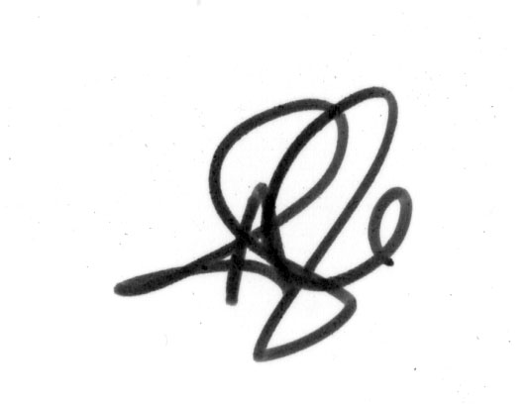
Andrea Dale
VP, Marketing, Sales & Corporate Affairs
The MEARIE Group
Tel: 905 265 5352
Email: adale@mearie.ca

