Balsam Lake Coalition
313 – 1550 Kingston Road,
Pickering, Ontario
L1V 1C3

10 June, 2013

Ms. Kirsten Walli,
Secretary,
Ontario Energy Board
2300 Yonge Street,
Suite 2700, PO Box 2319
Toronto, Ontario M4P 1E4

EB- 2012 0141– Hydro One Network Inc. IRM Distribution Rate Application

Dear Ms. Walli,

It is our intention to participate in the Hydro One Rate Application EB-2012-0141 as intervenors representing the Balsam Lake Coalition. We are Hydro One residential customers comprised largely of the ‘Seasonal Rate Class’.

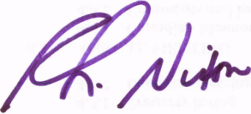

R.L Nixon, Principal
N. Copes, Principal
Balsam Lake Coalition

